Memoization and Tabulations of dynamic programming :

**CanSum :**

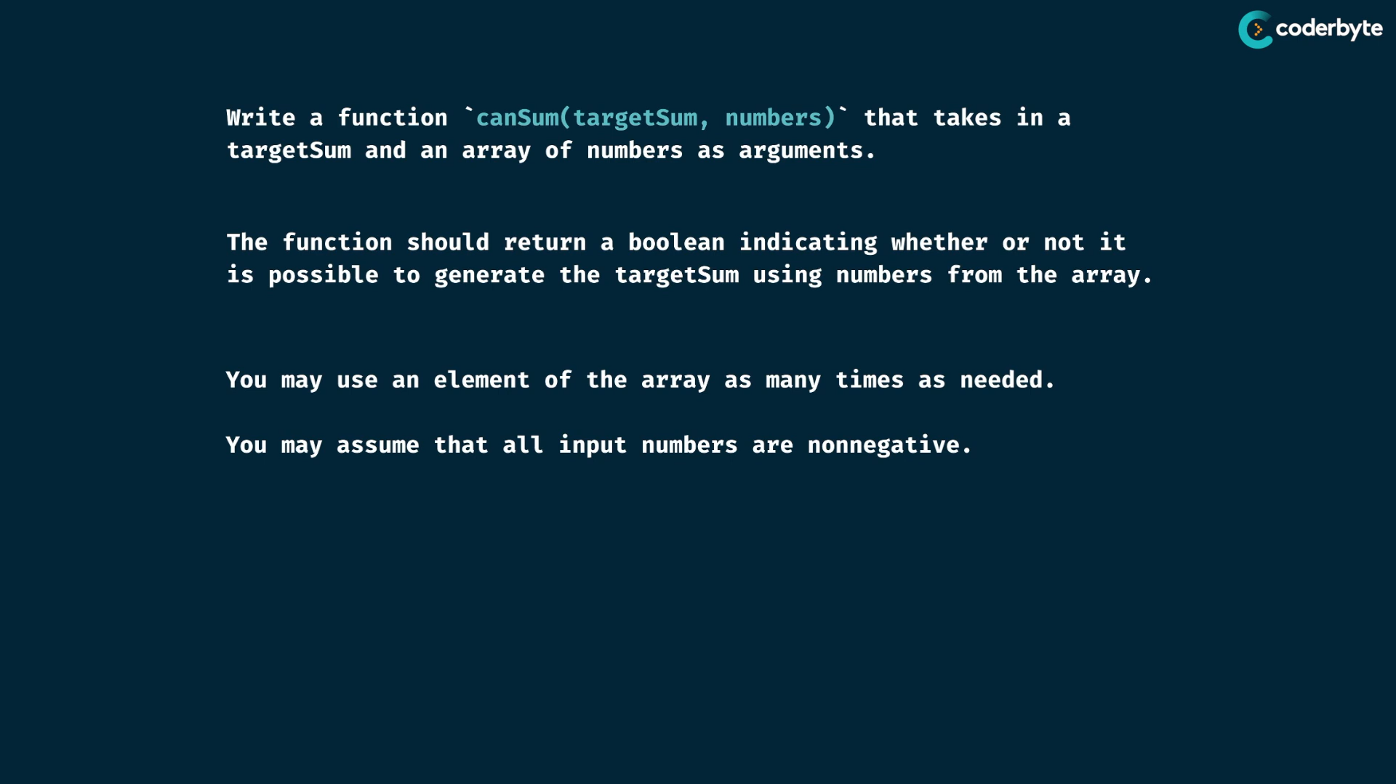

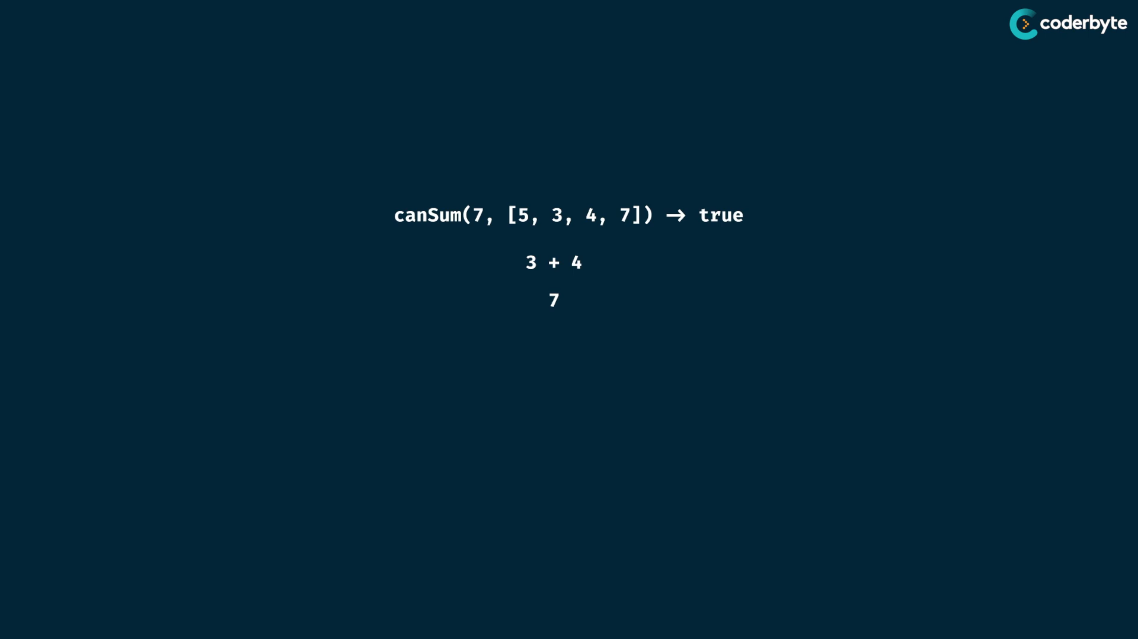

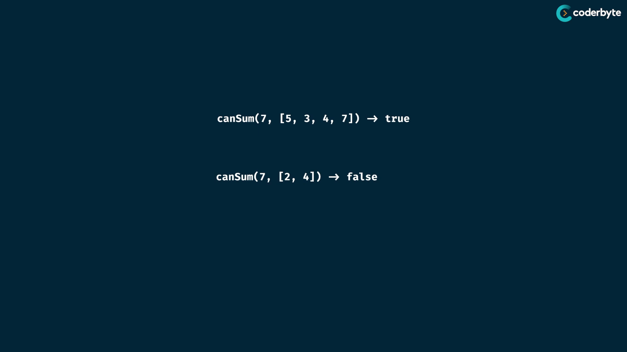

Recursive structure :

take target sum as root and then draw child which is in given array that is less than … since when we try greater one then parent to child , it results in negative values ..

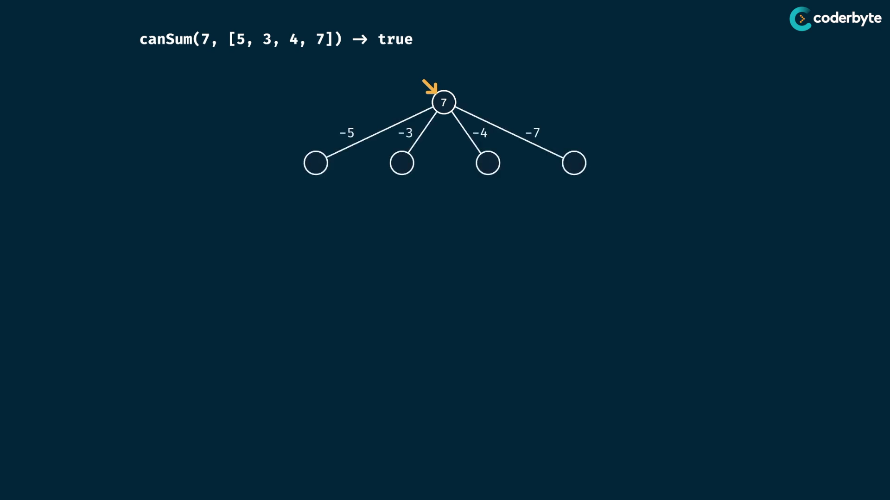

try all possible values path … and their remainder is the new child

compactible targetsum is not negative , no valid options for lesser ones of min of array elements ..

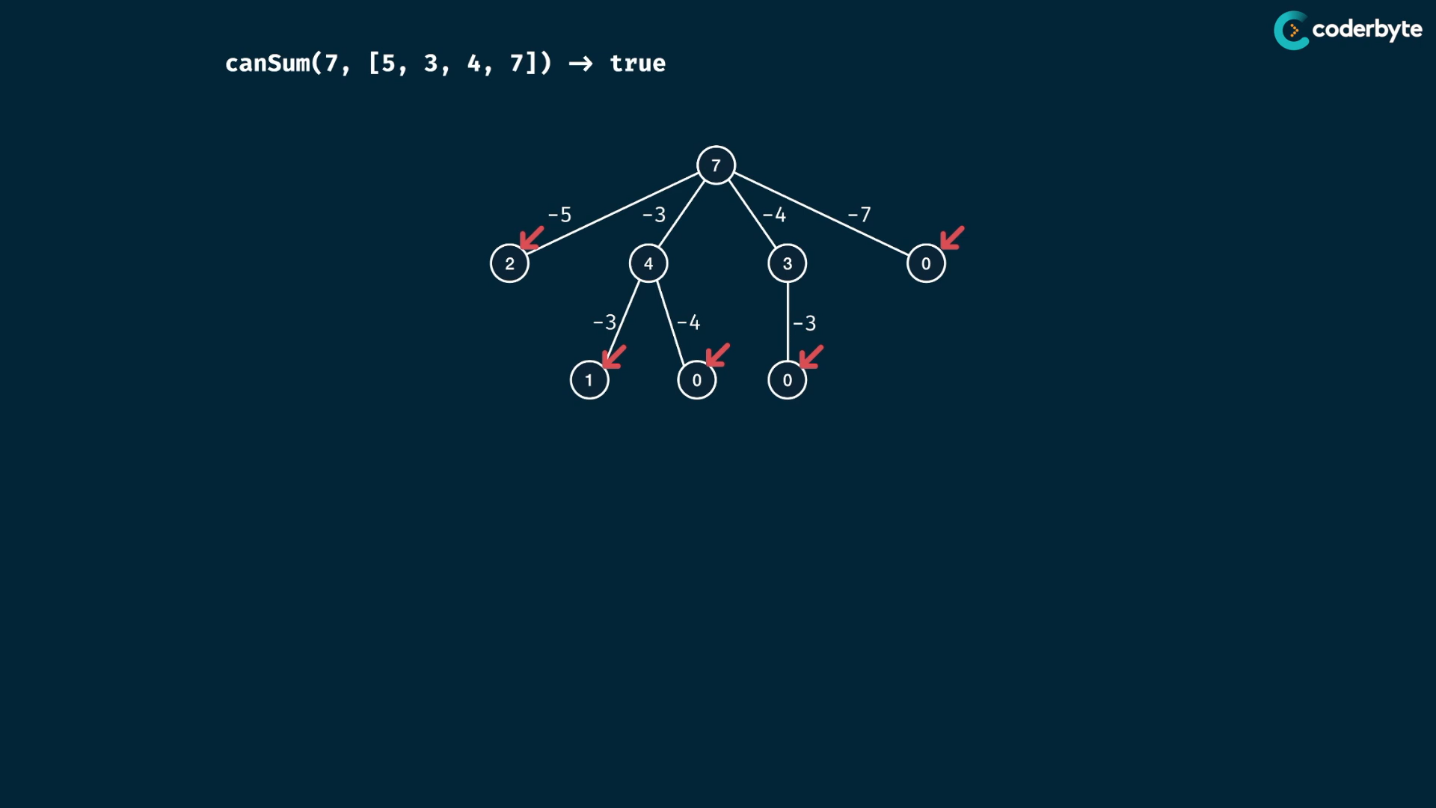

leaf nodes with 0 – path solved trivially

leaf nodes without 0 – path not solved trivially

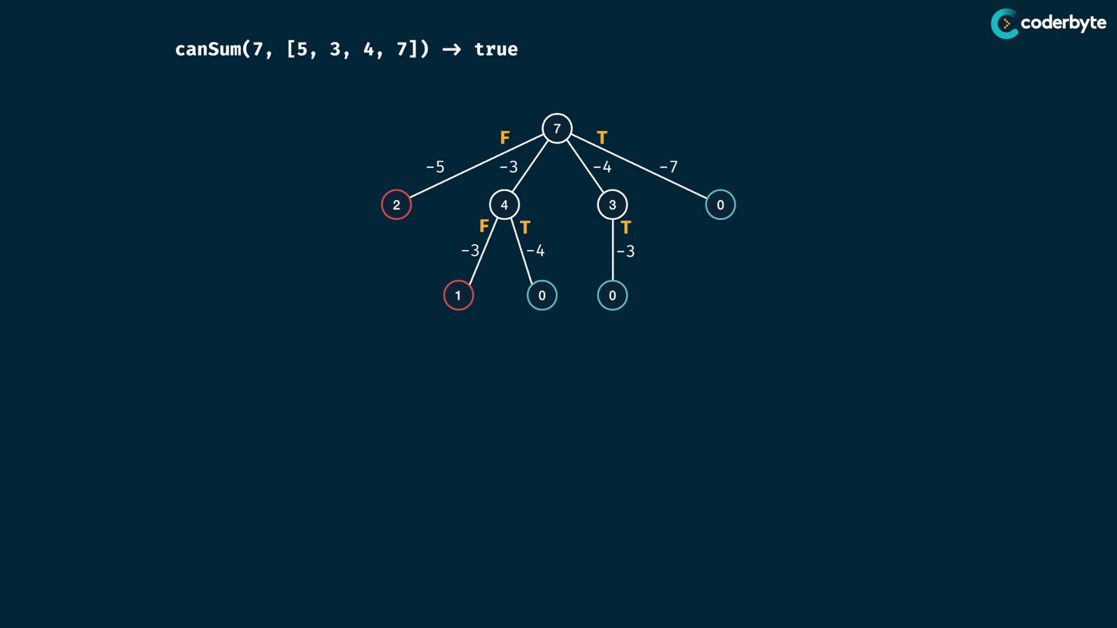

Bubbling up to parent…

parent check one of them is true , then parent should also return true , else false ..

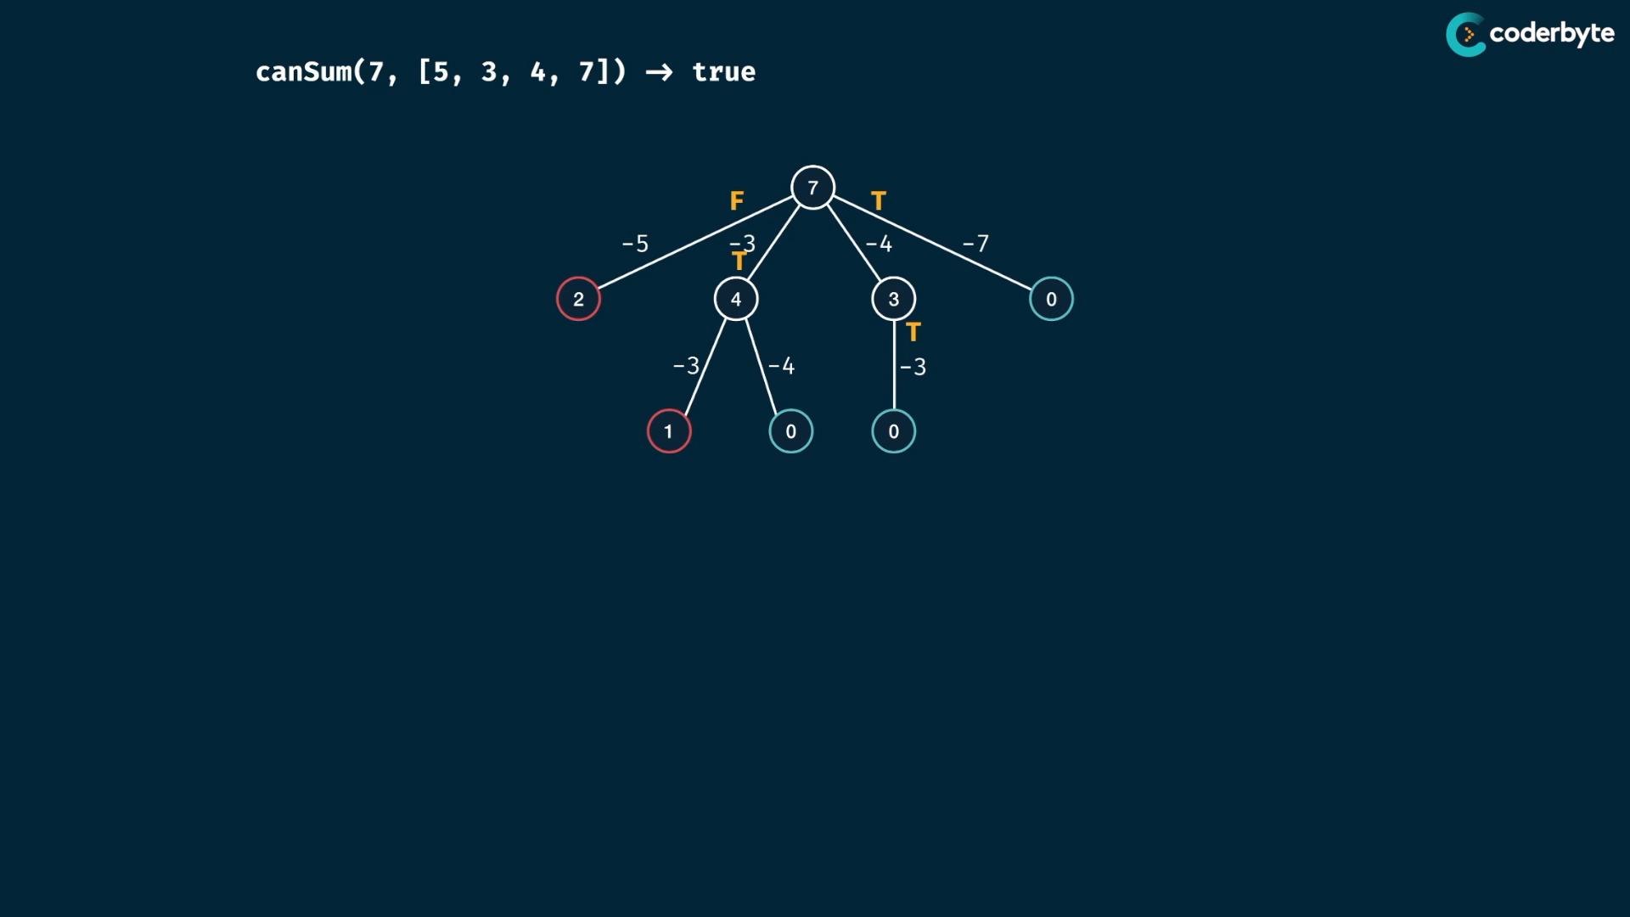

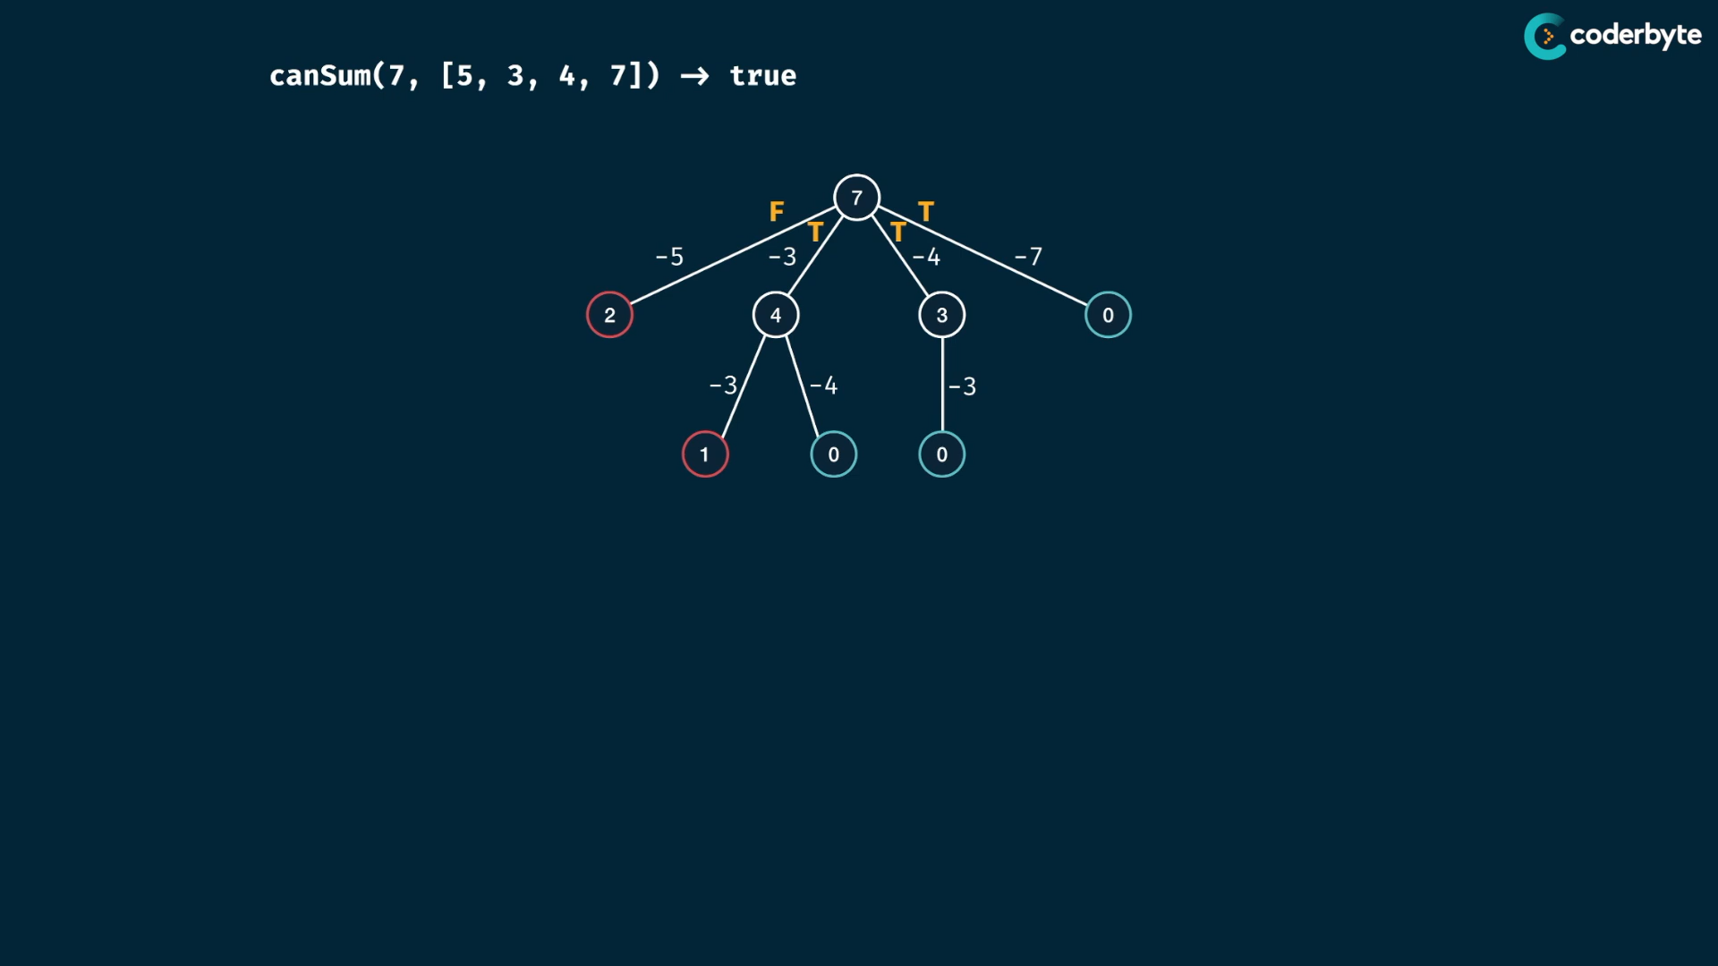

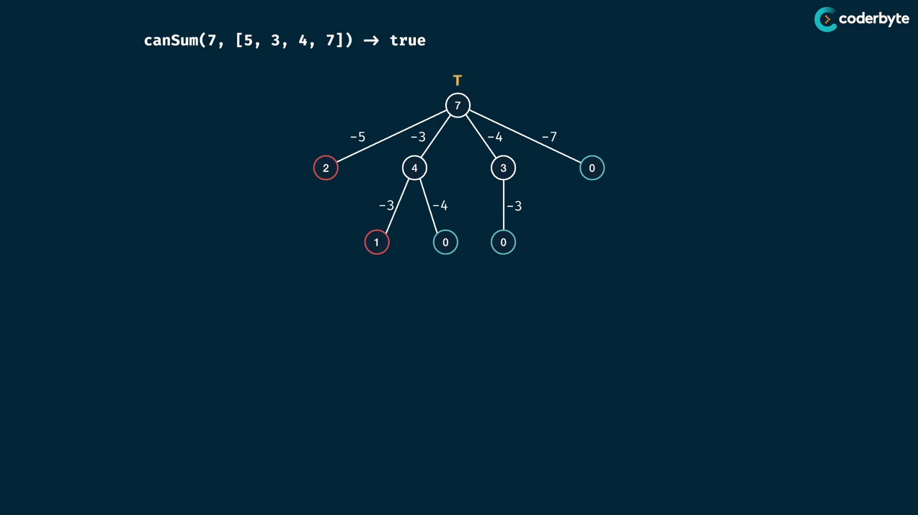

next exp:

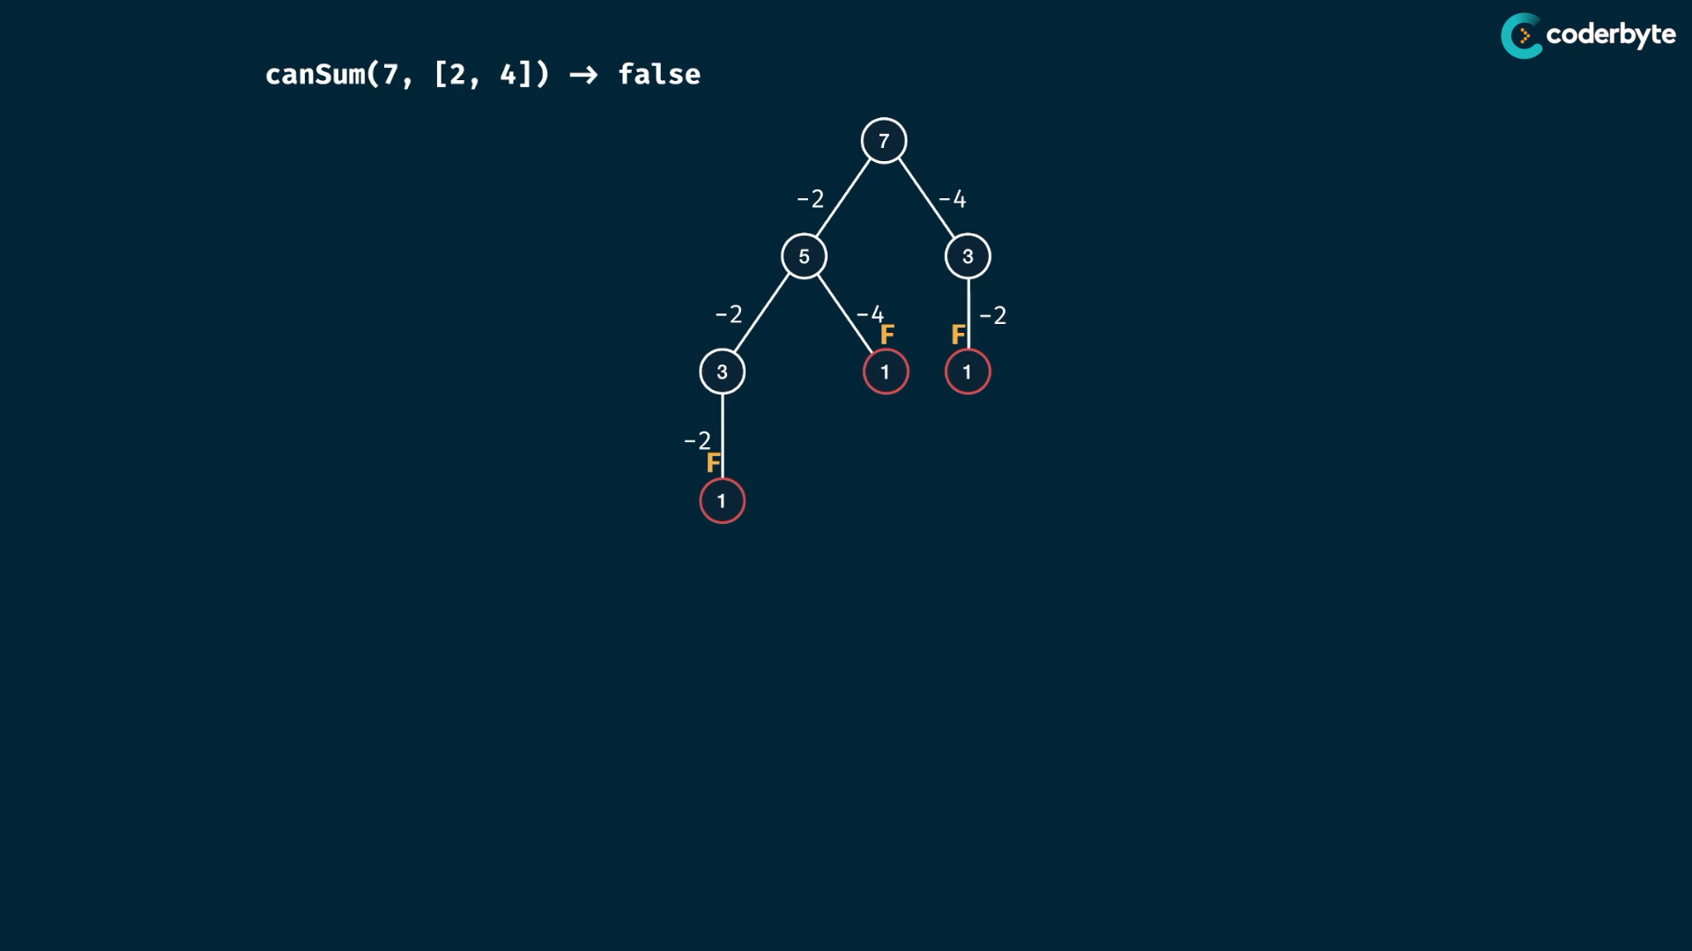

bubbling up all false , no true , so return false ..

code : brute force

//+ canSum[yes/no]

*const* canSum = (*targetSum*, *numbers*) *=>* {

    if(*targetSum* === 0) return true;

    if(*targetSum* < 0) return false;

    for(*let* num of *numbers*){

*const* remainder = *targetSum* - num;

        if( canSum(remainder, *numbers*) === true )

            return true;

    }

    return false;

};

console.log(canSum(7,[2,3]))     //=> true

console.log(canSum(7,[5,3,4,7])) //=> true

console.log(canSum(7,[2,4]))     //=> false

console.log(canSum(8,[2,3,5]))   //=> true

console.log(canSum(300,[7,14]))  //=> false {take little extra time}

{

try to use modulus operator inorder to reduce frequent subtraction ..

try modulus operator upto for all divisors upto value that is greater than max divisors …

}

complx:

tree structure .

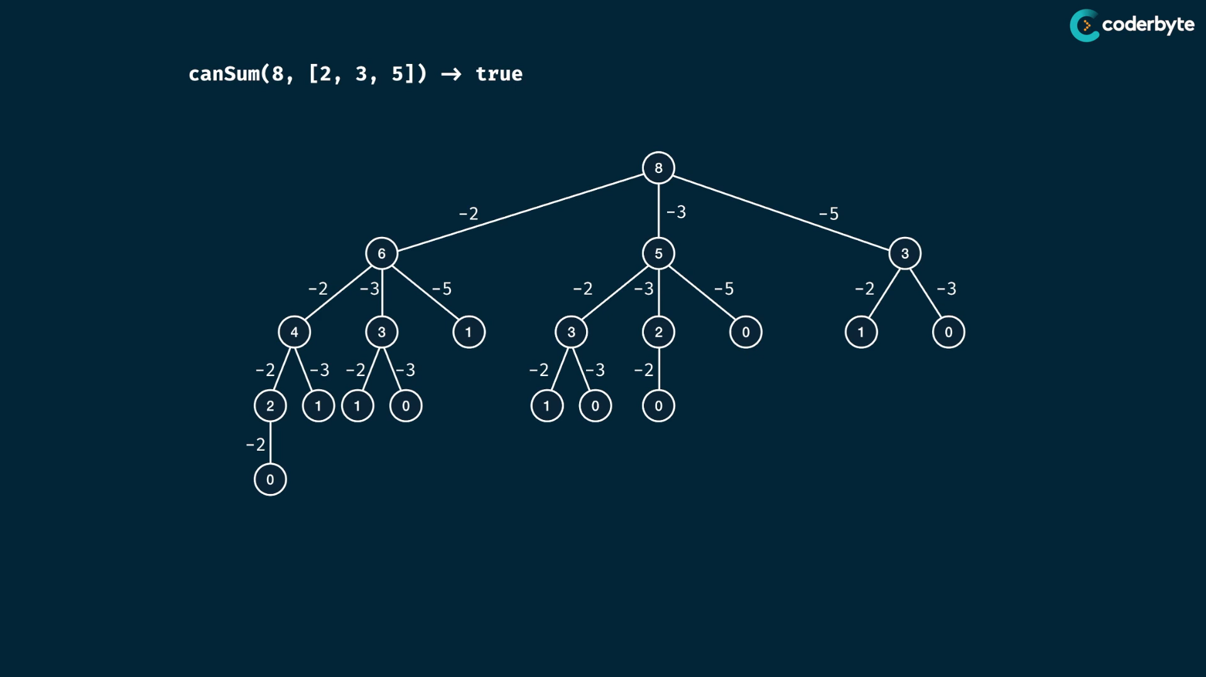

at worst case ..

consider the array have only 1 i.e[1] , then the height of tree is m { where m is target sum .. }

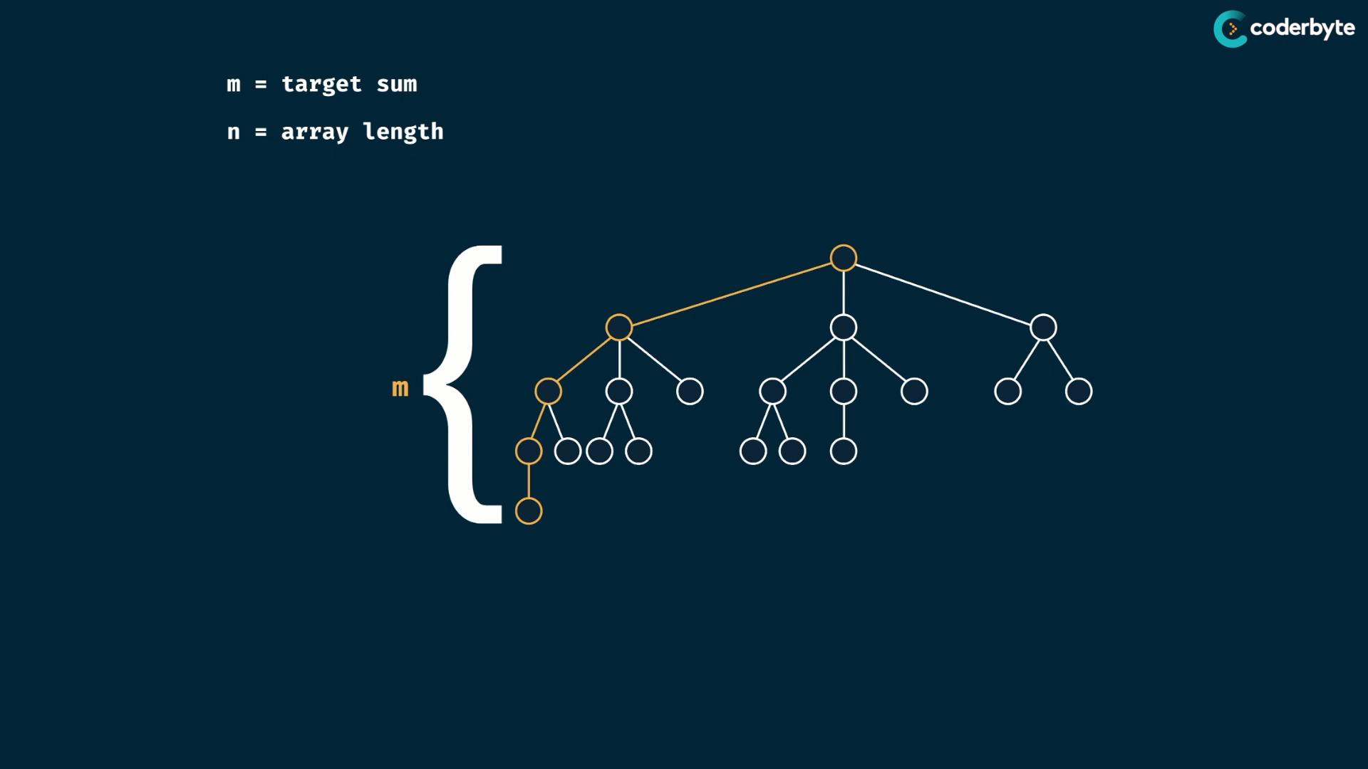

worst case : n elements in array , then m must be the branching factor of each branch ..

n is multiplied by m times to get the targetSum consideration …..

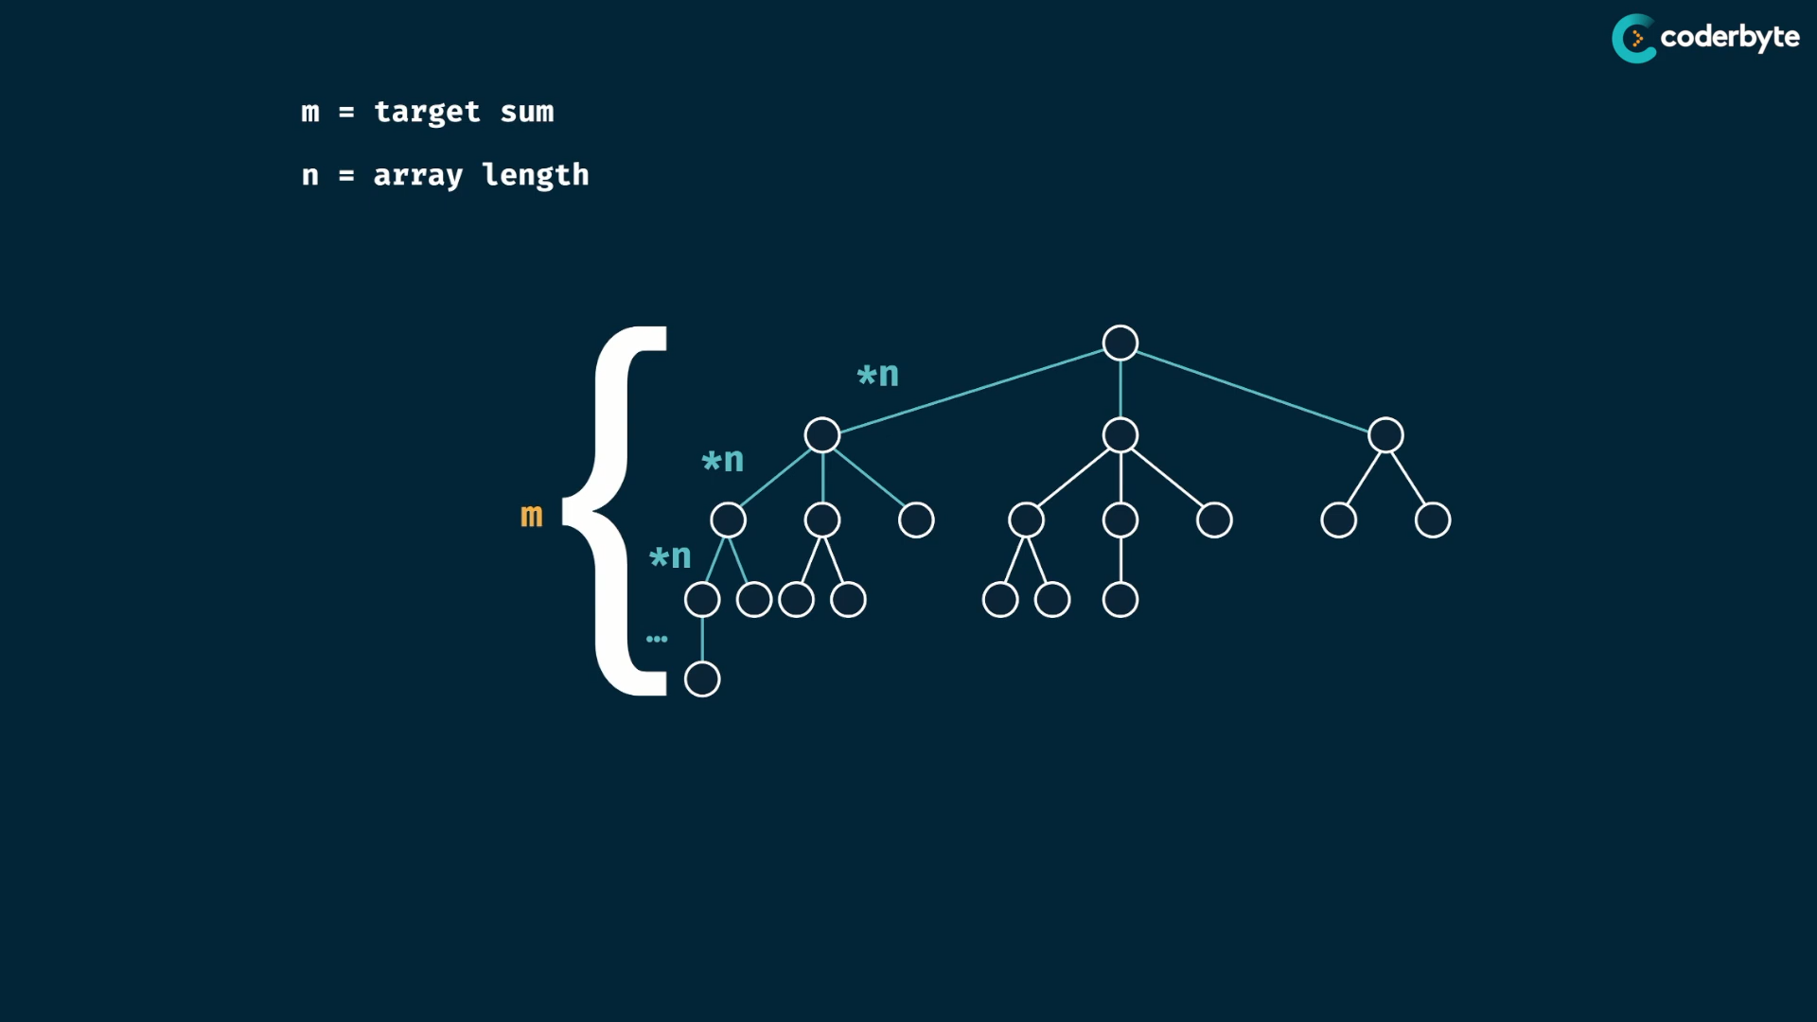

which results in O(n^m) time complexity

space takes is height of tree , which is m here …

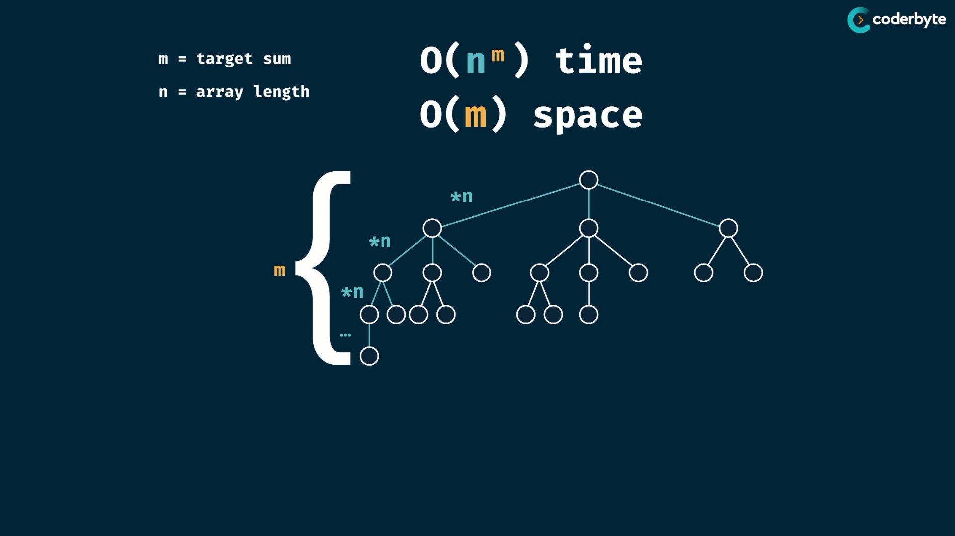

imporving the tree :

the is overlapping subproblem,since duplicating subtree ..

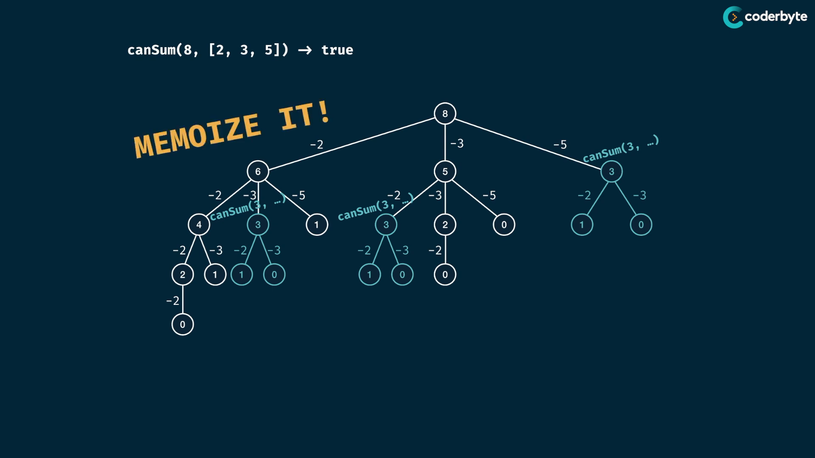

memorized code :

//+ canSum[yes/no] moi method

*const* canSum = (*targetSum*, *numbers*,*memo*={}) *=>* {

    if(*targetSum* in *memo*) return *memo*[*targetSum*];

    if(*targetSum* === 0) return true;

    if(*targetSum* < 0) return false;

    for(*let* num of *numbers*){

*const* remainder = *targetSum* - num;

        if( canSum(remainder, *numbers*,*memo*) === true ){

*memo*[*targetSum*] = true;

            return *memo*[*targetSum*];

        }

    }

*memo*[*targetSum*] = false;

    return *memo*[*targetSum*];

};

console.log(canSum(7,[2,3]))     //=> true

console.log(canSum(7,[5,3,4,7])) //=> true

console.log(canSum(7,[2,4]))     //=> false

console.log(canSum(8,[2,3,5]))   //=> true

console.log(canSum(300,[7,14]))  //=> false

updated:

*//+ canSum[yes/no] moi method*

const canSum = (targetSum, numbers,memo={},min=-1) => {

    if(min === -1){

        min = Math.min(...numbers);

        for(num of numbers)  {

            if(targetSum%num === 0) return memo[num] = true;

            memo[num] = true;

        }

    }

    if(targetSum < min) return false;

    if(targetSum in memo) return memo[targetSum];

    for(let num of numbers)

        if( canSum( targetSum-num , numbers,memo,min)) return (memo[targetSum] = true);

    return (memo[targetSum] = false);

};

console.log(canSum(7,[2,3]))     *//=> true*

console.log(canSum(7,[5,3,4,7])) *//=> true*

console.log(canSum(7,[2,4]))     *//=> false*

console.log(canSum(8,[2,3,5]))   *//=> true*

console.log(canSum(300,[7,14]))  *//=> false*

console.log(canSum(10002,[4,5,10,20]))  *//=> true*

imporved cmplx:

m – target sum , n – array length

tim. cmplx is m*n , since we solve only for each pairs.. no reexplore takes place ..

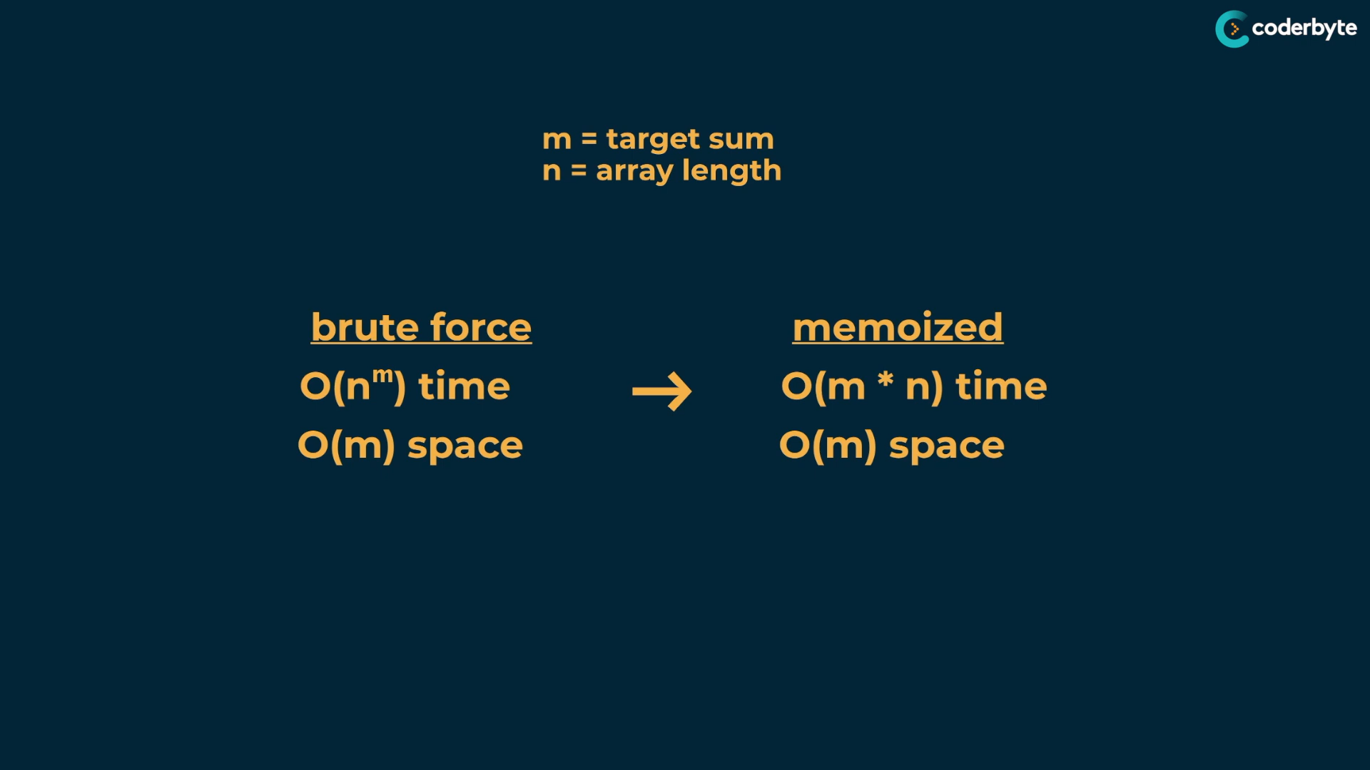

Consolidate:

const canSum1 = (target, numbers) => {

for(let num of numbers){

const rem = target - num;

if(rem === 0){

return true;

}if(rem < 0){

continue;

}else{

if(canSum(rem, numbers)){

return true;

}

}

}

return false;

};

const canSum2 = (target, numbers, mem = {0:true},min = -1) => {

if(min === -1){

min = Math.min(...numbers);

}

if(target in mem) return mem[target];

if(target < min) return false;

for(let num of numbers){

const rem = target - num;

if(canSum(rem, numbers, mem, min)){

mem[rem] = true;

return mem[rem];

}

}

mem[target] = false;

return false;

}

const canSum = (target, numbers,mem={},min=-1) => {

if(min === -1){

min = Math.min(...numbers);

for(num of numbers) {

// value divisible by any of the item

if(target%num === 0) return (mem[target] = true);

mem[num] = true;

}

}

// value lower than least item in numbers list

if(target < min) return false;

if(target in mem) return mem[target];

for(let num of numbers)

if( canSum( target-num , numbers,mem,min)) return (mem[target] = true);

return (mem[target] = false);

};

console.log(canSum(7,[2,3])) //=> true

console.log(canSum(7,[5,3,4,7])) //=> true

console.log(canSum(7,[2,4])) //=> false

console.log(canSum(8,[2,3,5])) //=> true

console.log(canSum(300,[7,14])) //=> false

console.log(canSum(10002,[4,5,10,20])) //=> true

howSum :

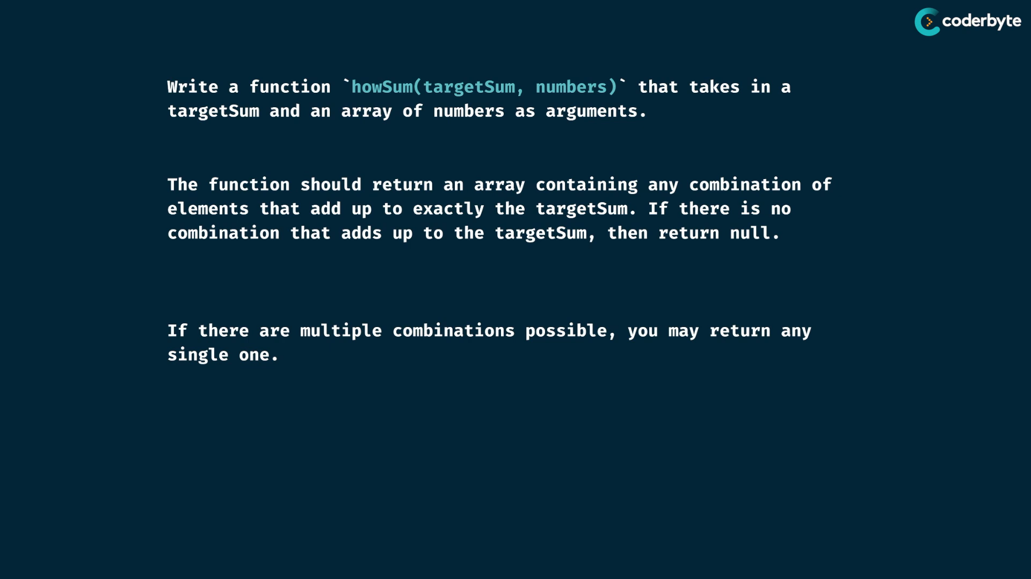

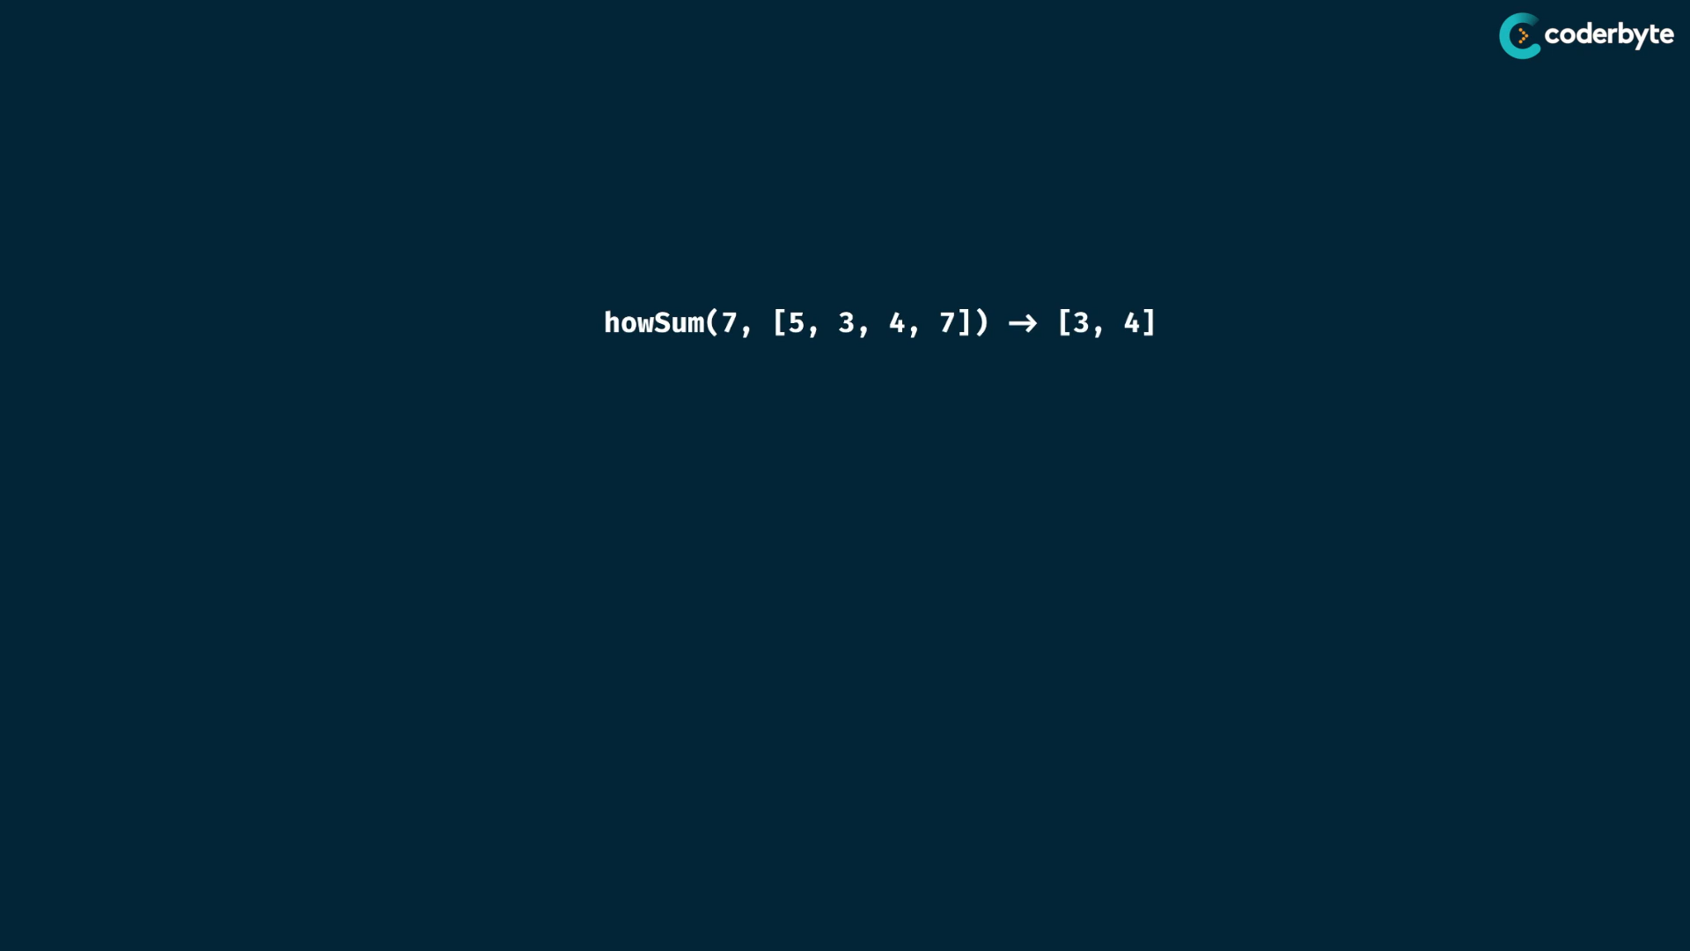

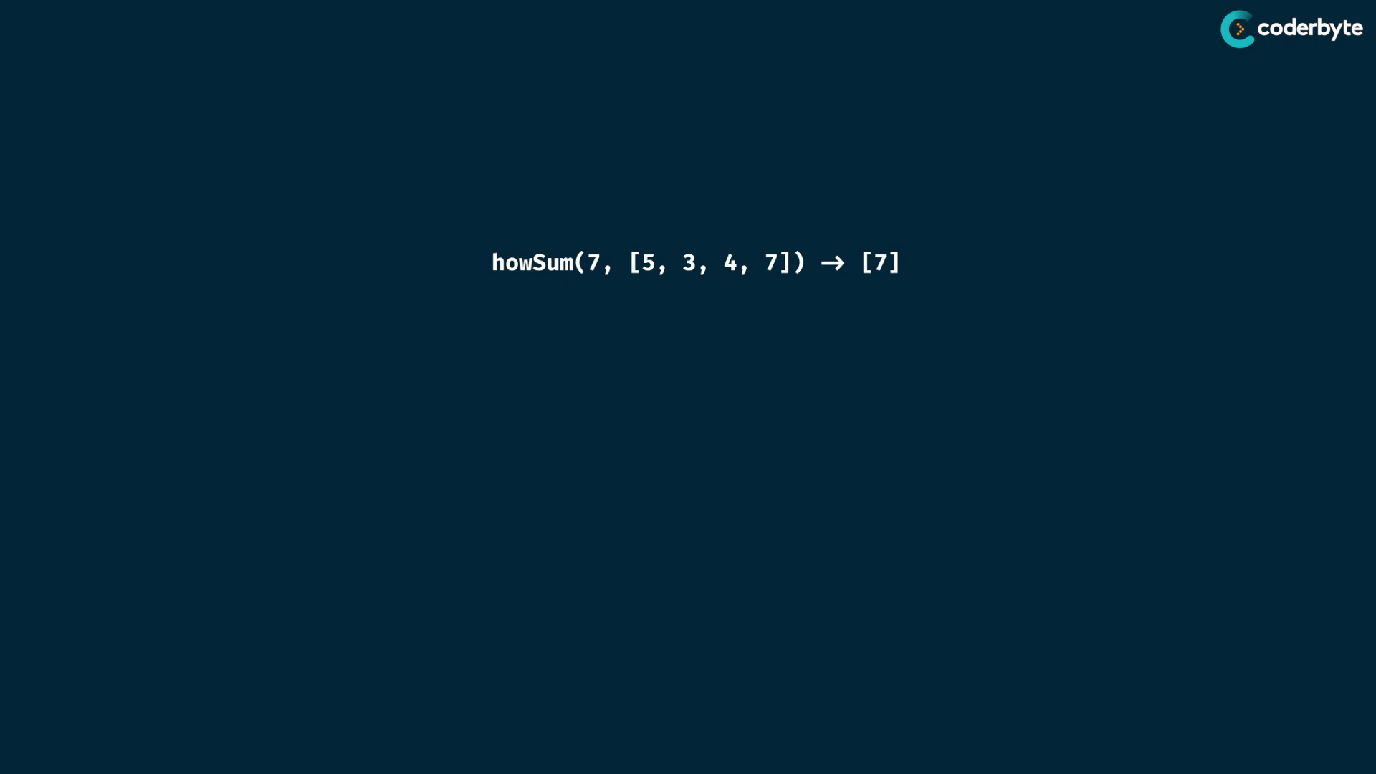

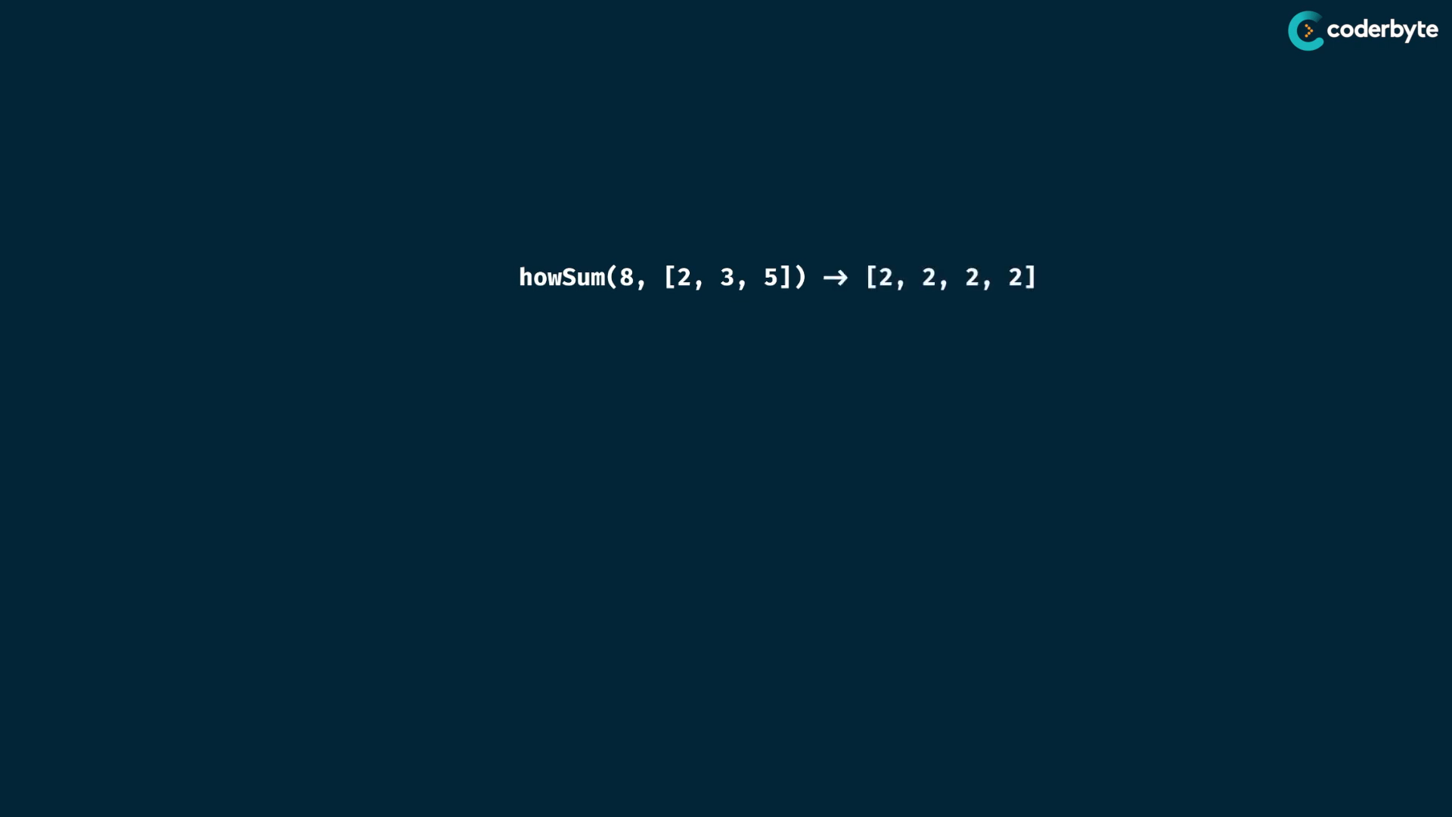

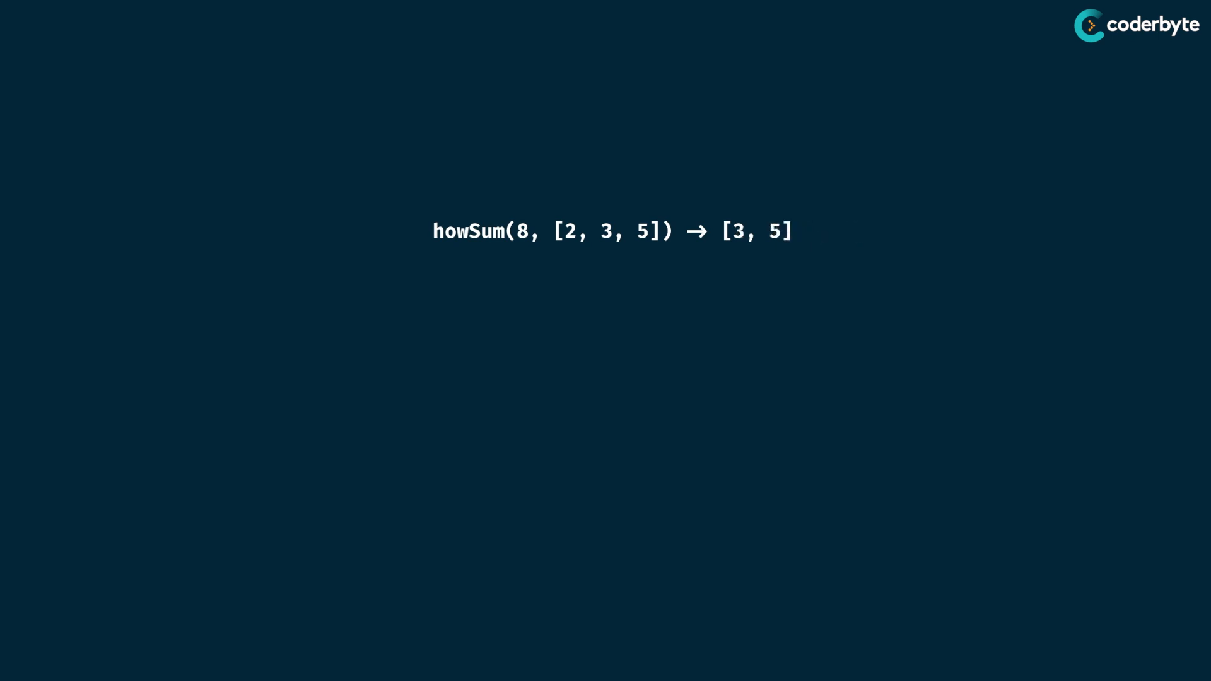

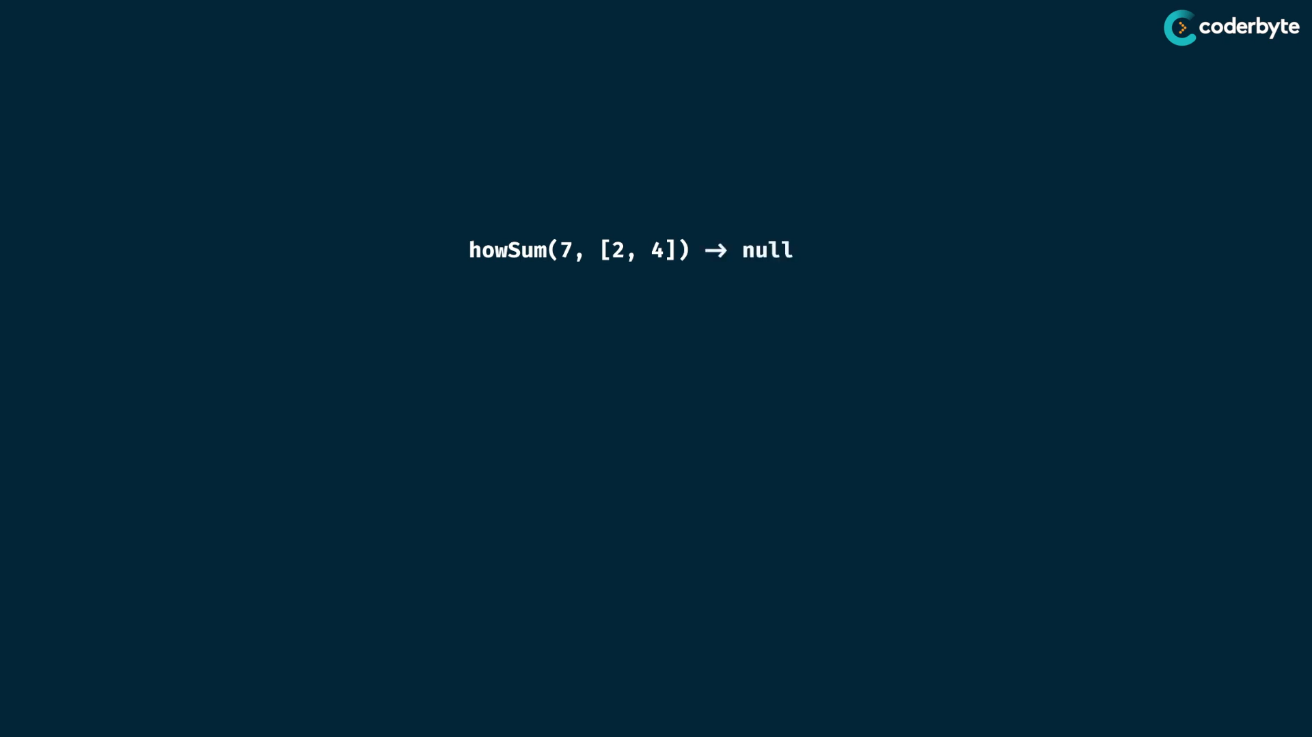

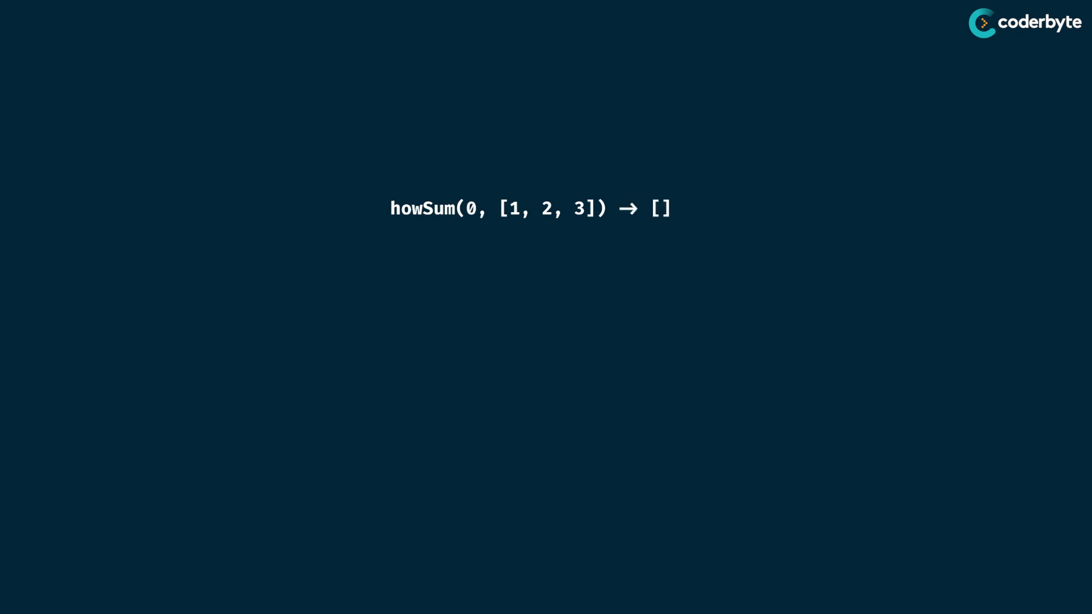

exp:

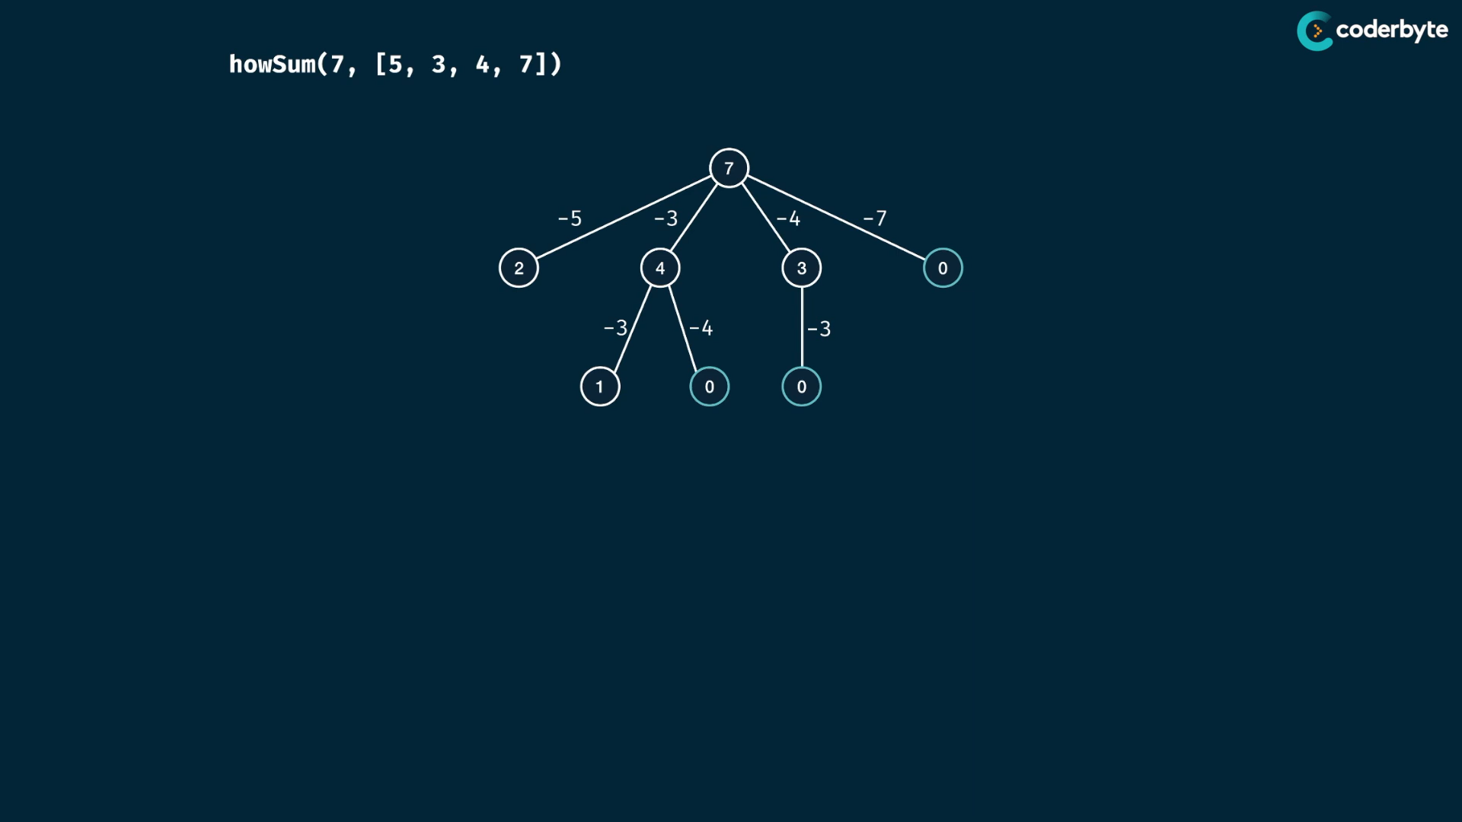

base case with target sum of 0 .. return with empty array

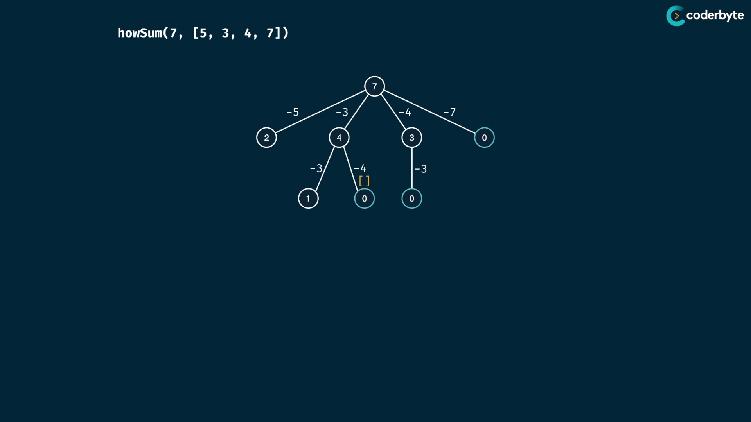

while bubling up , push the path to the array …

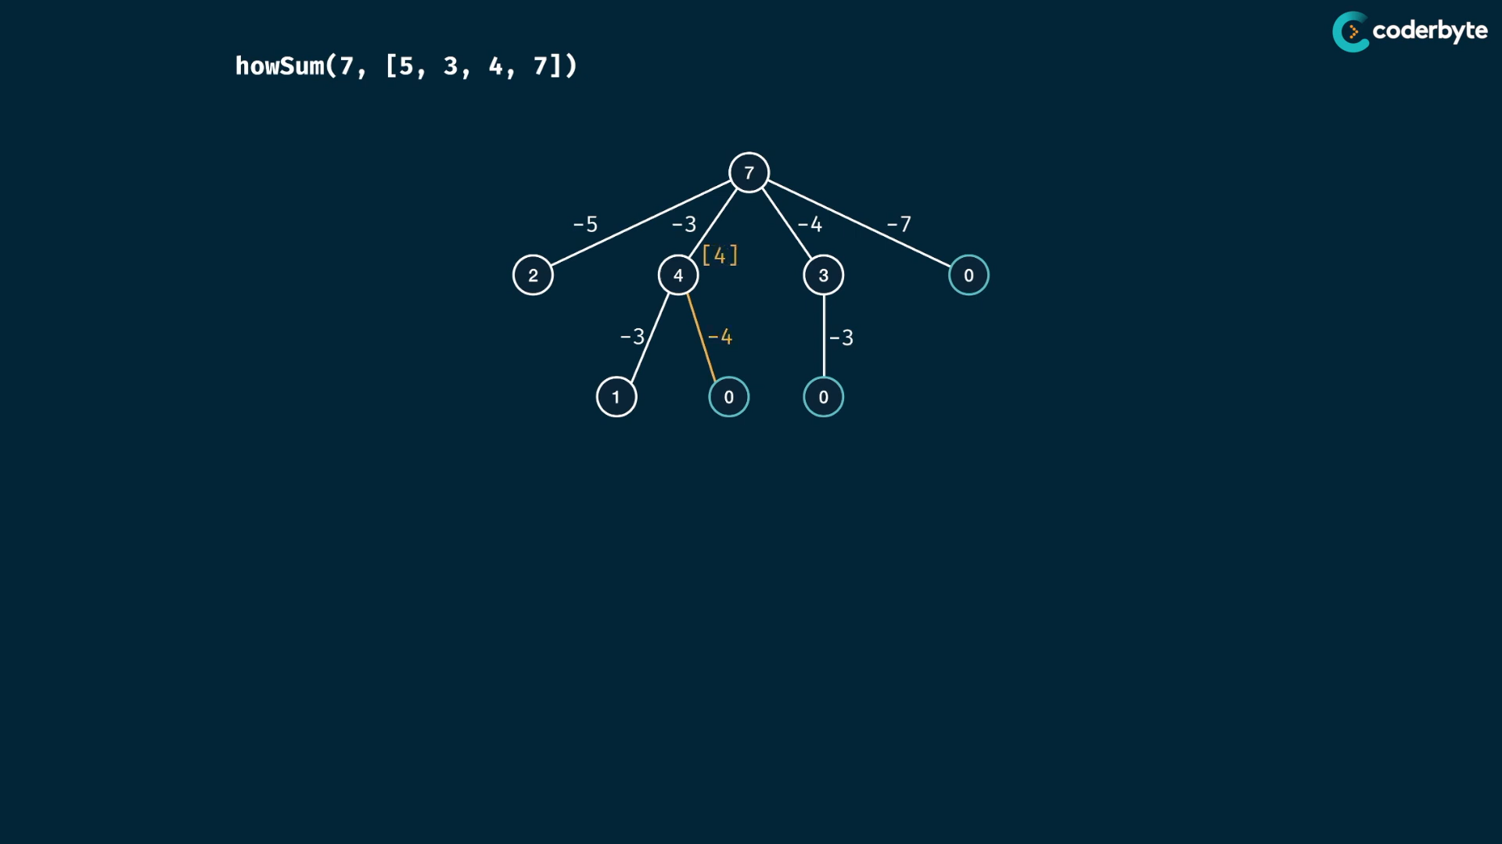

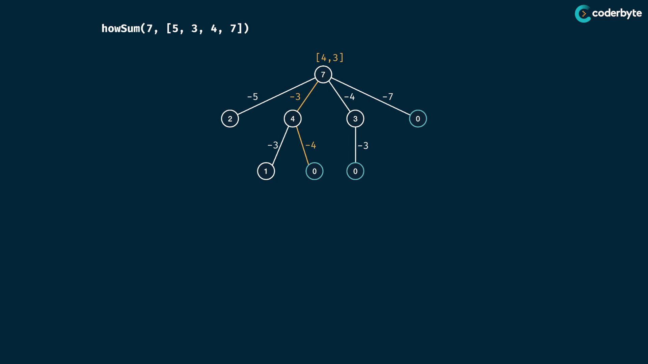

target sum array is got at root ..

other path …

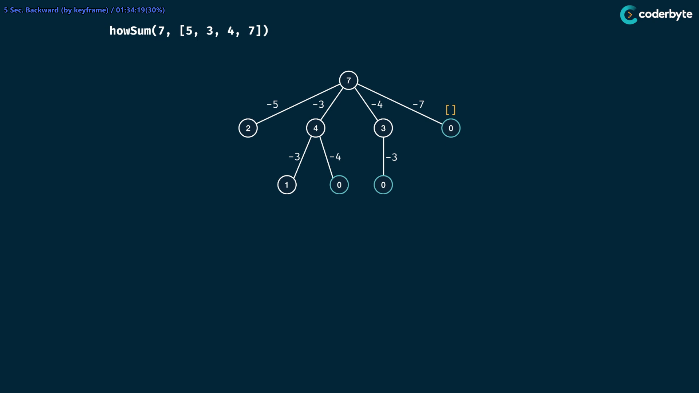

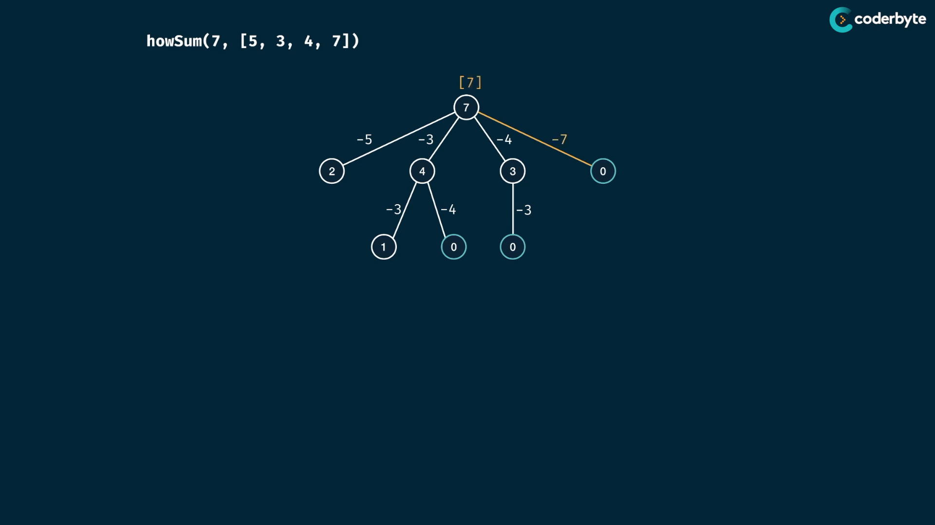

other path :

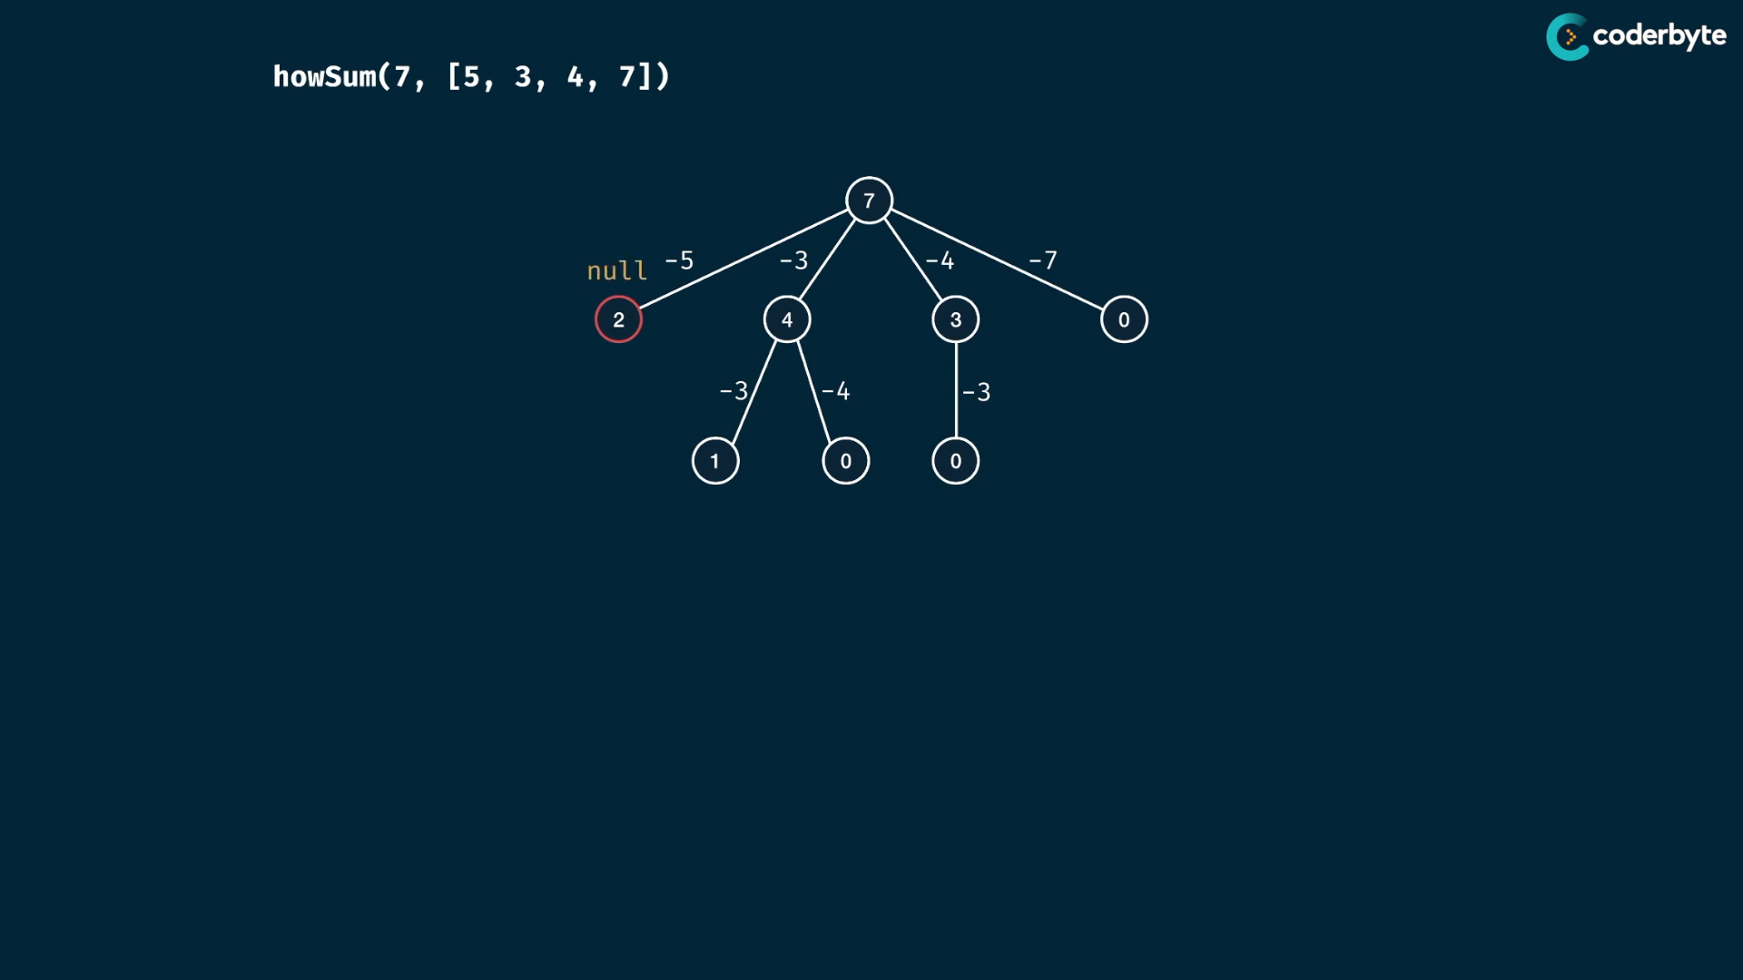

observe the base cases of childs to parents…

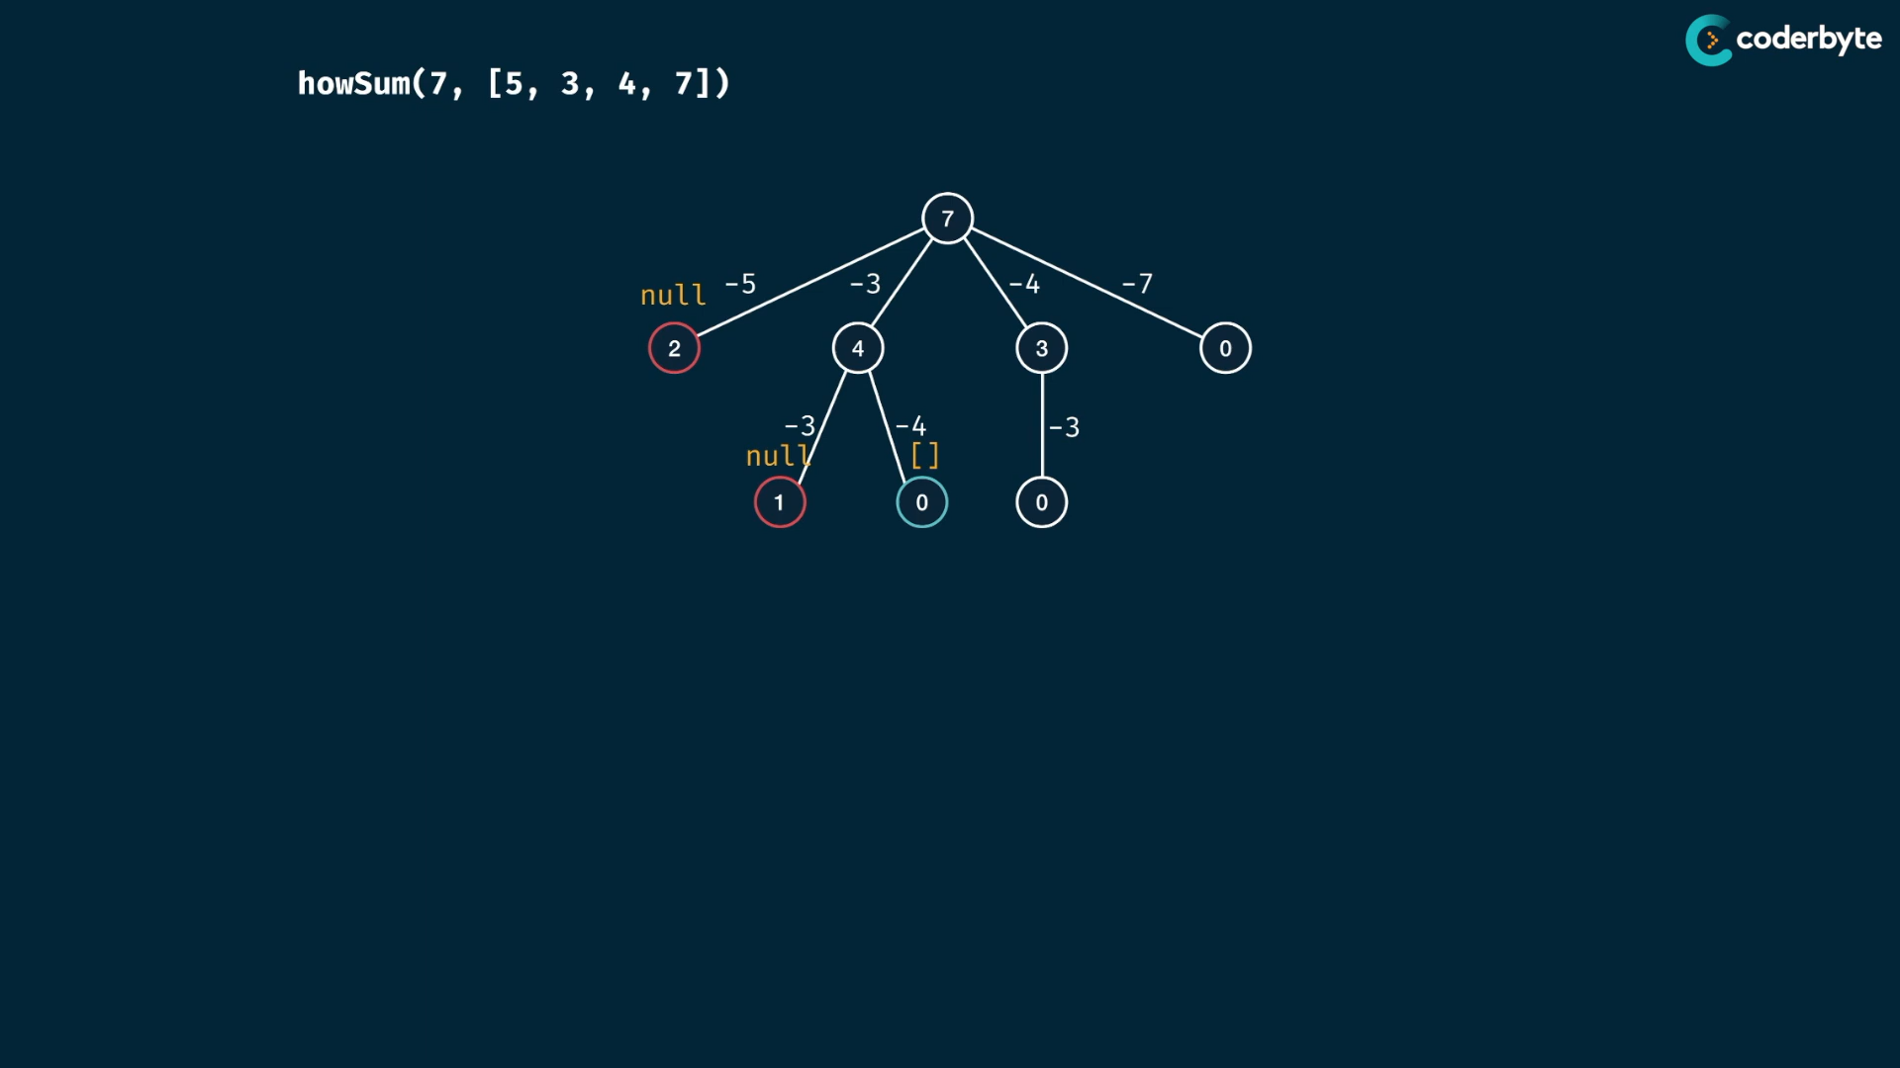

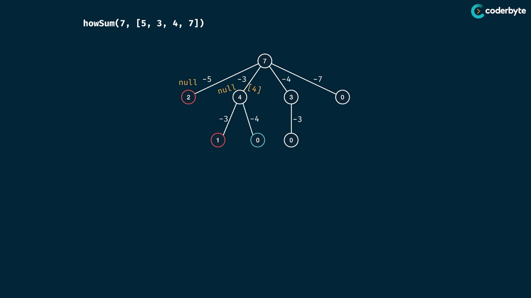

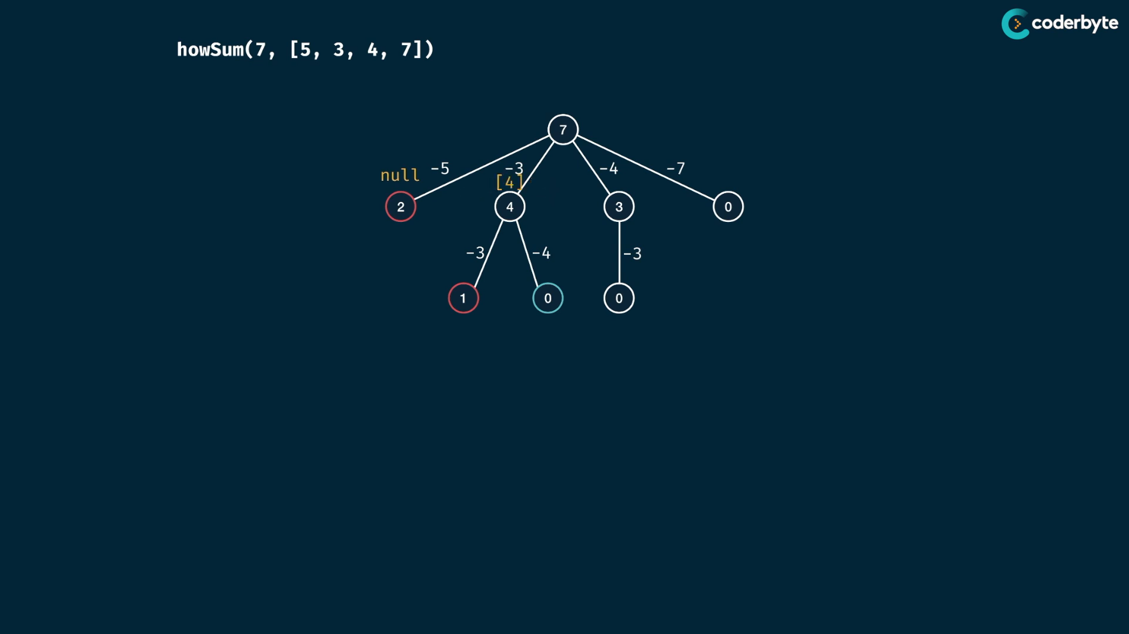

null vs array => the array override the null

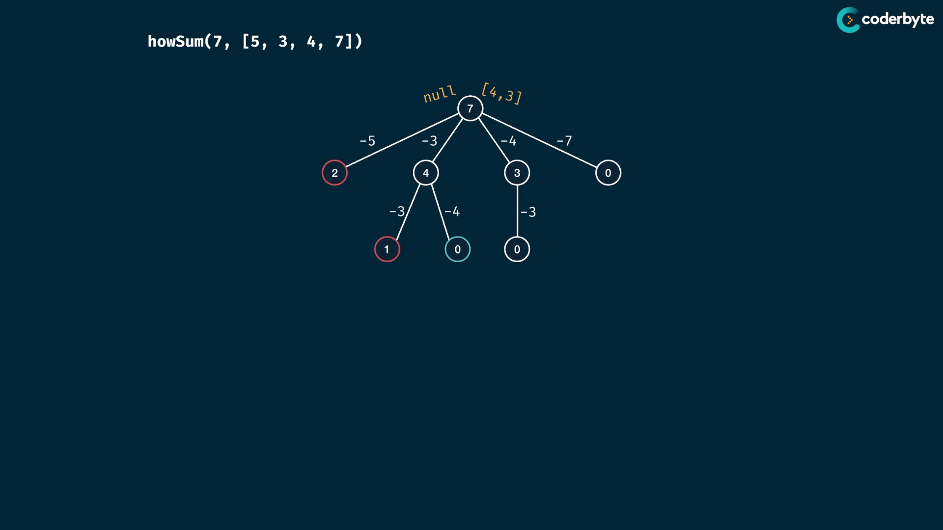

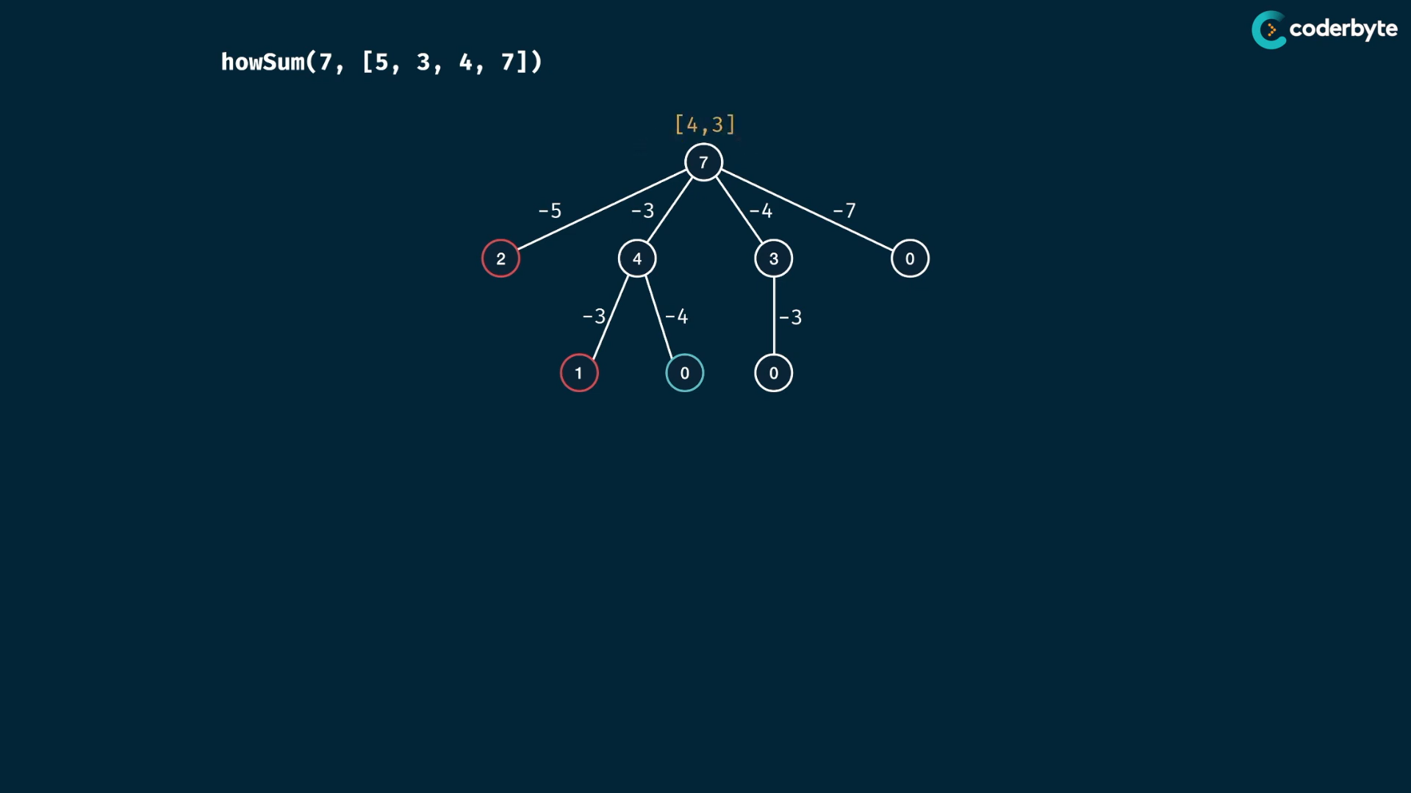

once we get values , the we donot need to check others ..

see from left most to right ..

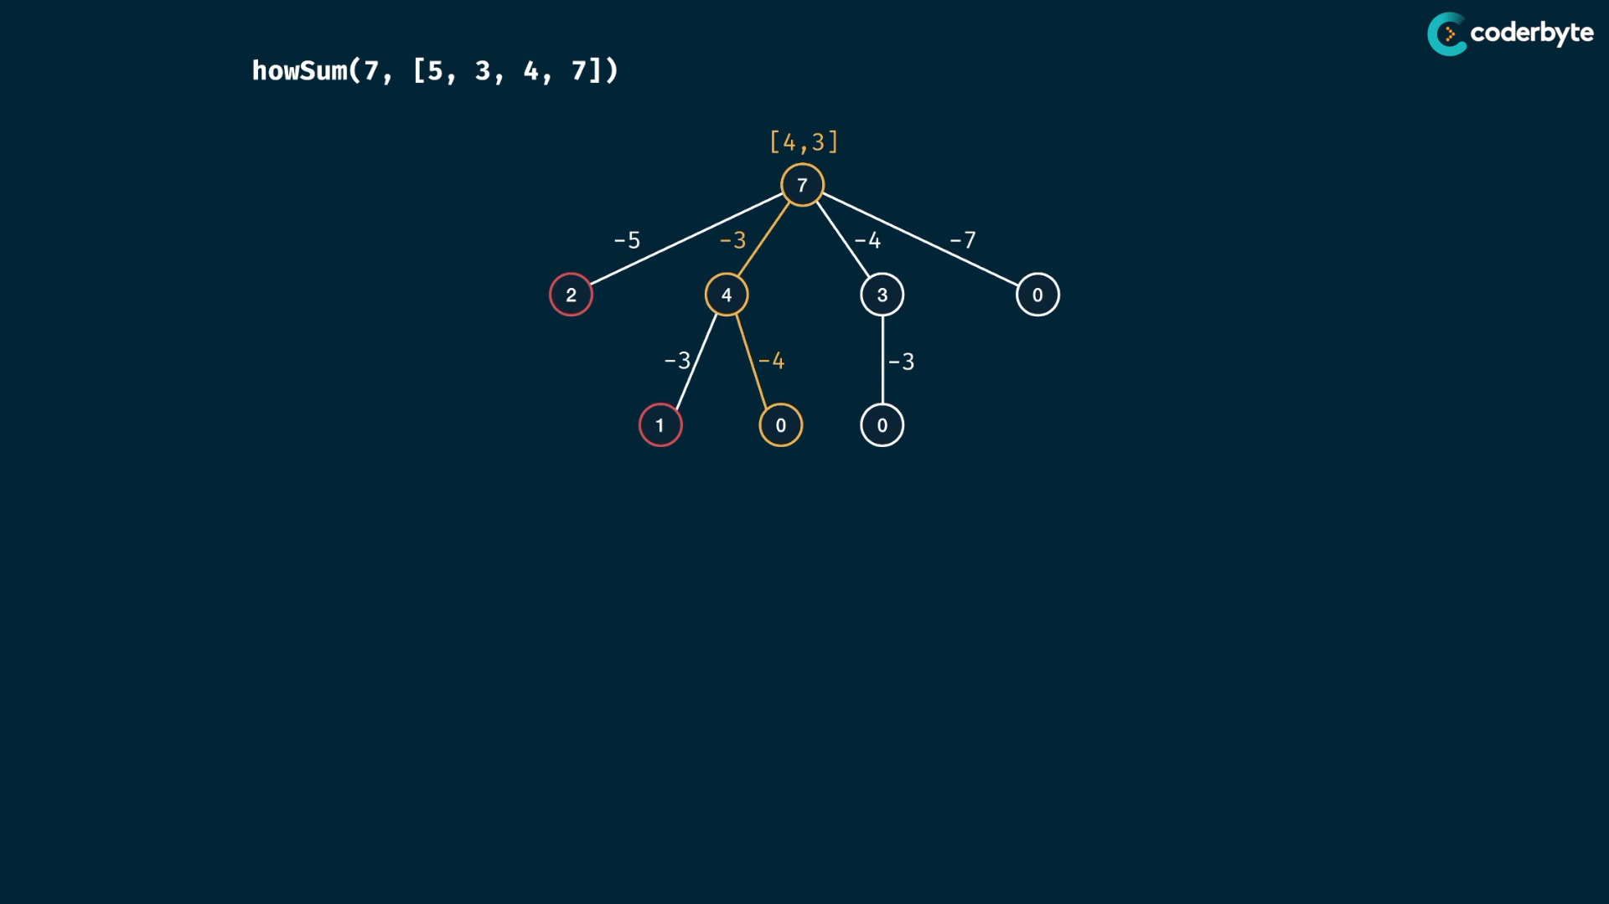

one valid combination is enough ..

code :

//+ howSum (brut)

*const* howSum = (*targetSum*, *numbers*) *=>* {

    if(*targetSum* == 0) return [];

    if(*targetSum* < 0) return null;

    for(*let* num of *numbers*) {

*const* remainder = *targetSum* - num;

*const* rem_result = howSum(remainder,*numbers*)

        if(rem_result != null) return [...rem_result, num];

    }

    return null;

};

console.log(howSum(7,[2,3]))     //=> [3,2,2]

console.log(howSum(7,[5,3,4,7])) //=> [4,3]

console.log(howSum(7,[2,4]))     //=> null

console.log(howSum(8,[2,3,5]))   //=> [2,2,2,2]

console.log(howSum(8,[3,5,2]))   //=> [2,3,3]

console.log(howSum(300,[7,14]))  //=> null {takes little extra time}

order of combination among many result is by order of iterating the items of array ..

cmplx:

m – target sum

n – numbers.length

like previous, same time : O(n^m) for iterations

we do extra copying , worst case exactly the targetSum size of array ..

i.e if 50 , we have array of 1+1+1 50 times..

so the copying opertions takes extra m steps ..

therefore , tim.cmplx => O(n^m*m)

like previous , space is O(m).. since the stack space .. the return array worst case is still m size .. so O(2m) is equals O(m)…

we have overlapping subprob. that we seen in last sum ,so memoize it …

moi code :

*//+ howSum (brut)*

const howSum = (targetSum, numbers,memo = {}) => {

    if(targetSum in memo) return memo[targetSum];

    if(targetSum == 0) return [];

    if(targetSum < 0) return null;

    for(let num of numbers) {

        const remainder = targetSum - num;

        const rem_result = howSum(remainder,numbers,memo)

        if(rem_result != null) return memo[targetSum] = [...rem_result, num];

    }

    return memo[targetSum] = null;

};

console.log(howSum(7,[2,3]))     *//=> [3,2,2]*

console.log(howSum(7,[5,3,4,7])) *//=> [4,3]*

console.log(howSum(7,[2,4]))     *//=> null*

console.log(howSum(8,[2,3,5]))   *//=> [2,2,2,2]*

console.log(howSum(8,[3,5,2]))   *//=> [2,3,3]*

console.log(howSum(300,[7,14]))  *//=> null*

updated :

*//+ howSum (moi)*

const howSum = (targetSum, numbers,memo={},min=-1) => {

    if(min === -1){

        min = Math.min(...numbers);

        for (let num of numbers) memo[num] = [num];

    }

    if(targetSum < min) return null;

    if( targetSum in memo ) return memo[targetSum];

    for(let num of numbers)

        if(targetSum % num === 0) return memo[targetSum] = new Array(targetSum/num).fill(num);

    for(let num of numbers) {

        const rem_result = howSum( targetSum-num ,numbers,memo,min)

        if(rem_result != null) return memo[targetSum] = [...rem_result, num] ;

    }

    return memo[targetSum] = null;

};

console.log(howSum(7,[2,3]))     *//=> [3,2,2]*

console.log(howSum(7,[5,3,4,7])) *//=> [ 7 ]*

console.log(howSum(7,[2,4]))     *//=> null*

console.log(howSum(8,[2,3,5]))   *//=> [2,2,2,2]*

console.log(howSum(8,[3,5,2]))   *//=> [ 2, 2, 2, 2 ]*

console.log(howSum(300,[7,14]))  *//=> null*

console.log(howSum(243,[13,17]))*//=> [17, 17, 17, 17, 17, 17,17, 17, 17, 17, 17, 17,13, 13, 13]*

console.log(howSum(243,[2,4,6,8,10,12,14,16,18,20]))*//=> null*

but here time complx. inc more on worst case ..

cmplx:

m = target sum

n = numbers.lengthm

brute force :

time: O(n^m*m)

space: O(m)

memoized:

n times m recursive calls , n*m ..

copying contents of array , at worst case m size array.. it takes m

so time: O(n*m*m) , i.e O(n*m^2)

memo target sum – all unique keys with values …

m – m keys at worst case

m – each key can have array values of size m at worst case ..

so space: O(m*m)

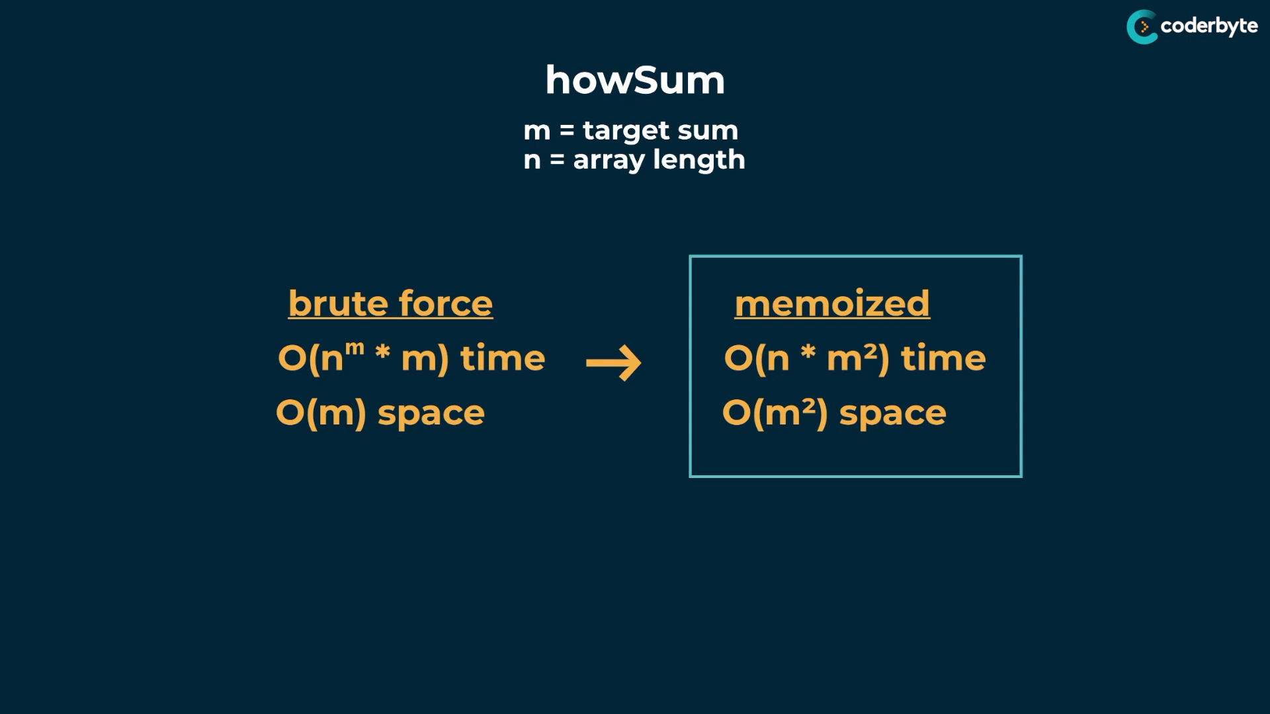

time:

brute force – exponential

memoized – not exponential

space:

brute force – less space linear

memoized – trade off to improve time , so have polynomial or quadratic time … not exponential ..

**const** howSum1 = (target, numbers,items=[]) **=>** {

for(**let** num of numbers){

**const** rem = target - num;

**const** newItems = [...items, num];

if(rem === 0){

return newItems;

}if(rem < 0){

continue;

}else{

**const** allItems = howSum(rem, numbers, [...items, num]);

if(allItems){

return allItems;

}

}

}

return null;

};

**const** howSum3 = (target, numbers, mem = {},min = -1, items=[]) **=>** {

if(min === -1){

min = Math.min(...numbers);

}

if(target === 0) return items;

if(target in mem) return mem[target];

if(target < min) return null;

for(**let** num of numbers){

**const** rem = target - num;

**const** newItems = [...items, num];

**const** allItems = howSum(rem, numbers, mem, min, newItems);

if(allItems){

mem[rem] = allItems;

return mem[rem];

}

}

mem[target] = null;

return null;

}

**const** howSum2 = (target, numbers,mem={},min=-1, items=[]) **=>** {

if(min === -1){

min = Math.min(...numbers);

for(num of numbers) {

*// value divisible by any of the item*

if(target%num === 0){

**const** newItems = Array(target/num).fill(num);

mem[target] = newItems;

return mem[target];

}

mem[num] = [num];

}

}

if(target === 0) return items;

if(target in mem) return mem[target];

*// value lower than least item in numbers list*

if(target < min) return null;

for(**let** num of numbers){

**const** rem = target - num;

**const** allItems = howSum(rem, numbers, mem, min, [...items,num]);

if( allItems){

mem[target] = allItems;

return mem[target];

}

}

mem[target] = null;

return mem[target];

};

console.log(howSum(8,[3,5,2])) *//=> [3,3,2] or [2,2,2,2]*

console.log(howSum(6,[2])) *//=> [2,2,2]*

console.log(howSum(7,[2,3])) *//=> [ 2, 2, 3 ]*

console.log(howSum(7,[5,3,4,7])) *//=> [ 3, 4 ] or [7]*

console.log(howSum(7,[2,4])) *//=> null*

console.log(howSum(8,[2,3,5])) *//=> [ 2, 2, 2, 2 ]*

console.log(howSum(300,[7,14])) *//=> null*

console.log(howSum(300,[8,7]) ) *//=>*

*/\**

*[*

*8, 8, 8, 8, 8, 8, 8, 8, 8, 8,*

*8, 8, 8, 8, 8, 8, 8, 8, 8, 8,*

*8, 8, 8, 8, 8, 8, 8, 8, 8, 8,*

*8, 8, 8, 8, 7, 7, 7, 7*

*]*

*\*/*

console.log(howSum(10002,[4,5,10,20]))

*/*=>*

*[*

*4, 4, 4, 4, 4, 4, 4, 4, 4, 4, 4, 4,*

*4, 4, 4, 4, 4, 4, 4, 4, 4, 4, 4, 4,*

*4, 4, 4, 4, 4, 4, 4, 4, 4, 4, 4, 4,*

*4, 4, 4, 4, 4, 4, 4, 4, 4, 4, 4, 4,*

*4, 4, 4, 4, 4, 4, 4, 4, 4, 4, 4, 4,*

*4, 4, 4, 4, 4, 4, 4, 4, 4, 4, 4, 4,*

*4, 4, 4, 4, 4, 4, 4, 4, 4, 4, 4, 4,*

*4, 4, 4, 4, 4, 4, 4, 4, 4, 4, 4, 4,*

*4, 4, 4, 4,*

*... 2400 more items*

*]*

*\*/*

console.log(howSum(10002,[400,50,11,20]))

*/*[*

*400, 400, 400, 400, 400, 400, 400, 400,*

*400, 400, 400, 400, 400, 400, 400, 400,*

*400, 400, 400, 400, 400, 400, 400, 400,*

*50, 50, 50, 50, 50, 50, 11, 11,*

*20, 20, 20, 20*

*]*

*\*/*

Best sum :

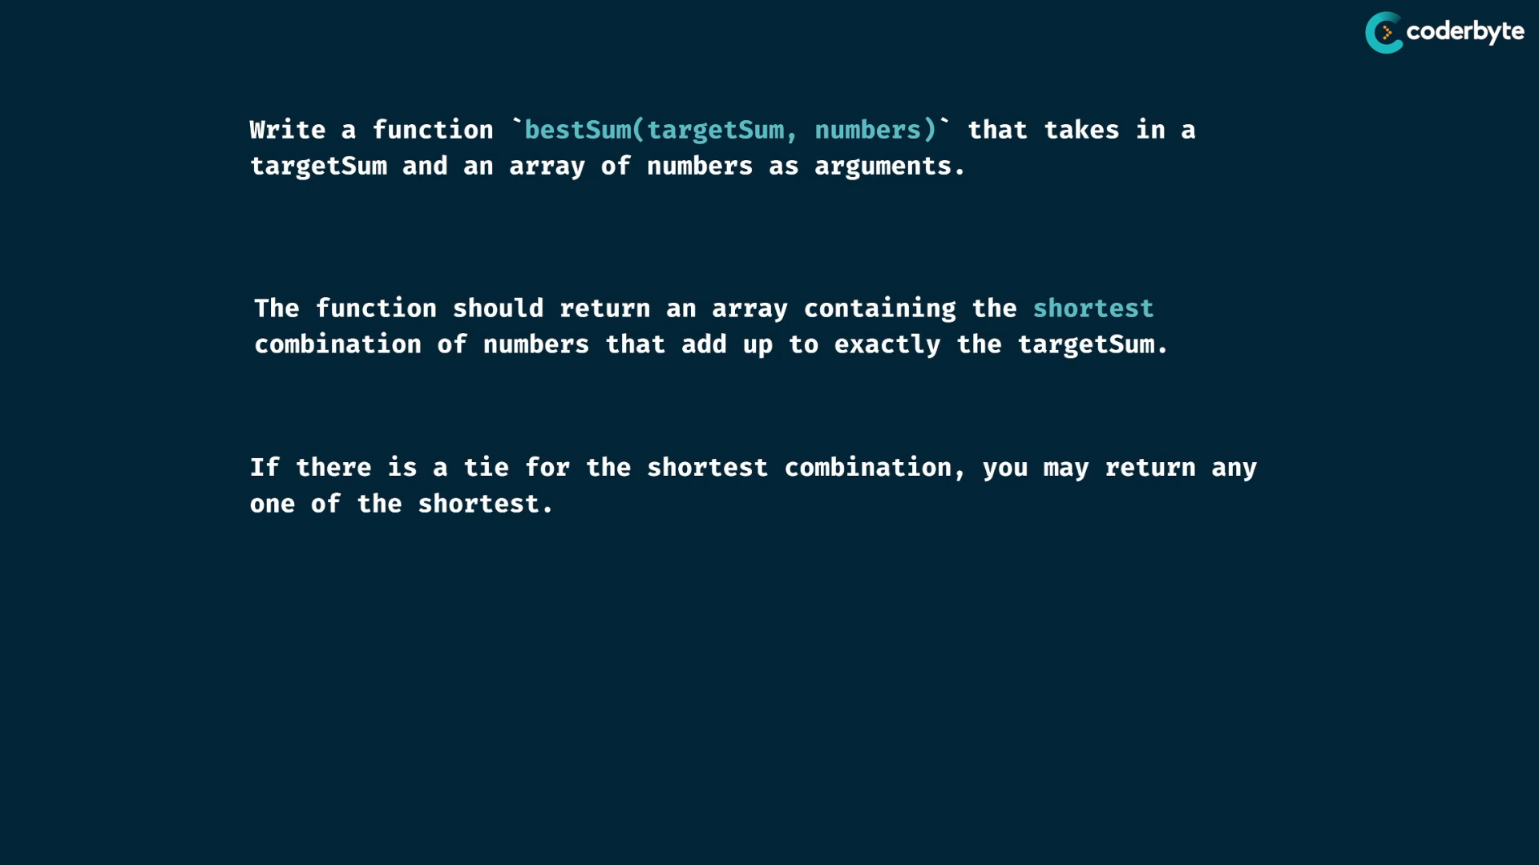

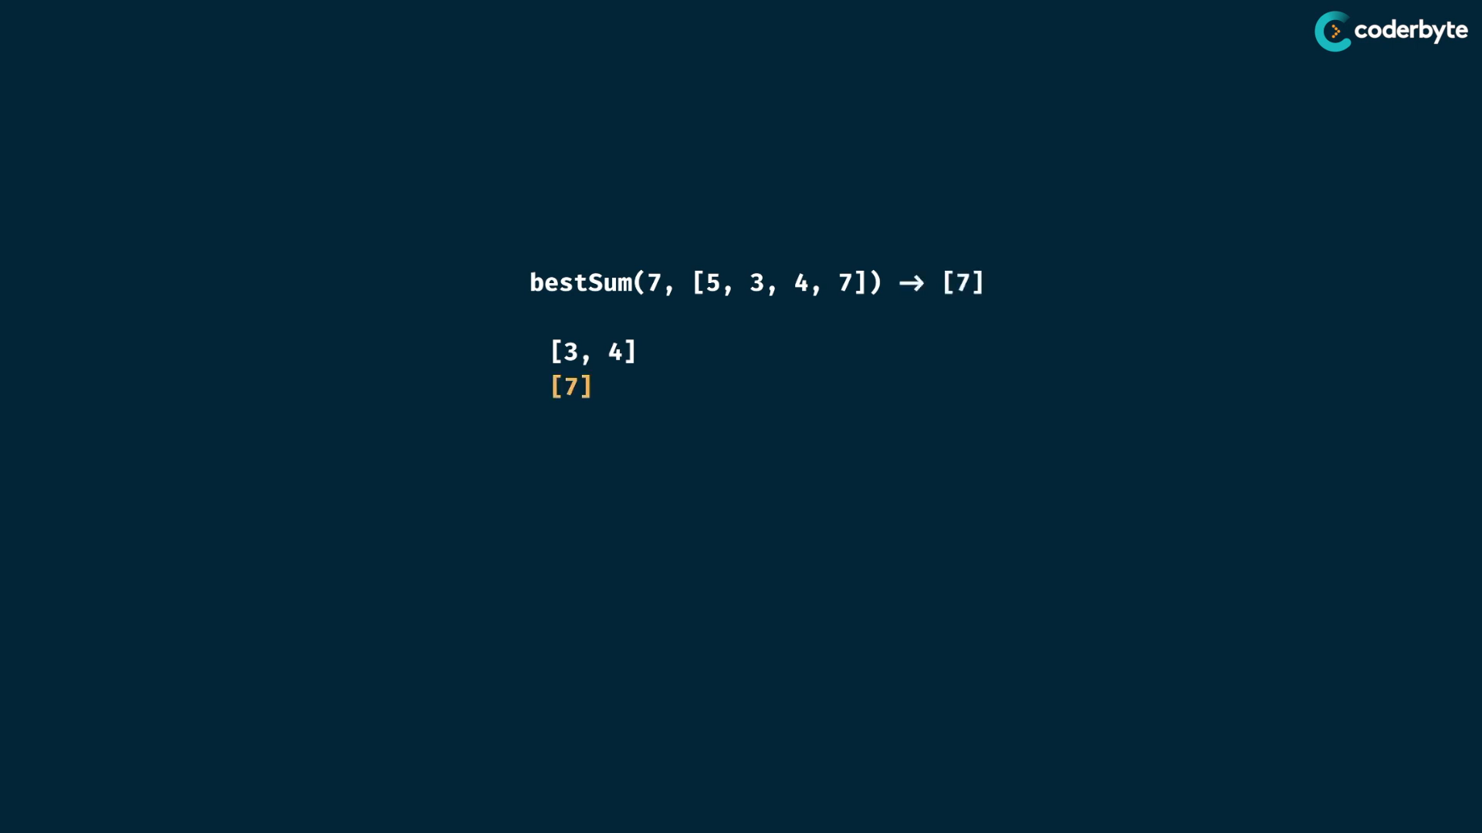

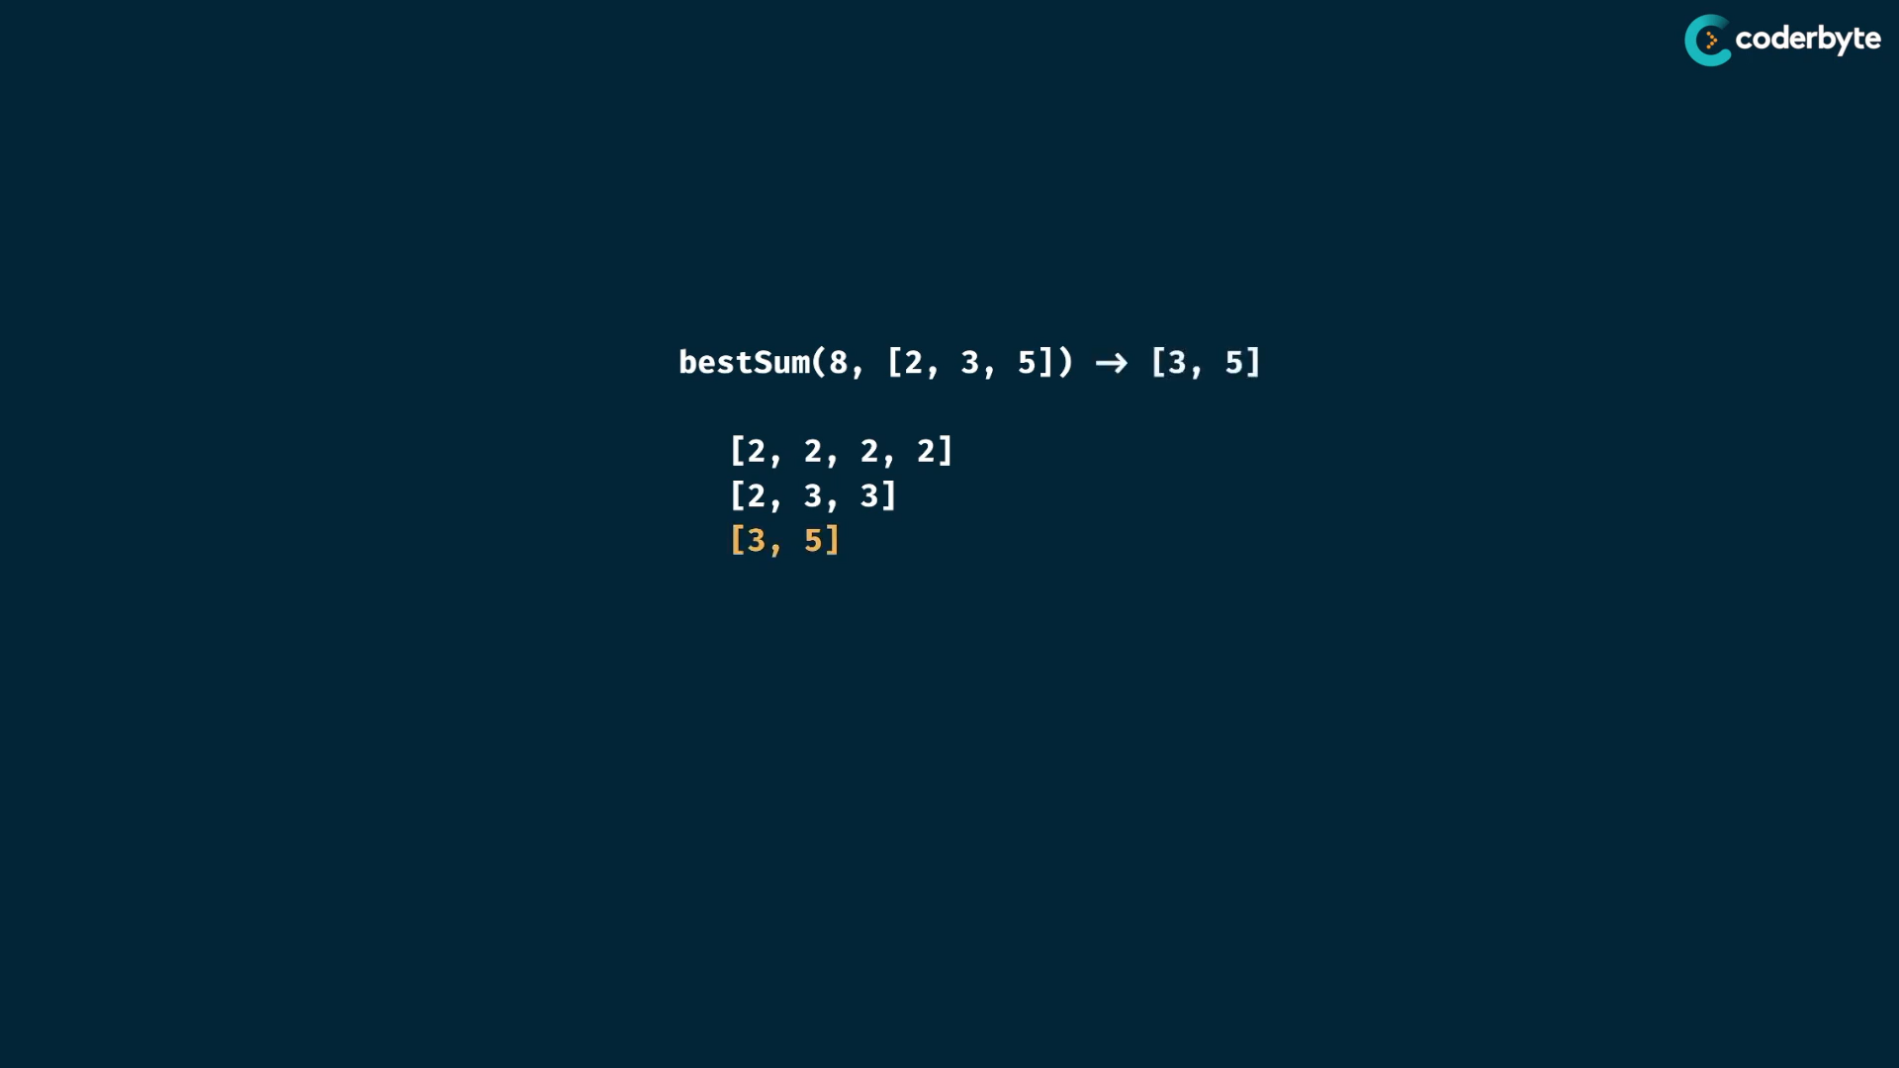

tree:

now we don’t want the first one, we want the best one…

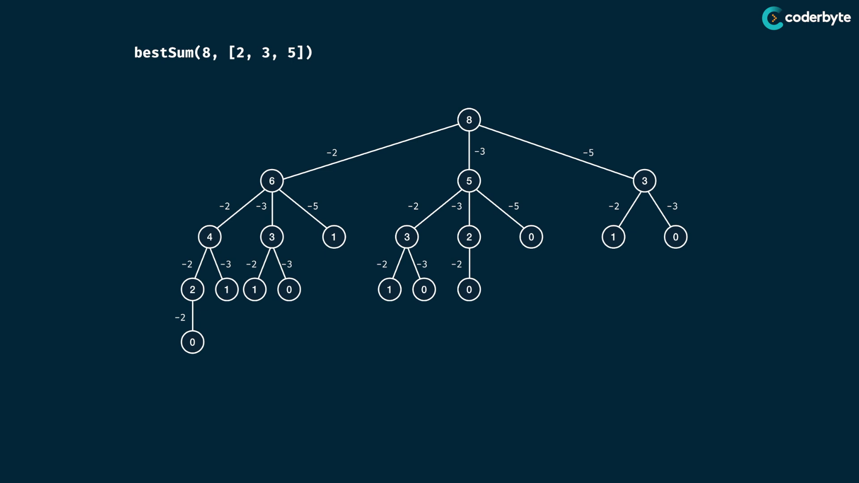

best way => shortest result array length

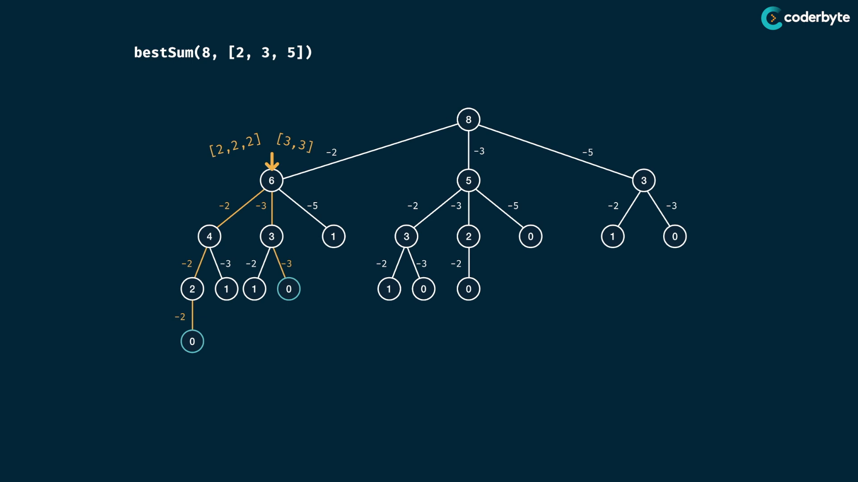

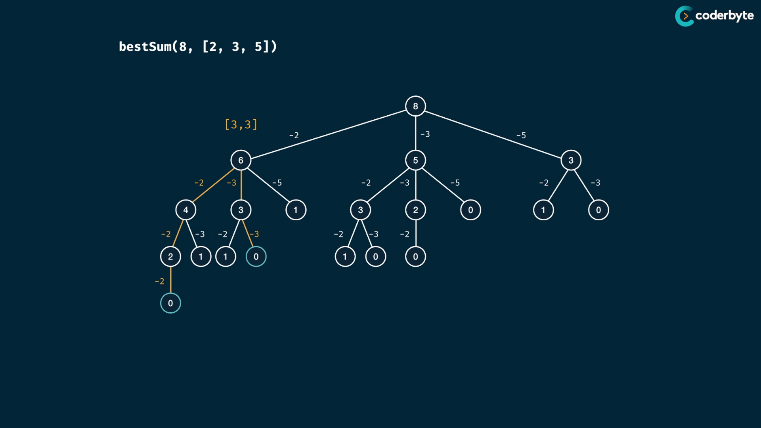

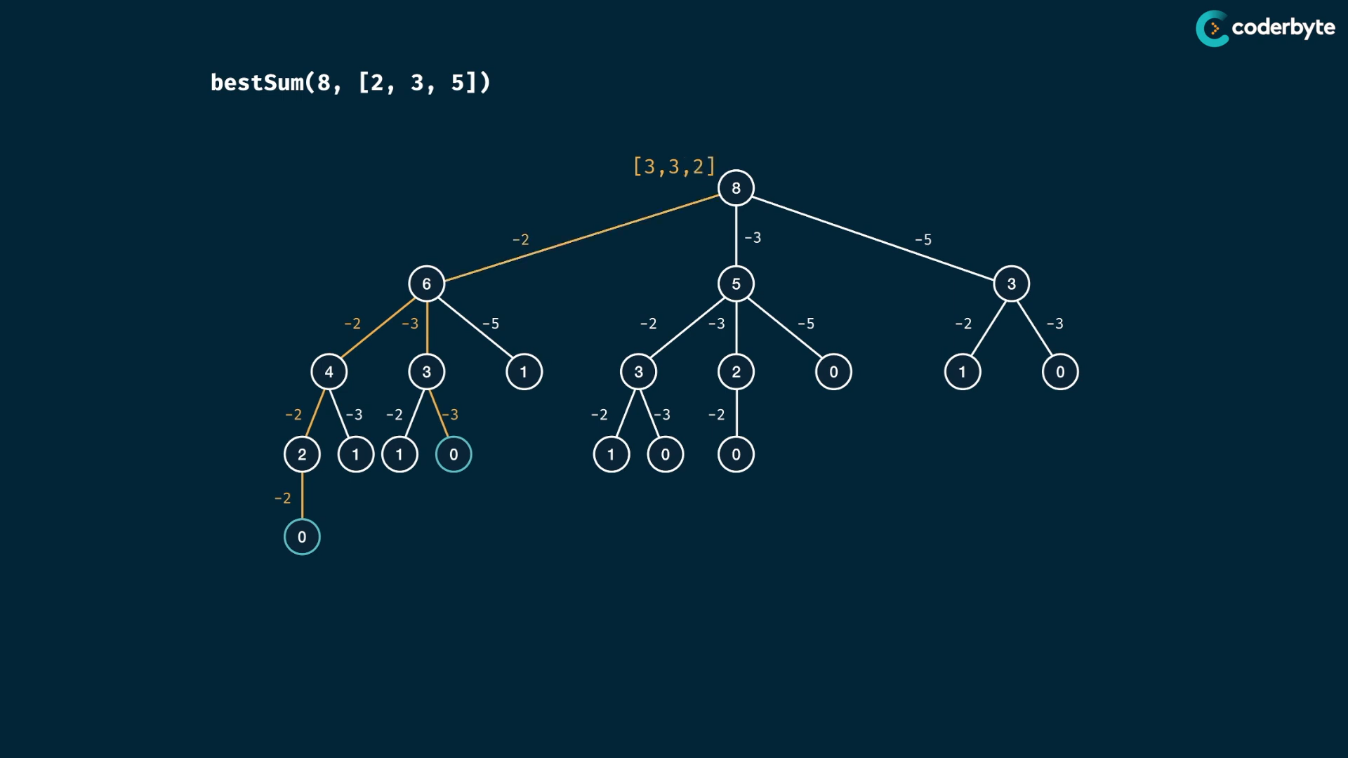

… likewise ….

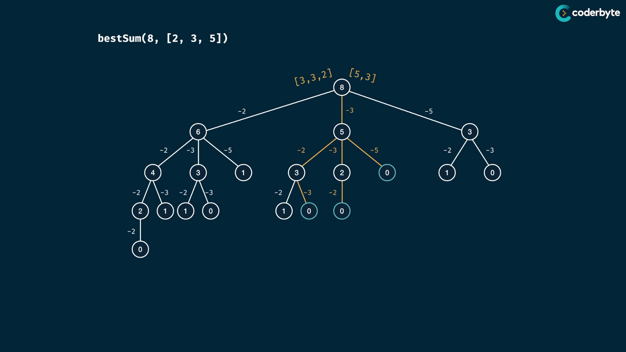

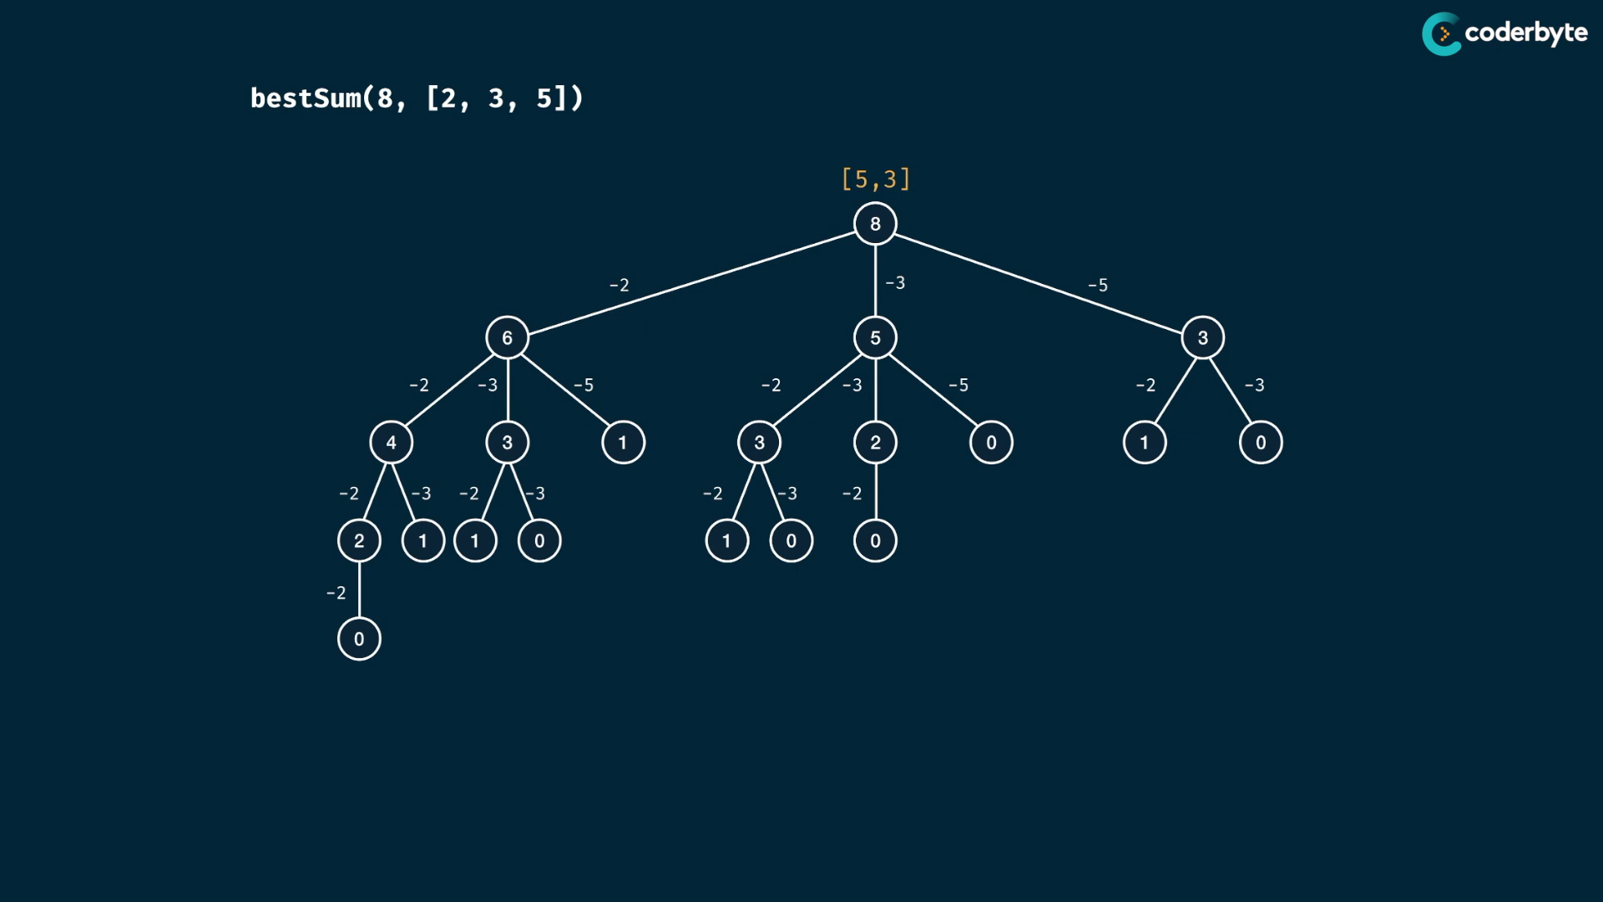

try the righter one and compare and make shorter array as top …

many think bestSum is got by taking larger number in consideration that is not true really …

for (8,[1,4,5]) … the best sum is 4,4 … not 5,1,1

//+ bestSum (brut)

*const* bestSum = (*targetSum*, *numbers*) *=>* {

    if( *targetSum* === 0 ) return [];

    if ( *targetSum* < 0 ) return null;

*let* short_combi  = null;

    for(*let* num of *numbers*) {

*const* remainder = *targetSum* - num;

*const* rem_result = bestSum(remainder,*numbers*)

        if(rem_result != null){

            temp = [...rem_result,num];

            if(short_combi === null || temp.length < short_combi.length){

                short_combi = temp;

            }

        }

    }

    return short_combi;

};

console.log(bestSum(7,[5,3,4,7]));  //=> [7]

console.log(bestSum(8,[2,3,5]));  //=> [3,5]

console.log(bestSum(8,[1,4,5]));  //=> [4,4]

console.log(bestSum(100,[1,2,5,25]));  //=> [25,25,25,25] {takes larger time}

m – target sum

n – numbers.length

tree height at worst case of m .. each track path is -1 … O(n)

breath of each level is n length array .. worst case having all .. O(m)

so O(n*m)

then we have combi at each node , at worst case the combination is m which has series of 1s …

so total time = O(n*m*m)

Time = O(n*m^2)

now space ,

stack space is height of tree .. which is m ..

then at each stack , we maintain shortest combination at most m elements .. so which is also m

so Space = O(m^2)

Memoized:

//+ bestSum (moi)

const bestSum = (targetSum, numbers,memo={}) => {

    if( targetSum in memo ) return memo[targetSum];

    if( targetSum === 0 ) return [];

    if ( targetSum < 0 ) return null;

    let short_combi = null;

    for(let num of numbers) {

        const remainder = targetSum - num;

        const rem_result = bestSum(remainder,numbers,memo)

        if(rem_result != null){

            temp = [...rem_result,num];

            if(short_combi === null || temp.length < short_combi.length){

                short_combi = temp;

            }

        }

    }

    memo[targetSum] =  short_combi;

    return memo[targetSum];

};

console.log(bestSum(7,[5,3,4,7]));  //=> [7]

console.log(bestSum(8,[2,3,5]));  //=> [3,5]

console.log(bestSum(8,[1,4,5]));  //=> [4,4]

console.log(bestSum(100,[1,2,5,25]));  //=> [25,25,25,25]

{

try using mod operators .. it must not give best sum , but give sum ..

}

updated:

*//+ bestSum (moi)*

const bestSum = (targetSum, numbers,memo={},min =-1) => {

    if(min === -1){

        min = Math.min(...numbers);

        for(num of numbers) memo[num] = [num];

    }

    if ( targetSum < min ) return null;

    if( targetSum in memo ) return memo[targetSum];

    let short_combi = null;

    for(let num of numbers) {

        const rem_result = bestSum( targetSum - num,numbers,memo,min)

        if(rem_result != null){

            temp = [...rem_result,num];

            if(short_combi === null || temp.length < short_combi.length) short_combi = temp;

        }

    }

    return memo[targetSum] = short_combi;

};

console.log(bestSum(7,[5,3,4,7]));  *//=> [7]*

console.log(bestSum(8,[2,3,5]));  *//=> [3,5]*

console.log(bestSum(8,[1,4,5]));  *//=> [4,4]*

console.log(bestSum(100,[1,2,5,25]));  *//=> [25,25,25,25]*

**const** bestSum1 = (target, numbers, items = [], ans = null) **=>** {

for (**let** num of numbers) {

**const** rem = target - num;

**const** newItems = [...items, num];

if (rem === 0) {

return newItems;

}

if (rem < 0) {

continue;

} else {

**const** allItems = bestSum(rem, numbers, [...items, num]);

if (allItems) {

if (!ans) {

ans = [];

}

ans.push(allItems);

}

}

}

return ans ? ans.sort((a, b) **=>** a.length - b.length)[0] : null;

};

**const** bestSum2 = (target, numbers, items = [], ans = null) **=>** {

for (**let** num of numbers) {

**const** rem = target - num;

**const** newItems = [...items, num];

if (rem === 0) {

return newItems;

}

if (rem < 0) {

continue;

} else {

**const** allItems = bestSum(rem, numbers, newItems);

if (allItems) {

if (!ans) {

ans = allItems;

} else {

if (ans.length > allItems.length) {

ans = allItems;

}

}

}

}

}

return ans;

};

**const** bestSum3 = (target, numbers, mem = {}, min = -1, items = []) **=>** {

if (min === -1) {

min = Math.min(...numbers);

}

if (target === 0) return items;

if (target in mem) return mem[target];

if (target < min) return null;

*// maintaining outside loop to put in mem only after least one found!*

*// which improves performance*

**let** ans = null;

for (**let** num of numbers) {

**const** rem = target - num;

**const** newItems = [...items, num];

*// only considering minimum items from before*

if(!ans || ans.length > newItems.length){

**const** allItems = bestSum(rem, numbers, mem, min, newItems);

if (allItems) {

if (ans) {

if (ans.length > allItems.length) {

ans = allItems;

}

} else {

ans = allItems;

}

}

}

}

;

return (mem[target] = ans);

};

*// not able to convert this, try later*

*// const bestSum4 = (target, numbers, mem = {}, min = -1, items = []) => {*

*// if (min === -1) {*

*// min = Math.min(...numbers);*

*// for (num of numbers) {*

*// // value divisible by any of the item*

*// if (target % num === 0) {*

*// const newItems = Array(target / num).fill(num);*

*// mem[target] = newItems;*

*// return mem[target];*

*// }*

*// mem[num] = [num];*

*// }*

*// }*

*// if (target === 0) return items;*

*// if (target in mem) return mem[target];*

*// // value lower than least item in numbers list*

*// if (target < min) return null;*

*// for (let num of numbers) {*

*// const rem = target - num;*

*// const allItems = bestSum(rem, numbers, mem, min, [...items, num]);*

*// if (allItems) {*

*// mem[target] = allItems;*

*// return mem[target];*

*// }*

*// }*

*// mem[target] = null;*

*// return mem[target];*

*// };*

console.log(bestSum(8, [3, 5, 2])); *//=> [3,5]*

console.log(bestSum(6, [2])); *//=> [2,2,2]*

console.log(bestSum(7, [2, 3])); *//=> [ 2, 2, 3 ]*

console.log(bestSum(7, [5, 3, 4, 7])); *//=> [7]*

console.log(bestSum(7, [2, 4])); *//=> null*

console.log(bestSum(8, [2, 3, 5])); *//=> [ 3,5 ]*

*// performance soln needed*

console.log(bestSum(300,[7,14])) *//=> null*

console.log(bestSum(300,[8,7]) ) *//=>*

*/\**

*[*

*8, 8, 8, 8, 8, 8, 8, 8, 8, 8,*

*8, 8, 8, 8, 8, 8, 8, 8, 8, 8,*

*8, 8, 8, 8, 8, 8, 8, 8, 8, 8,*

*8, 8, 8, 8, 7, 7, 7, 7*

*]*

*\*/*

console.log(bestSum(10002,[4,5,10,20]))

*/*=>*

*[*

*4, 4, 4, 4, 4, 4, 4, 4, 4, 4, 4, 4,*

*4, 4, 4, 4, 4, 4, 4, 4, 4, 4, 4, 4,*

*4, 4, 4, 4, 4, 4, 4, 4, 4, 4, 4, 4,*

*4, 4, 4, 4, 4, 4, 4, 4, 4, 4, 4, 4,*

*4, 4, 4, 4, 4, 4, 4, 4, 4, 4, 4, 4,*

*4, 4, 4, 4, 4, 4, 4, 4, 4, 4, 4, 4,*

*4, 4, 4, 4, 4, 4, 4, 4, 4, 4, 4, 4,*

*4, 4, 4, 4, 4, 4, 4, 4, 4, 4, 4, 4,*

*4, 4, 4, 4,*

*... 2400 more items*

*]*

*\*/*

console.log(bestSum(10002,[400,50,11,20]))

*/*[*

*400, 400, 400, 400, 400, 400, 400, 400,*

*400, 400, 400, 400, 400, 400, 400, 400,*

*400, 400, 400, 400, 400, 400, 400, 400,*

*50, 50, 50, 50, 50, 50, 11, 11,*

*20, 20, 20, 20*

*]*

*\*/*

Complexities:

time:

for each combination of numbers with targetsum => O(m*n)

each unique target sum is key of memo object,

each combination have not only shorter memo , but also maintain combination of O(m)

so time is O(m^2*n)

space is each array have m possibilities of m elements

memo keys … memo keys have m possibilities ..for each keys have values of array m ..

so space O(m^2)

cmplx:

time => exponential time of brute force to polynomial time …

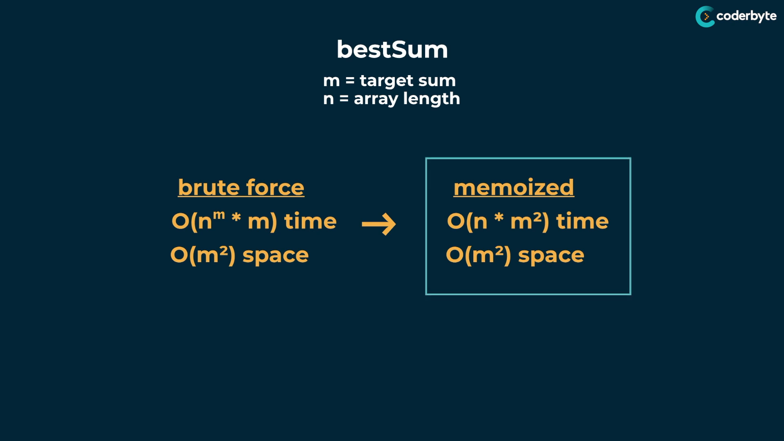

there is logical progression problem

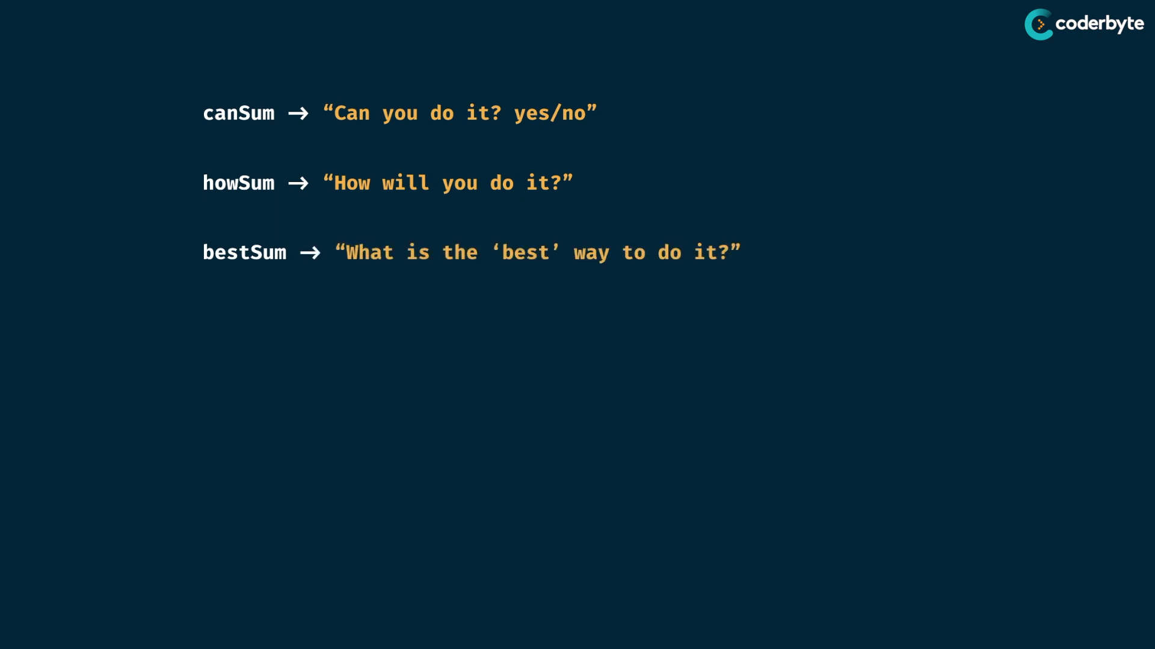

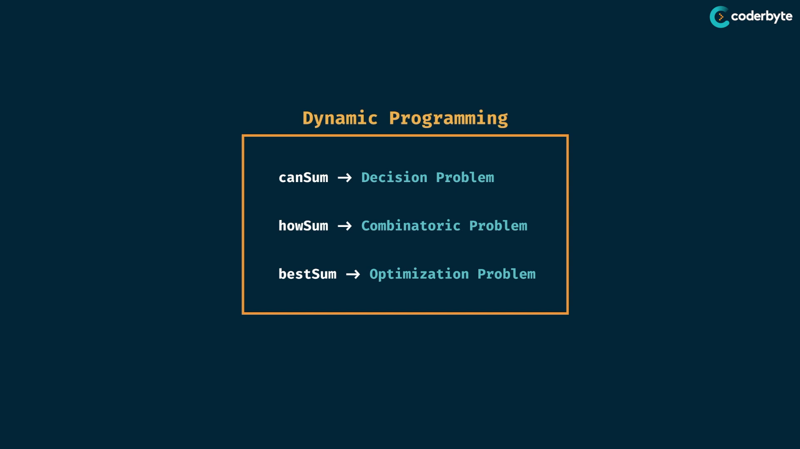

remember – dyn. prg. problems are limited to numbers only .

**CanConstruct :**

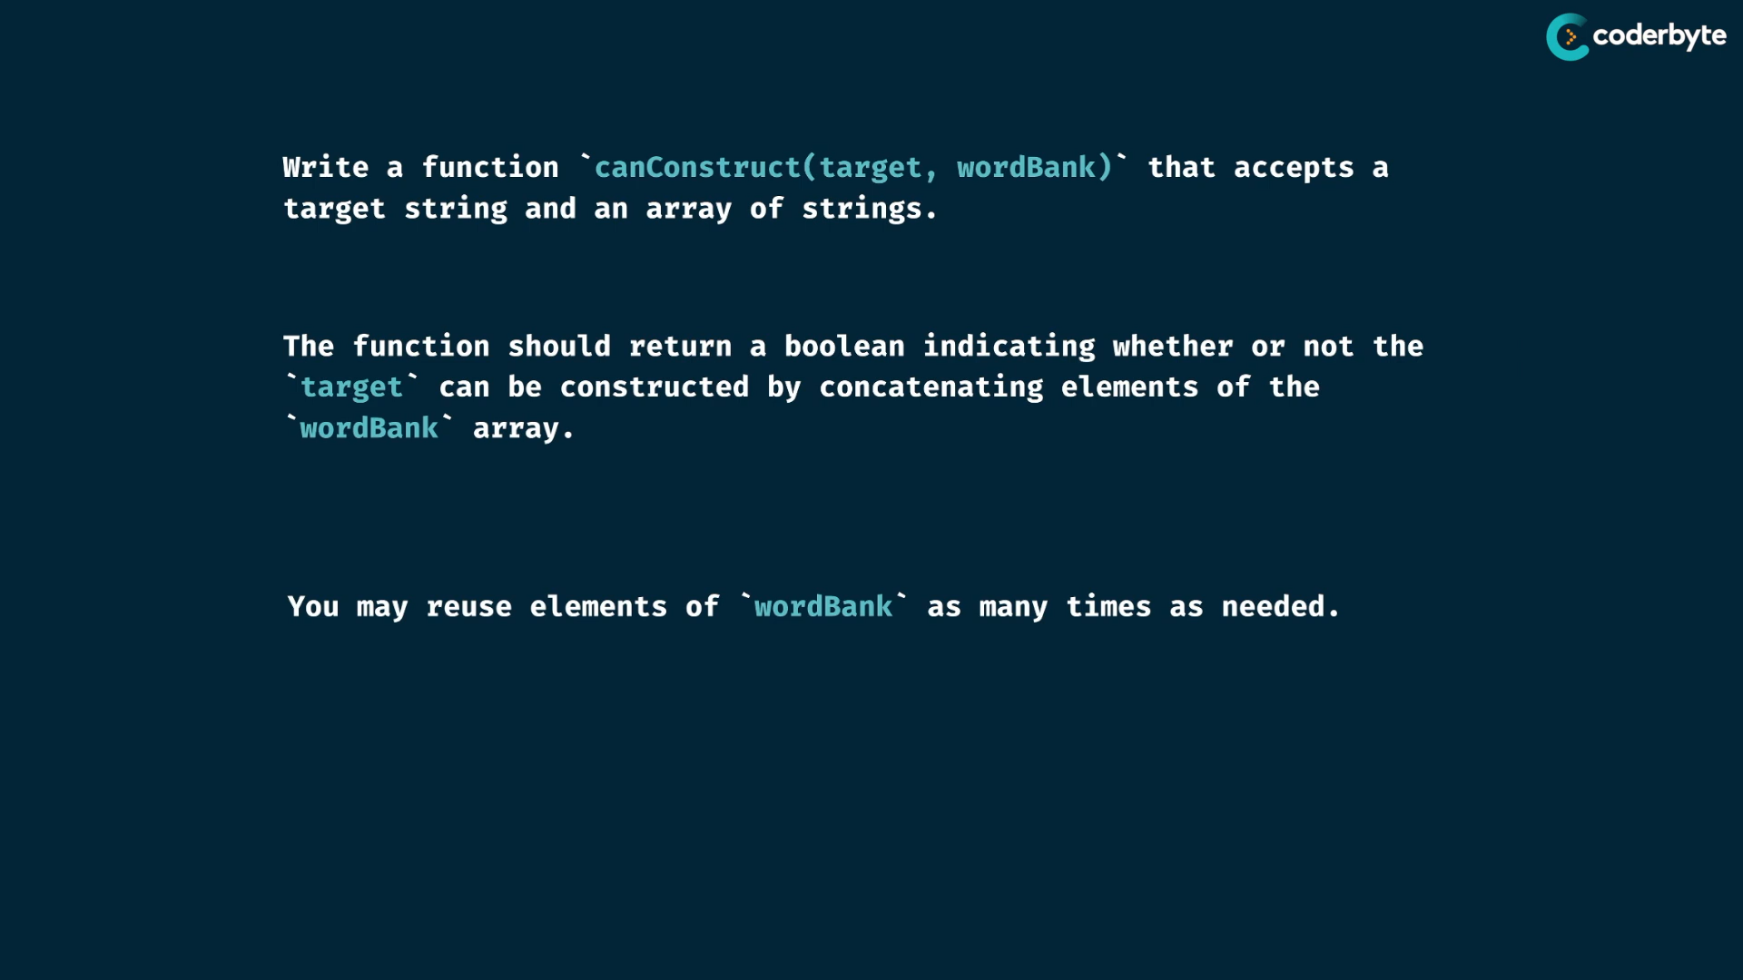

exp:

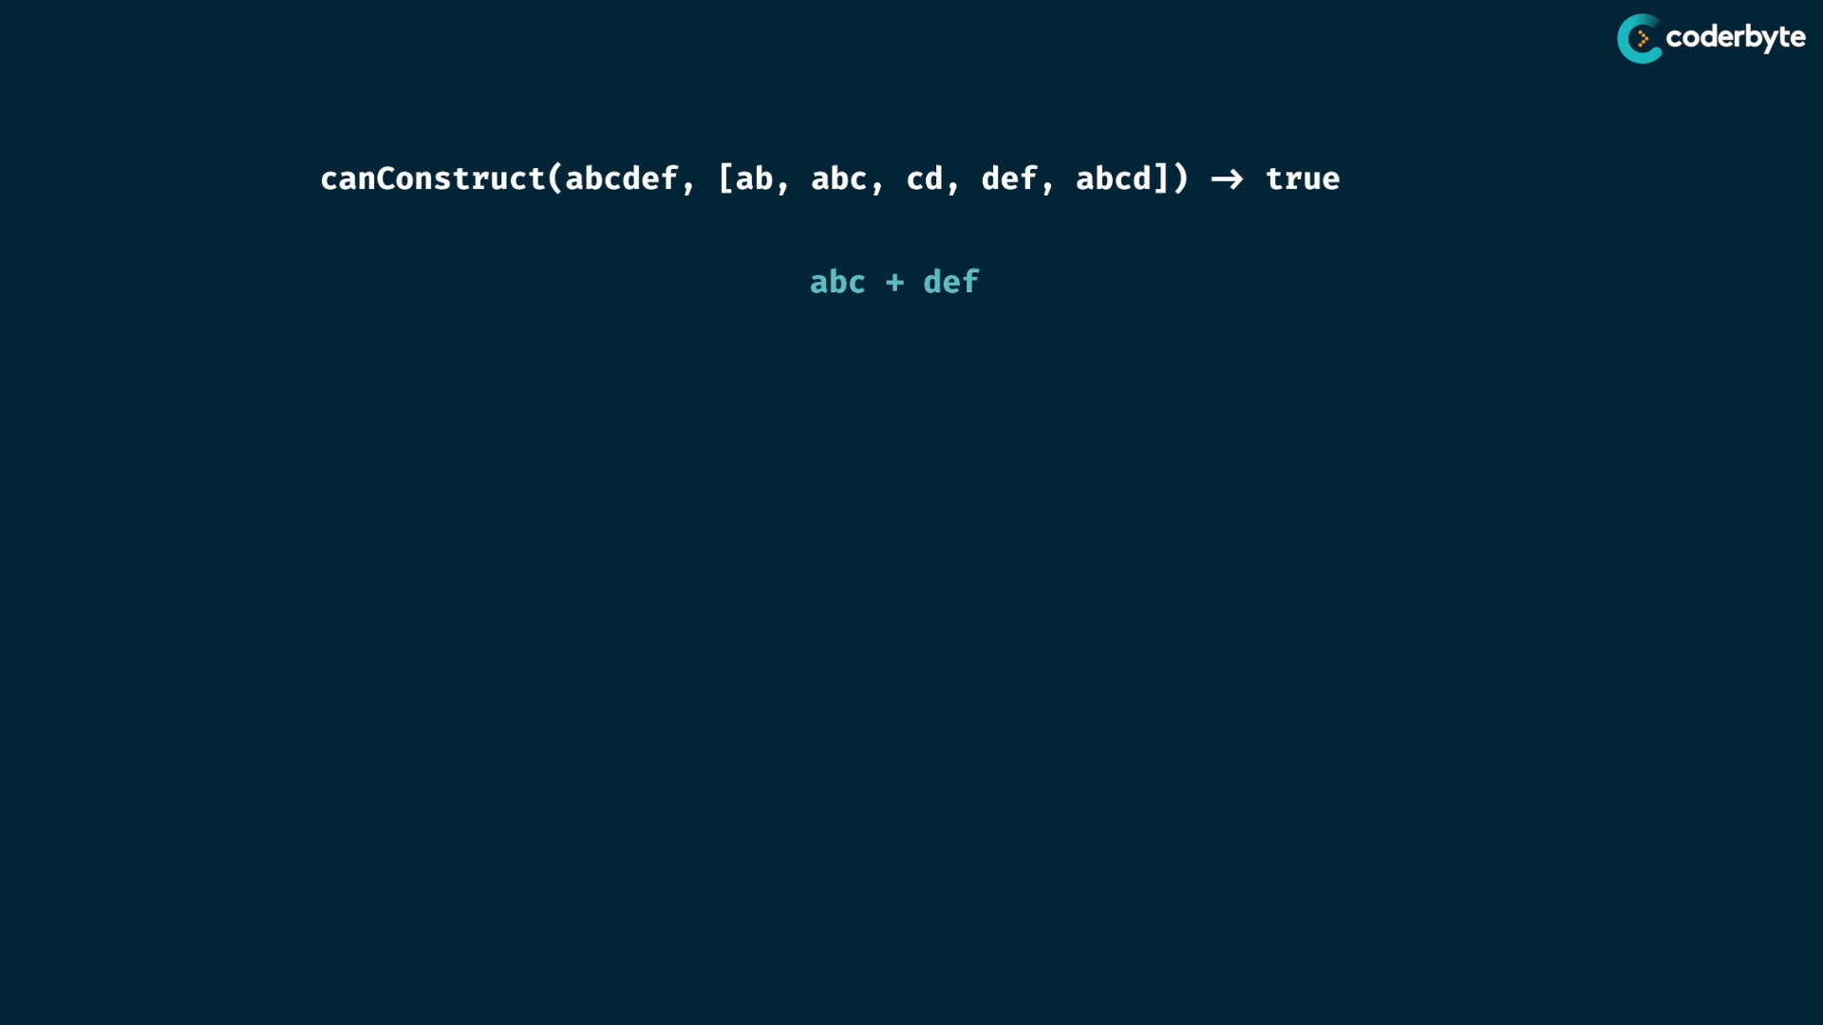

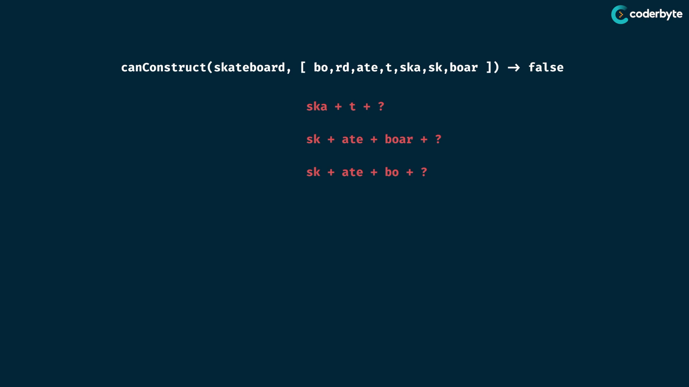

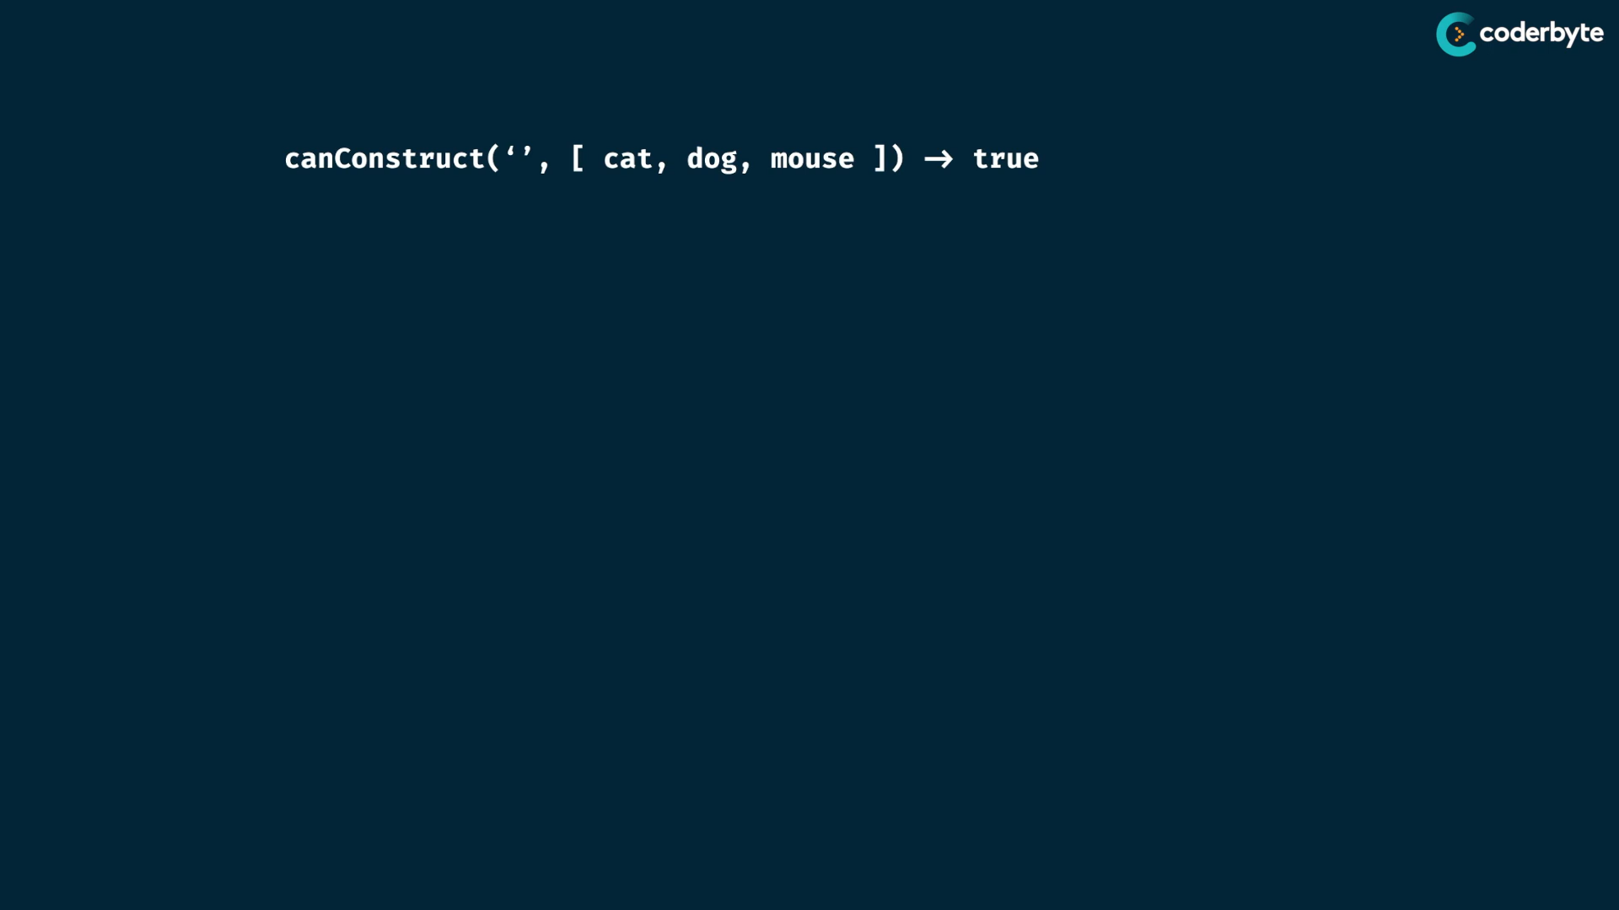

define process by visualizing in tree:

make target str as root node …

compare the starting letters with the array elements.. and make the remaining as child node…

always take the starting equal string …

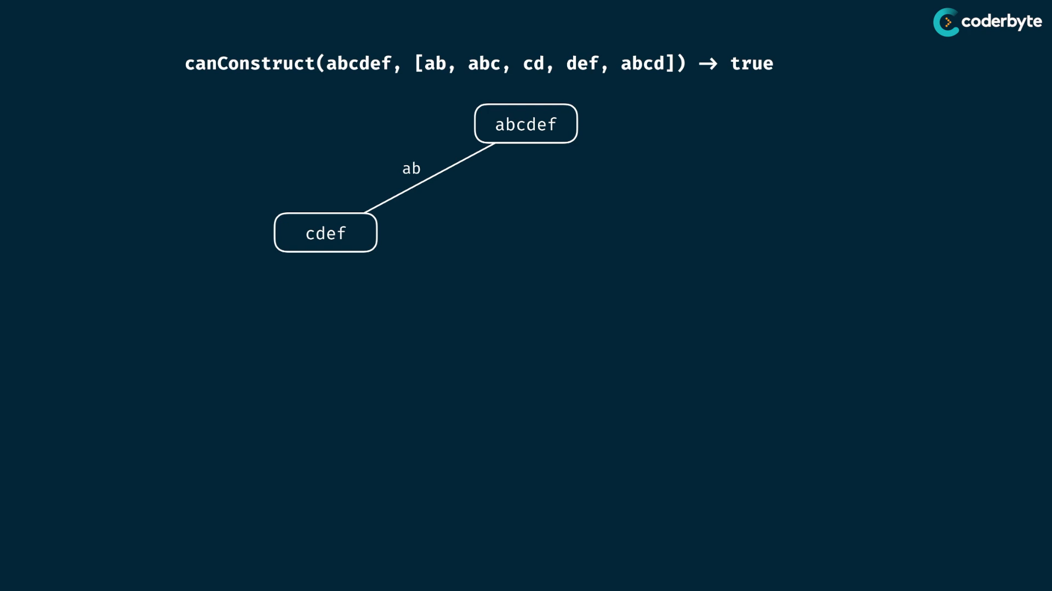

donot compare with middle and end ones ..

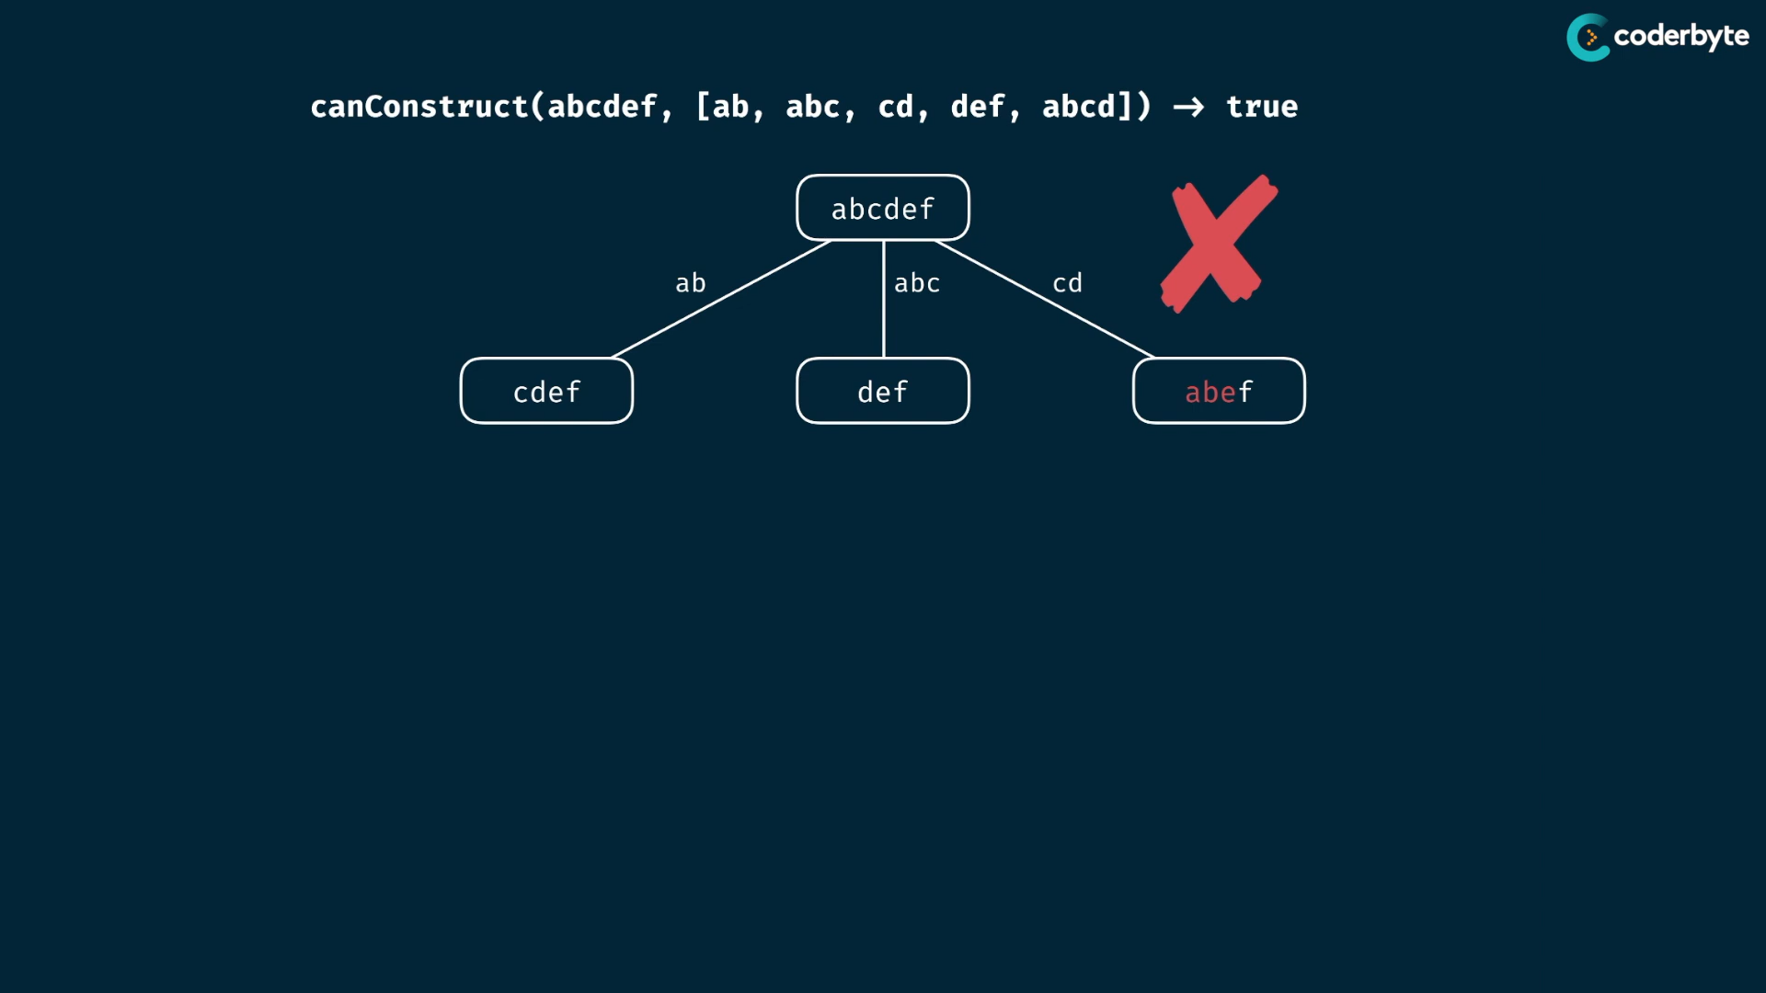

taking out strings in middle , makes the node of new series of chars that collapse the method ..

just take prefixes …

do them subsequently upto empty string or no match string ..

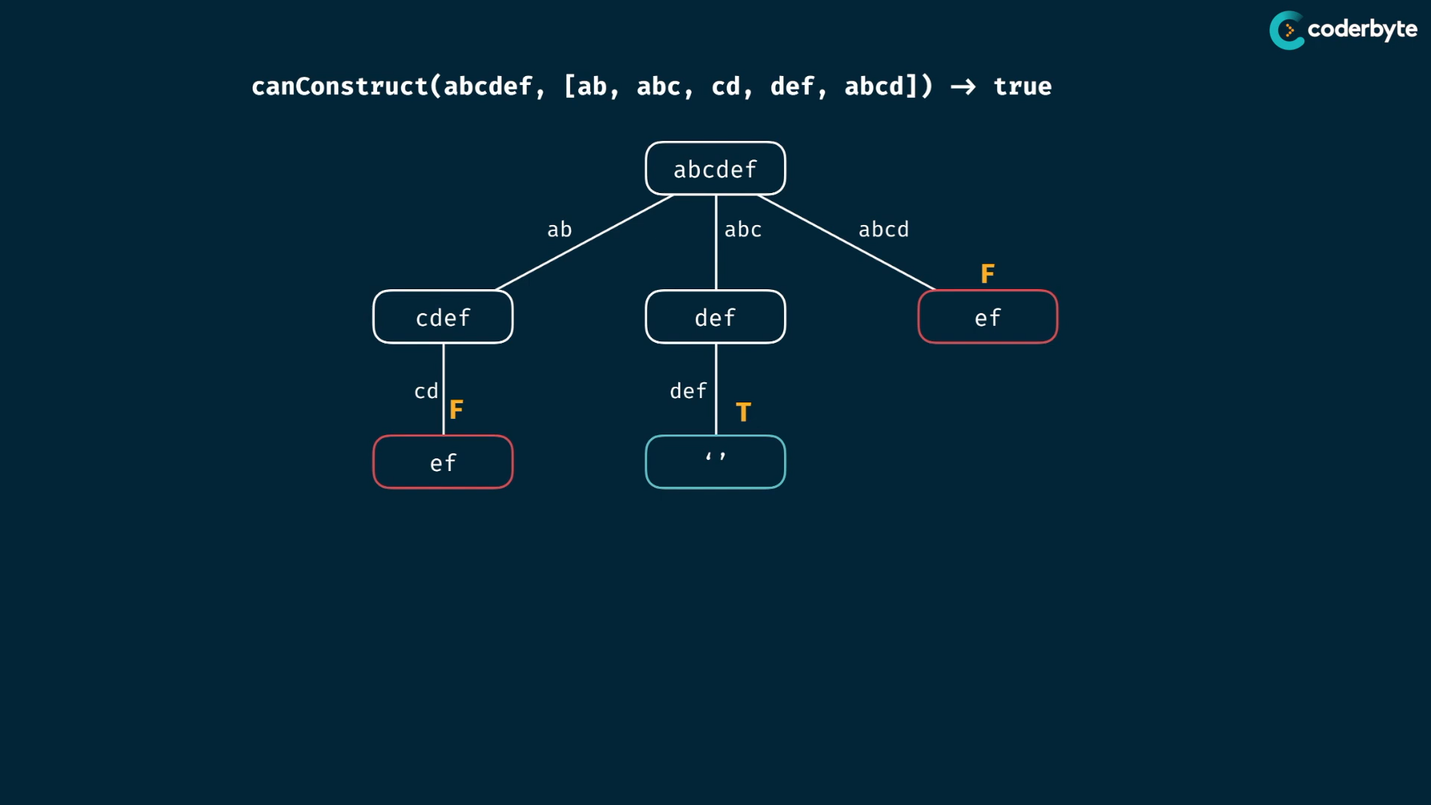

bubble ups and one of child is true , whole true ..

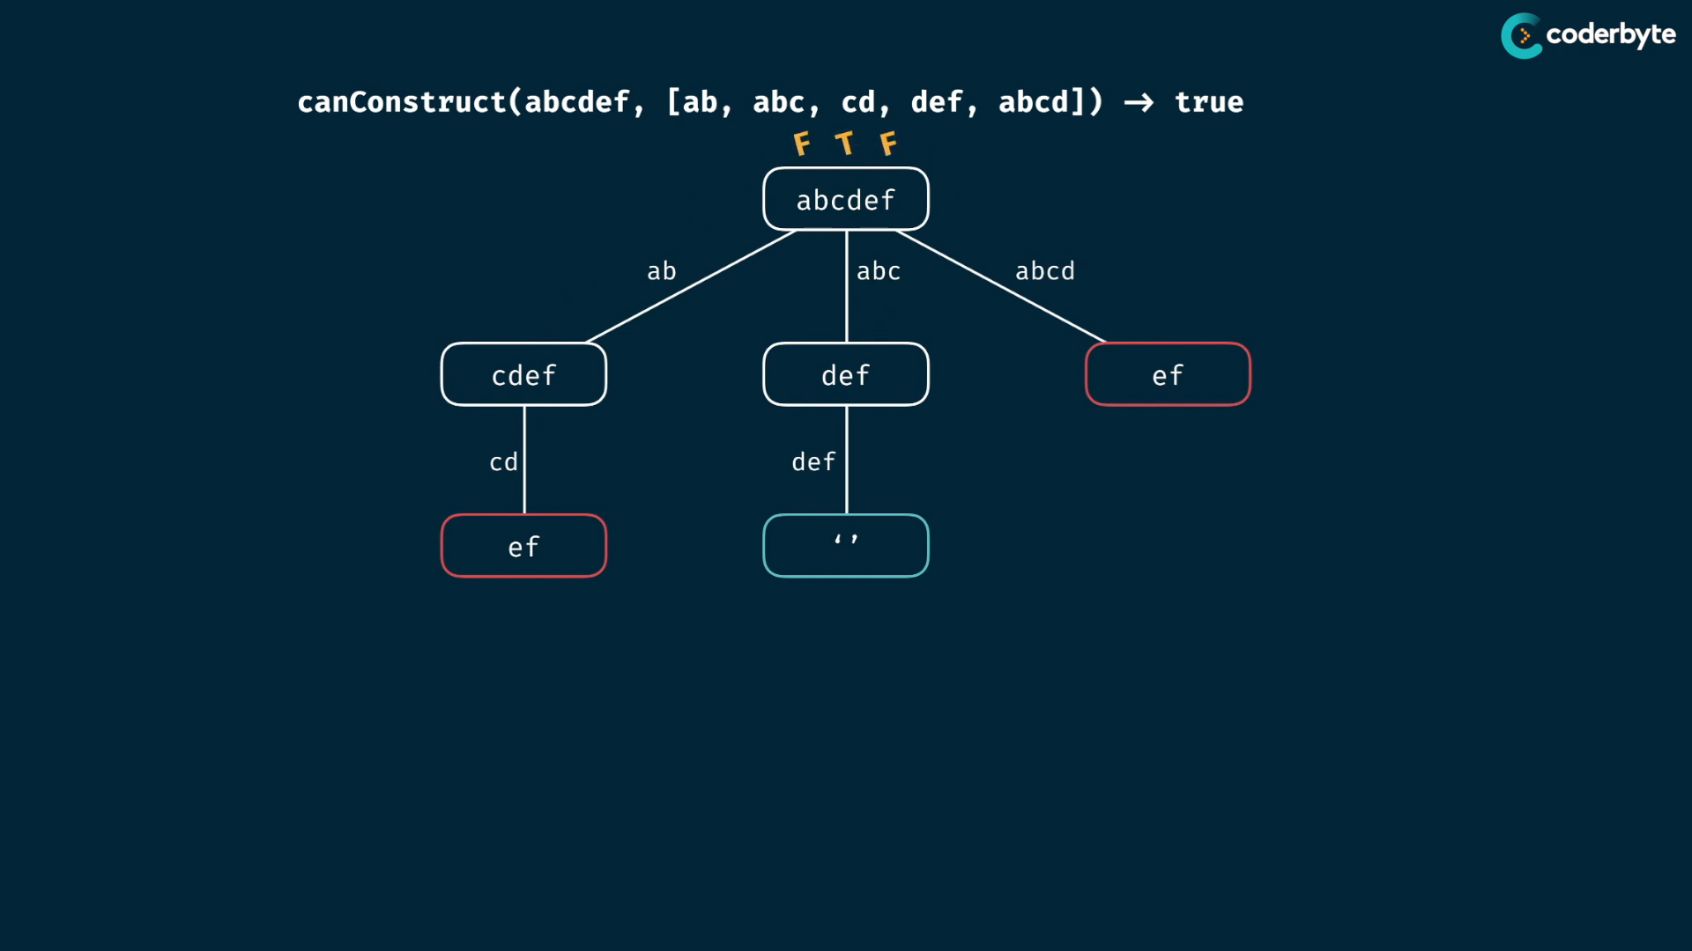

other exp:

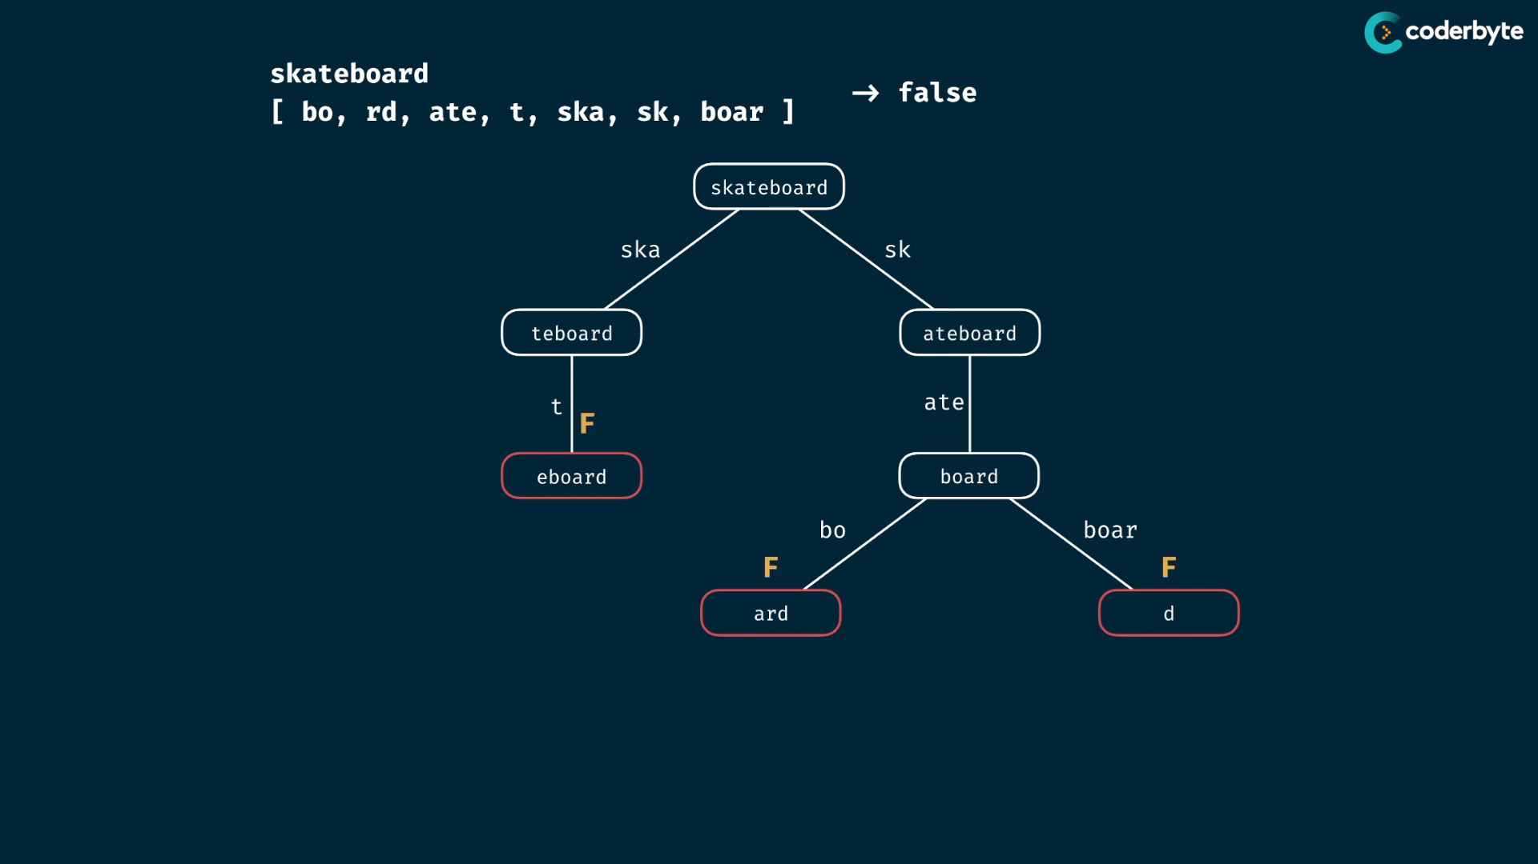

code :

//+ canConstruct (brut)

const canConstruct = (target,wordBank) => {

    if (target === "") return true;

    for(let word of wordBank){

        if(target.indexOf(word) === 0){

            const suffix = target.slice(word.length);

            if( canConstruct( suffix,wordBank) === true)

                return true;

        }

    }

    return false;

}

console.log(canConstruct("abcdef",['ab','abc','cd','def','abcd']));     //=> true

console.log(canConstruct("skateboard",['bo','rd','ate','t','ska','sk','boar']));//=> false

console.log(canConstruct("enterapotentpot",['a','p','ent','enter','ot','o','t']));//=> true

console.log(canConstruct("eeeeeeeeeeeeeeeeeeeeeeeeeeeeeeeeeeeef",[

    'e',

    'ee',

    'eee',

    'eeee',

    'eeeee',

    'eeeeee',

    'eeeeeeee',

]))   //=> false  {takes extra longer time}

updation:

*//+ canConstruct (moi)*

const canConstruct = (target,wordBank,memo={}) => {

    if(Object.keys(memo).length === 0){

        if (target === "") return true;

        cet = new Set();

        for(word of wordBank){

            memo[word] = true;

            [...word].forEach((e)=> cet.add(e) );

        }

        for( let i of  [...new Set(target)])

            if(! cet.has(i)) return false;

    }

    if(target in memo) return memo[target];

    for(let word of wordBank){

        if(target.indexOf(word) === 0){

            if( canConstruct(target.slice(word.length),wordBank,memo) ){

                return memo[target] = true;

            }

        }

    }

    return memo[target] = false;

}

console.log(canConstruct("abcdef",['ab','abc','cd','def','abcd']));     *//=> true*

console.log(canConstruct("skateboard",['bo','rd','ate','t','ska','sk','boar']));*//=> false*

console.log(canConstruct("enterapotentpot",['a','p','ent','enter','ot','o','t']));*//=> true*

console.log(canConstruct("eeeeeeeeeeeeeeeeeeeeeeeeeeeeeeeeeeeef",[

    'e',

    'ee',

    'eee',

    'eeee',

    'eeeee',

    'eeeeee',

    'eeeeeeee',

]))   *//=> false*

console.log(canConstruct("abcd",['e','f','g','h']));*//=> false*

observing complx:

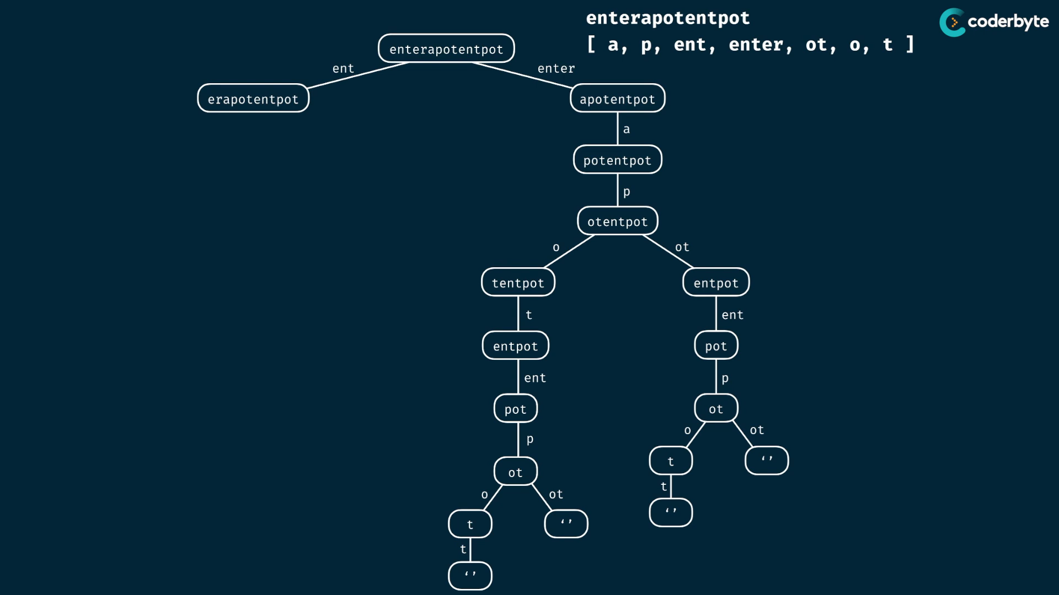

single char prefixes for all string , it become worst case and become tallest tree….

m = target.length

n = wordBank.length

time cmplx = nodes of call tree

height of tree => single char choices ,so m at worst case

branching factore => is about the elements of wordBank count .. which is n for each nodes ..

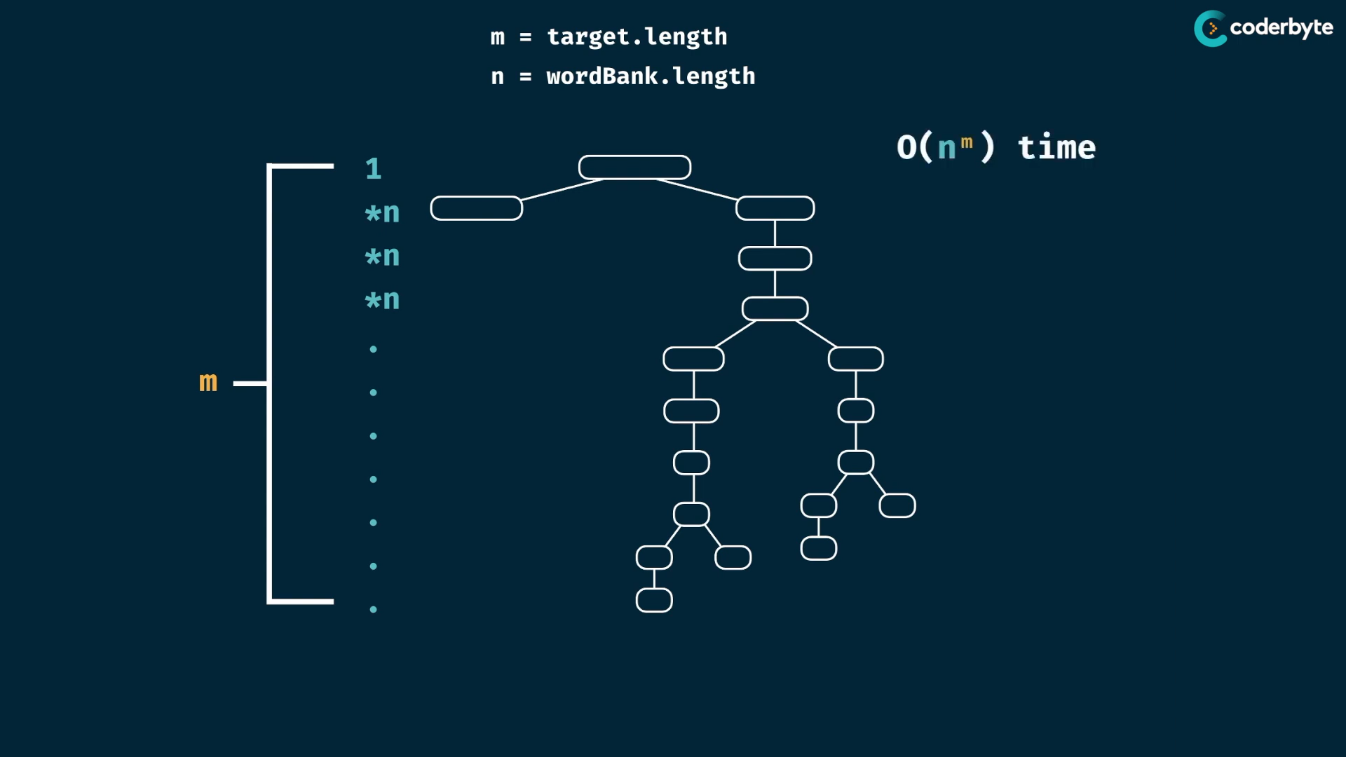

thus time cmplx => O(n^m)

see code , we do slicing operations which uses iteration of target strings of length m … so evernode also gets this additionally ..

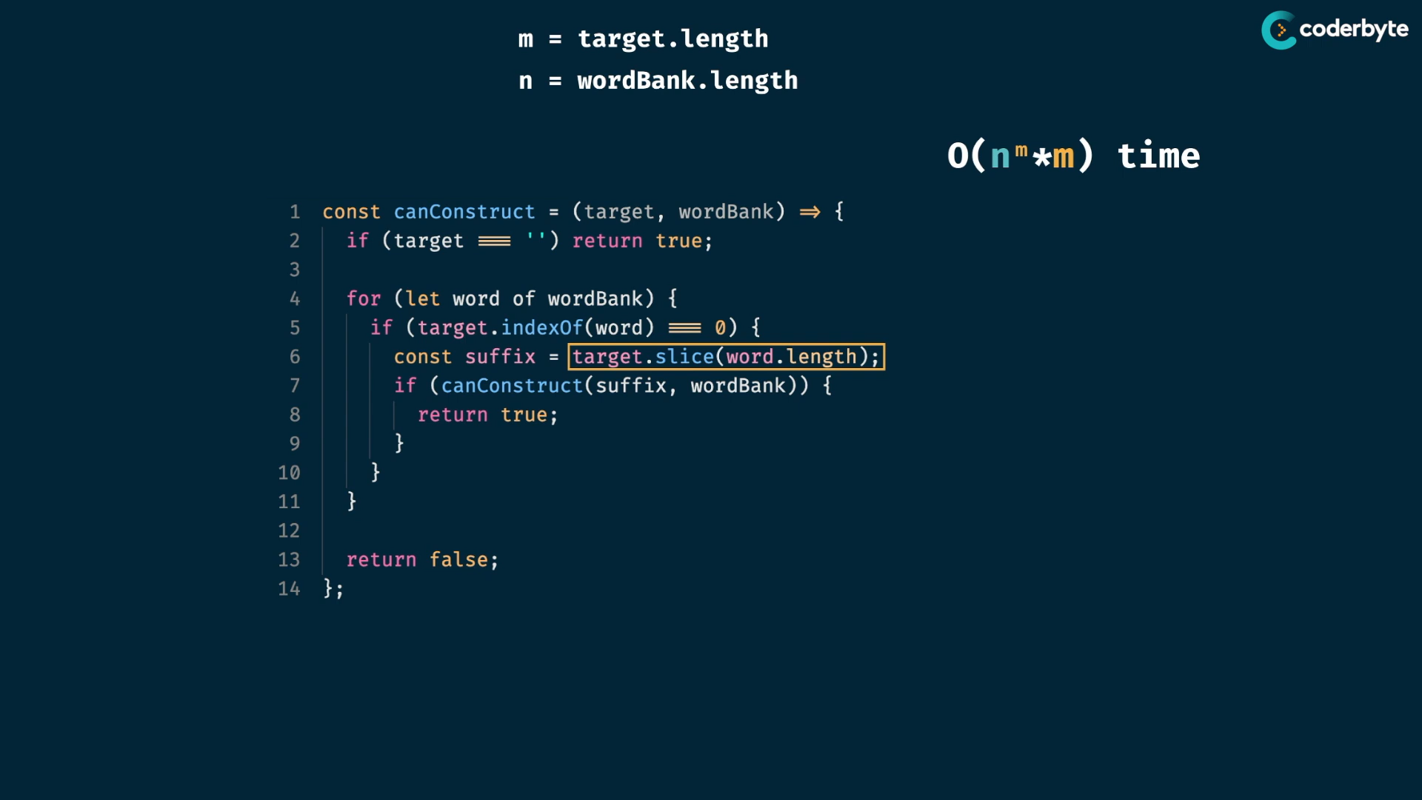

therefore , space O(m* n^m ) , it is exponential which is very large time complexity ..

space ; -> height of tree ..i.e call stack so its O(m)

see code , we maintain a buffer string which takes space upto m length ..

which is for every node ..

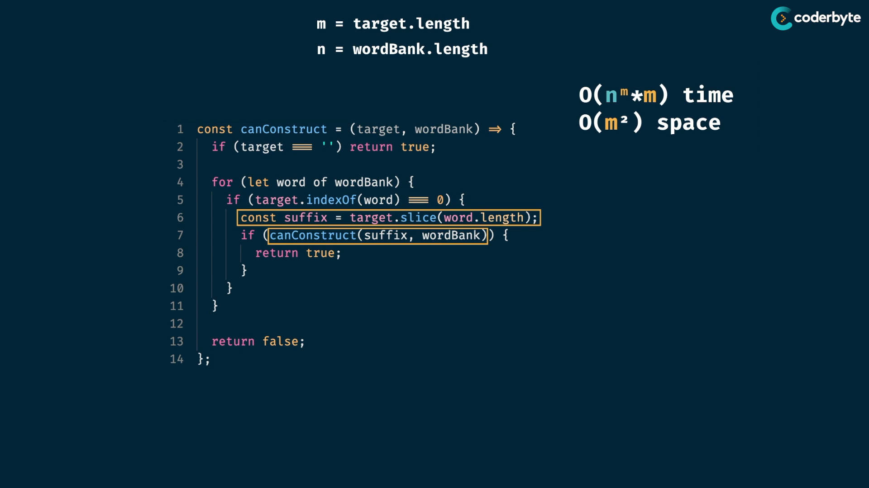

so space cmplx is O(m^2).

so brute force gives quadratic in time and exponential in space ..

look tree , we have overlapping subprob.

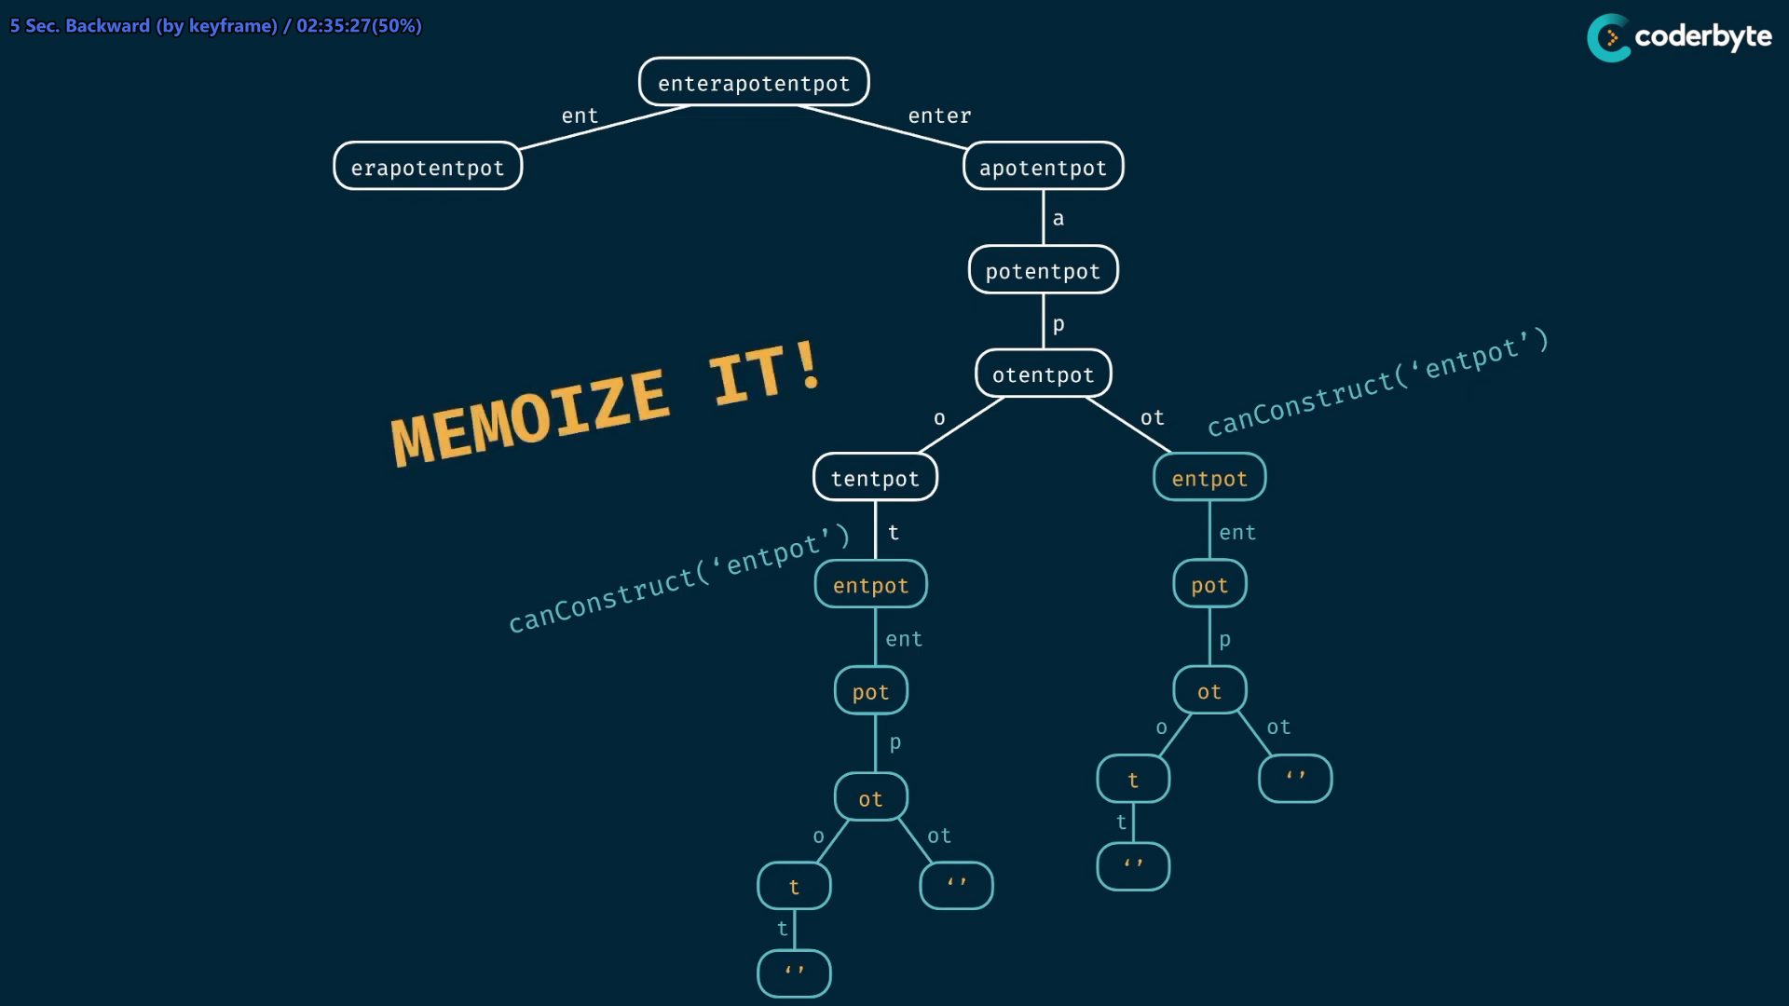

memoi:

//+ canConstruct (moi)

const canConstruct = (target,wordBank,memo={}) => {

    if(target in memo) return memo[target];

    if (target === "") return true;

    for(let word of wordBank){

        if(target.indexOf(word) === 0){

            const suffix = target.slice(word.length);

            if( canConstruct( suffix,wordBank,memo) === true){

                memo[target] = true;

                return true;

            }

        }

    }

    memo[target] = false;

    return false;

}

console.log(canConstruct("abcdef",['ab','abc','cd','def','abcd']));     //=> true

console.log(canConstruct("skateboard",['bo','rd','ate','t','ska','sk','boar']));//=> false

console.log(canConstruct("enterapotentpot",['a','p','ent','enter','ot','o','t']));//=> true

console.log(canConstruct("eeeeeeeeeeeeeeeeeeeeeeeeeeeeeeeeeeeef",[

    'e',

    'ee',

    'eee',

    'eeee',

    'eeeee',

    'eeeeee',

    'eeeeeeee',

]))   //=> false

time cmplx:

through memo , we just create combination of n and m nodes for solving …

so O(n*m)..

then we have done slicing of suffix at each nodes.. that must worst case at m length .. O(m)

so space = O(n*m^2)

space=> for each node have m length , and its suffic of m .. then memo space ....

space = O(m^2)

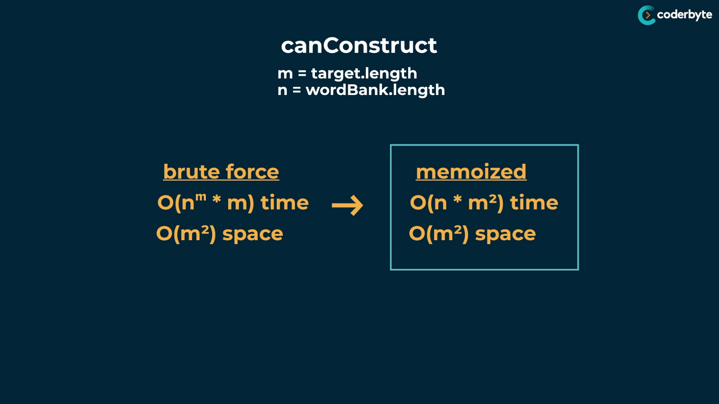

CountConstruct :

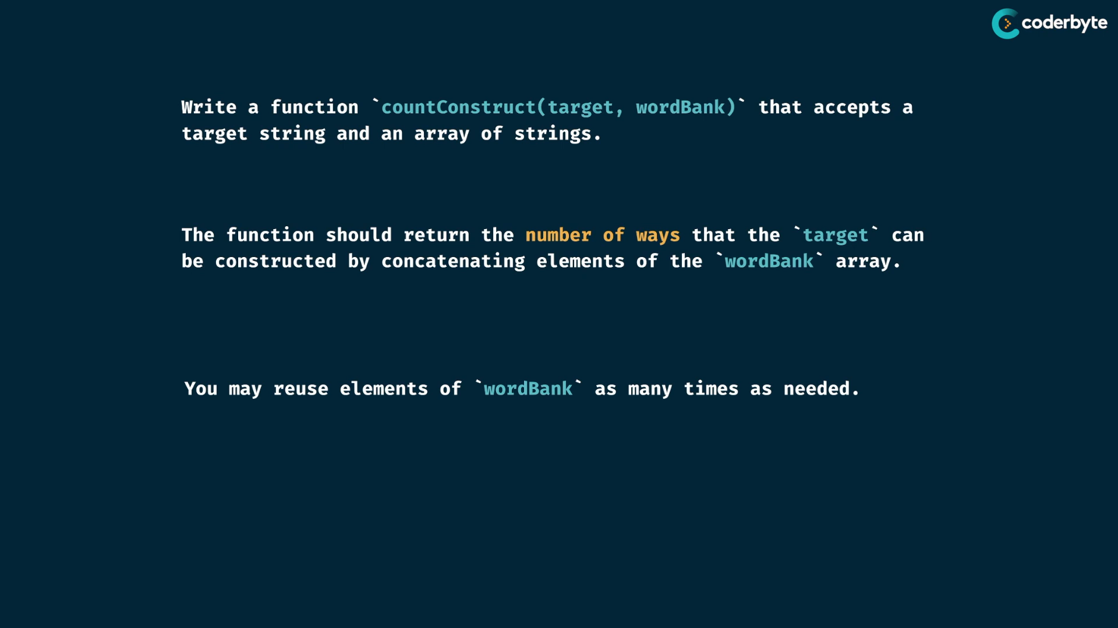

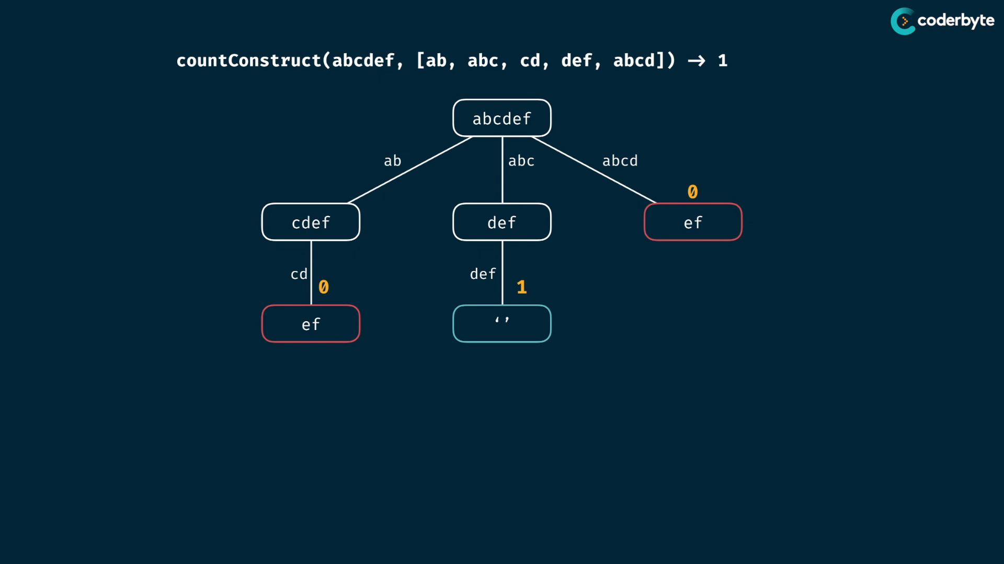

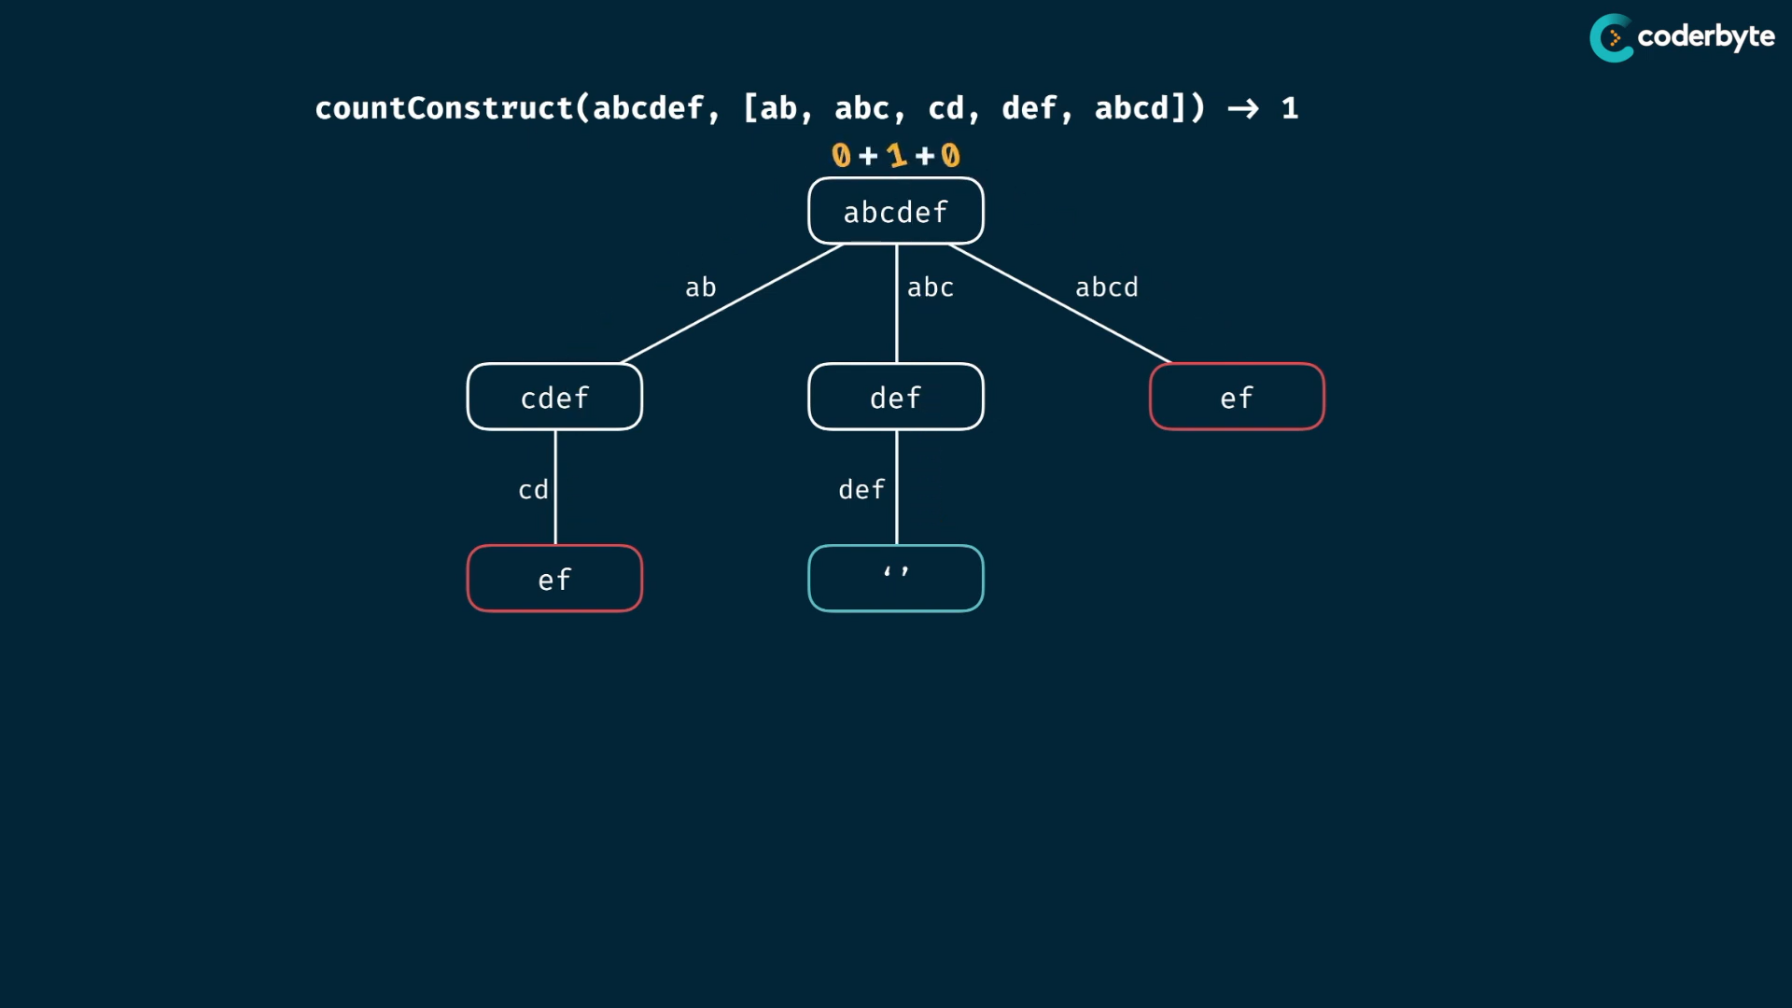

exp:

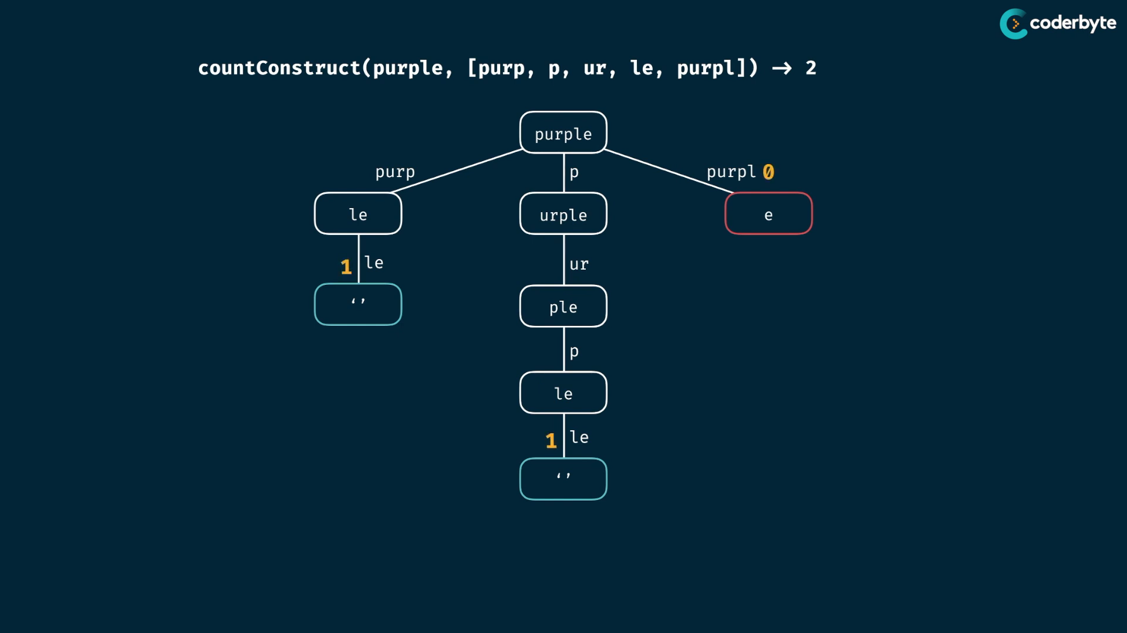

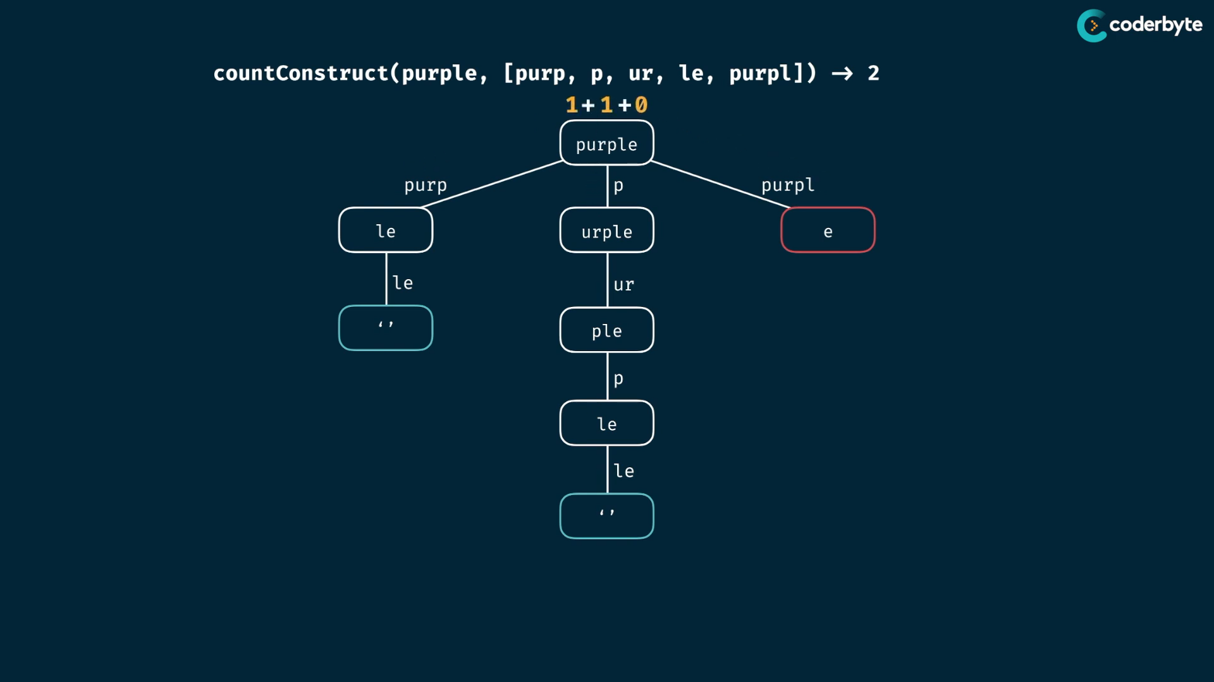

code :

*//+ countConstruct (brut)*

const countConstruct = (target,wordBank) => {

    if (target === "") return 1;

    let totalCount = 0;

    for (word of wordBank){

        if(target.indexOf(word) === 0){

            const totalCountOfRest = countConstruct(target.slice(word.length),wordBank);

            totalCount += totalCountOfRest;

        }

    }

    return totalCount;

}

console.log(countConstruct('purple',['purp','p','ur','le','purpl']))        *//=> 2*

console.log(countConstruct("abcdef",['ab','abc','cd','def','abcd']));     *//=> 1*

console.log(countConstruct("skateboard",['bo','rd','ate','t','ska','sk','boar']));*//=> 0*

console.log(countConstruct("enterapotentpot",['a','p','ent','enter','ot','o','t']));*//=> 4*

console.log(countConstruct("eeeeeeeeeeeeeeeeeeeeeeeeeeeeeeeeeeeef",[

    'e',

    'ee',

    'eee',

    'eeee',

    'eeeee',

    'eeeeee',

    'eeeeeeee',

]))   *//=> 0 {takes larger time}*

memoi:

//+ countConstruct (moi)

*const* countConstruct = (*target*,*wordBank*,*memo*={}) *=>* {

    if (*target* in *memo*) return *memo*[*target*];

    if (*target* === "") return 1;

*let* totalCount = 0;

    for (word of *wordBank*){

        if(*target*.indexOf(word) === 0){

*const* totalCountOfRest = countConstruct(*target*.slice(word.length),*wordBank*,*memo*);

            totalCount += totalCountOfRest;

        }

    }

*memo*[*target*] = totalCount;

    return totalCount;

}

console.log(countConstruct('purple',['purp','p','ur','le','purpl']))        //=> 2

console.log(countConstruct("abcdef",['ab','abc','cd','def','abcd']));     //=> 1

console.log(countConstruct("skateboard",['bo','rd','ate','t','ska','sk','boar']));//=> 0

console.log(countConstruct("enterapotentpot",['a','p','ent','enter','ot','o','t']));//=> 4

console.log(countConstruct("eeeeeeeeeeeeeeeeeeeeeeeeeeeeeeeeeeeef",[

    'e',

    'ee',

    'eee',

    'eeee',

    'eeeee',

    'eeeeee',

    'eeeeeeee',

]))   //=> 0

time complexities :

m = target.length

n = wordBank.length

like the last ones, the complexities become same.. since last time we return Boolean , this time just count number…

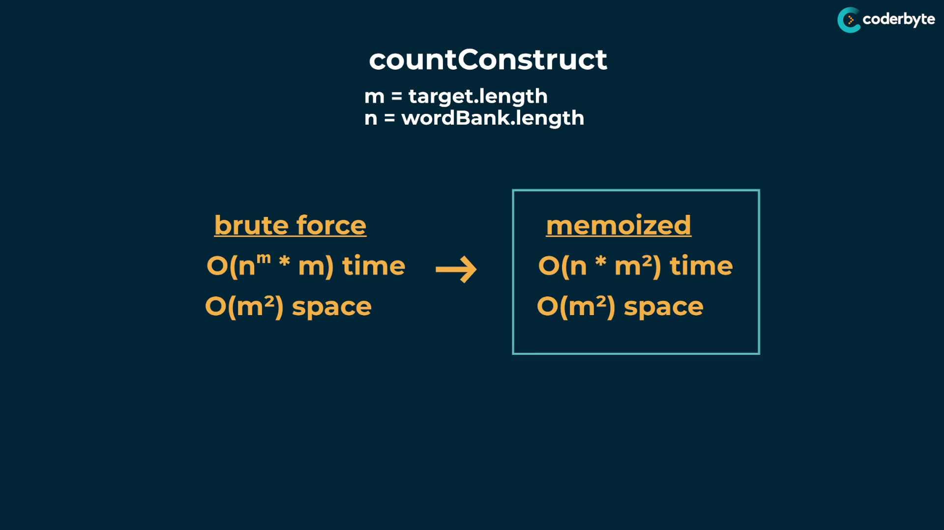

**allConstruct:**

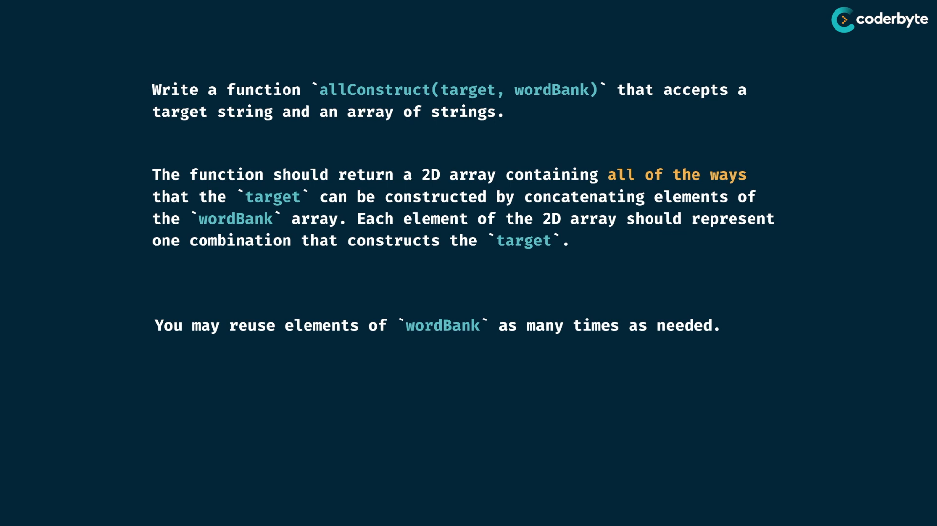

exp:

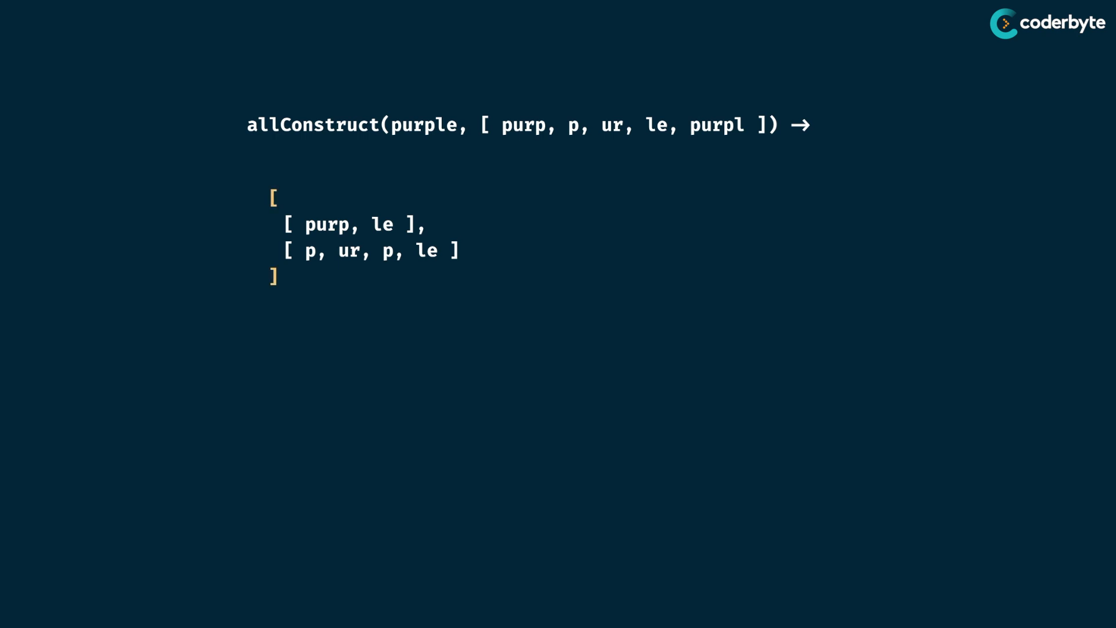

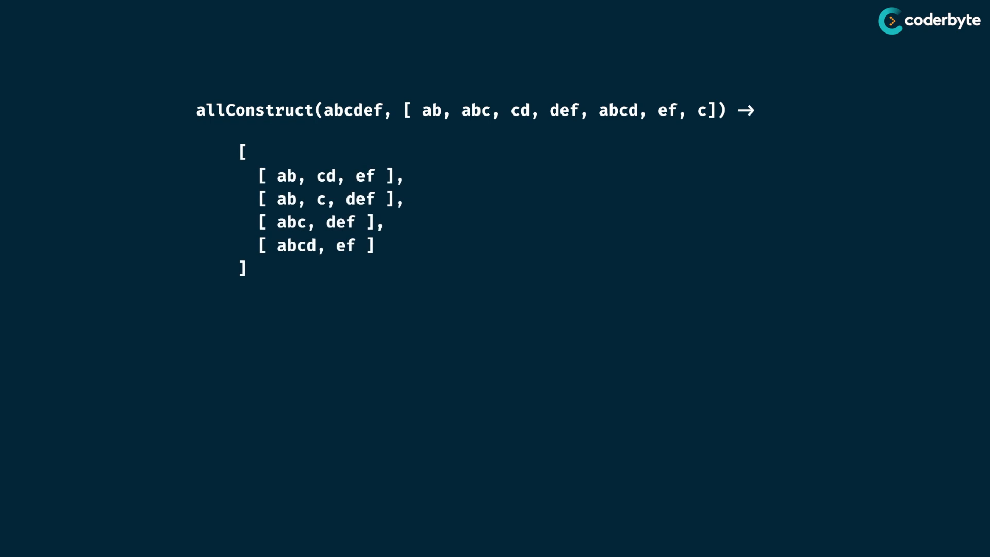

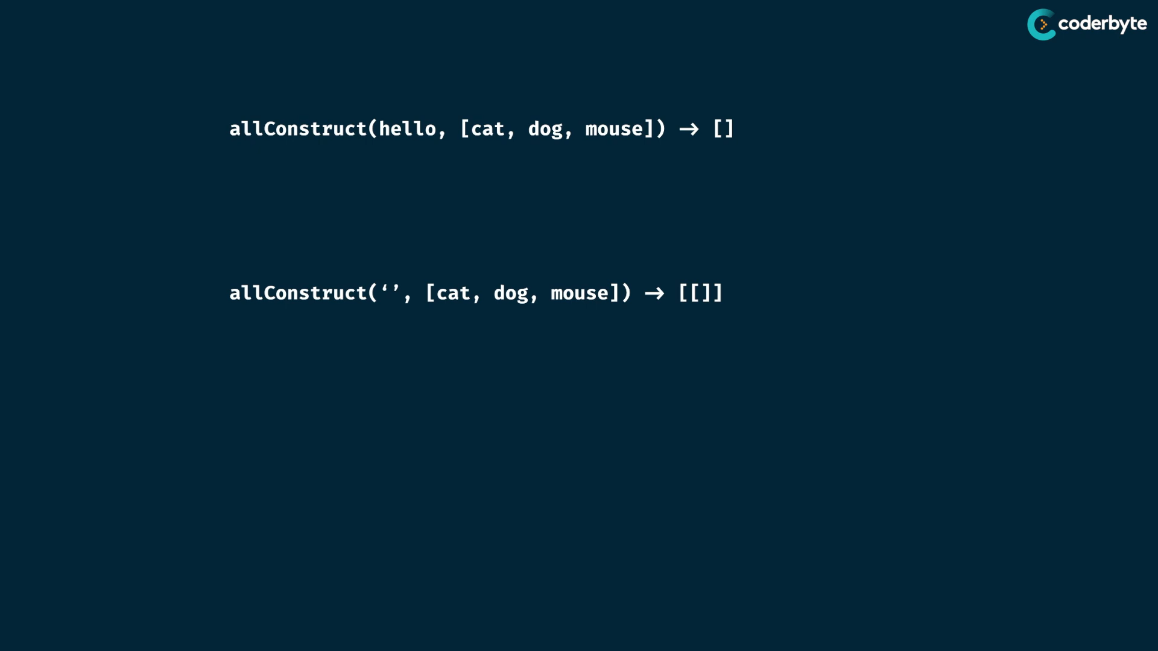

tree :

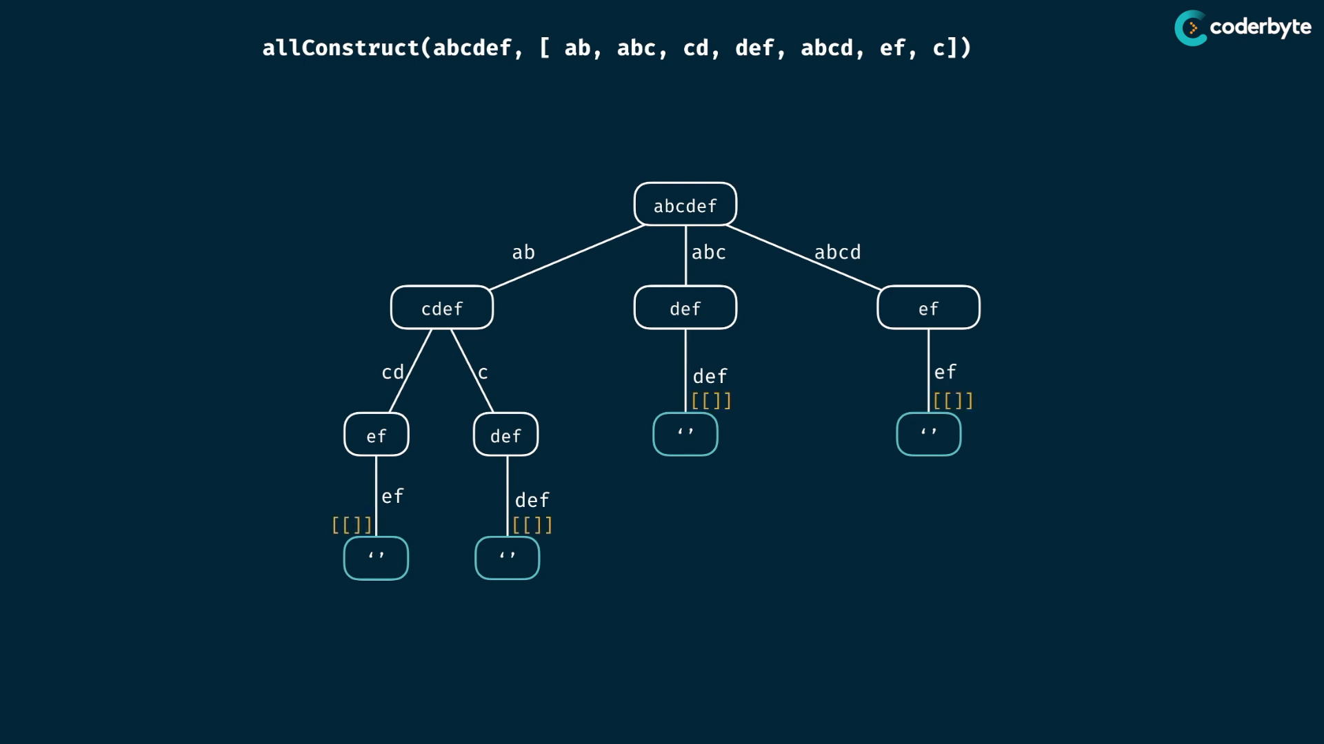

pushing edge is done while passing to the parent …

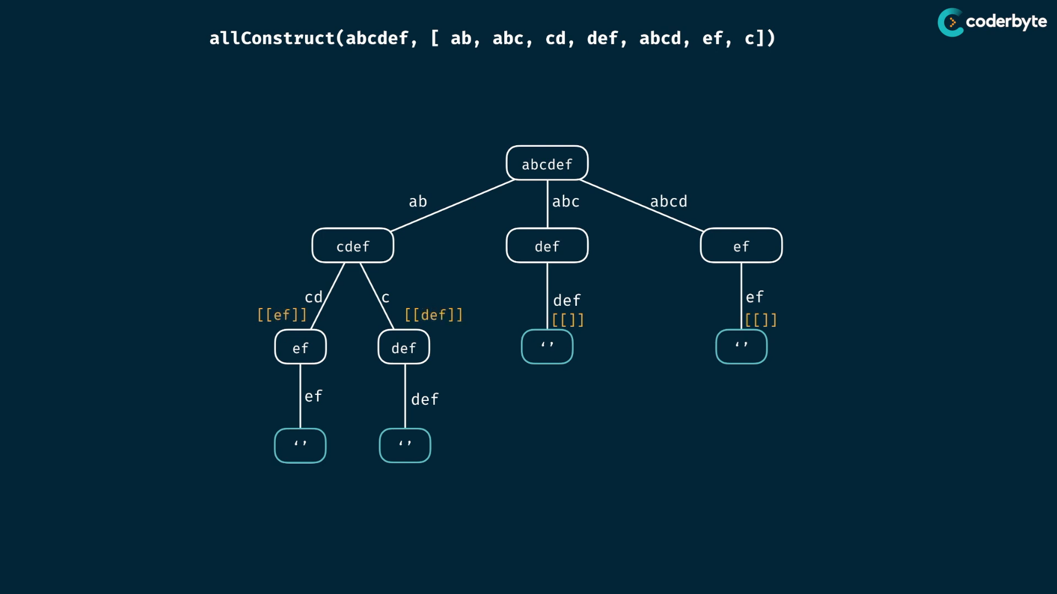

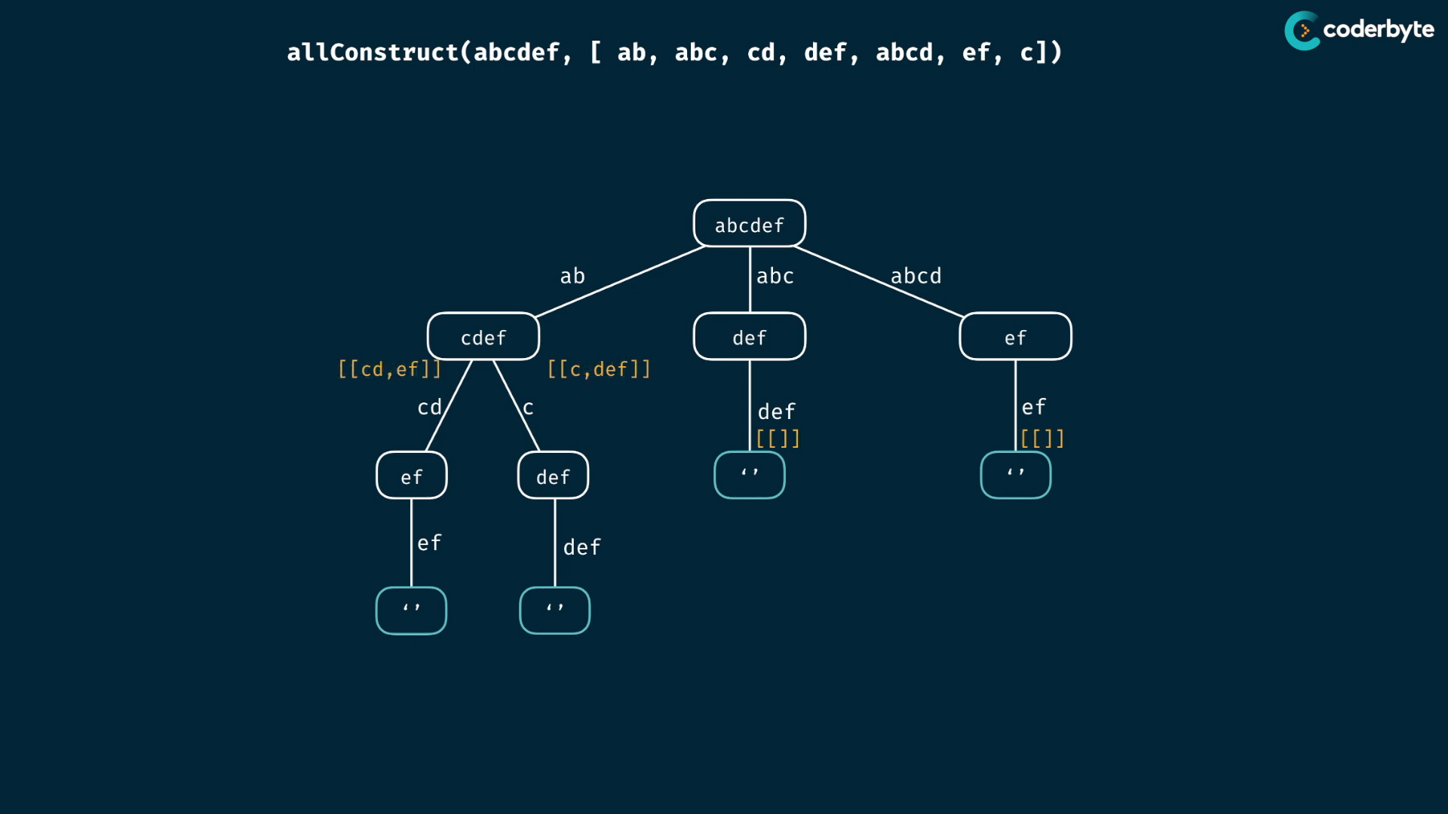

parents must combine the child nodes results…

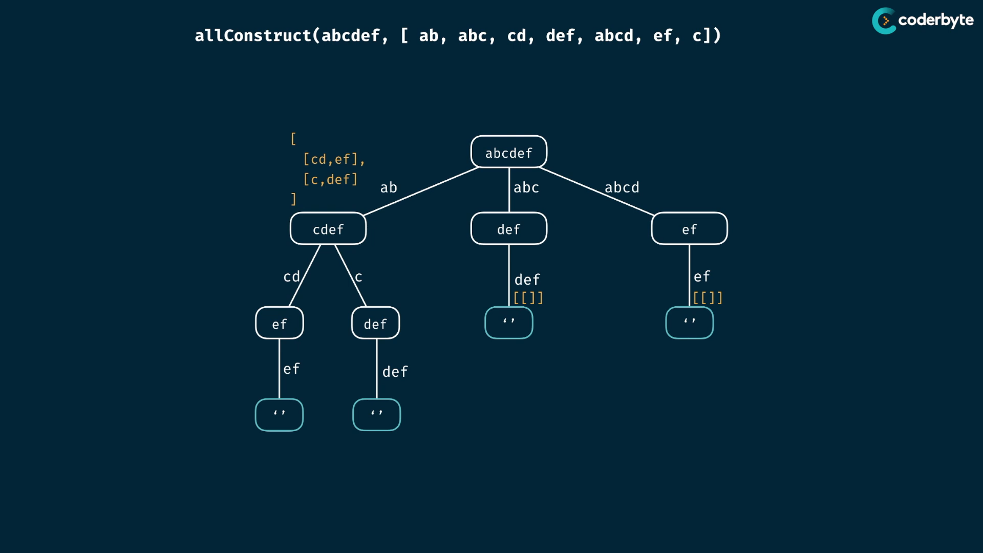

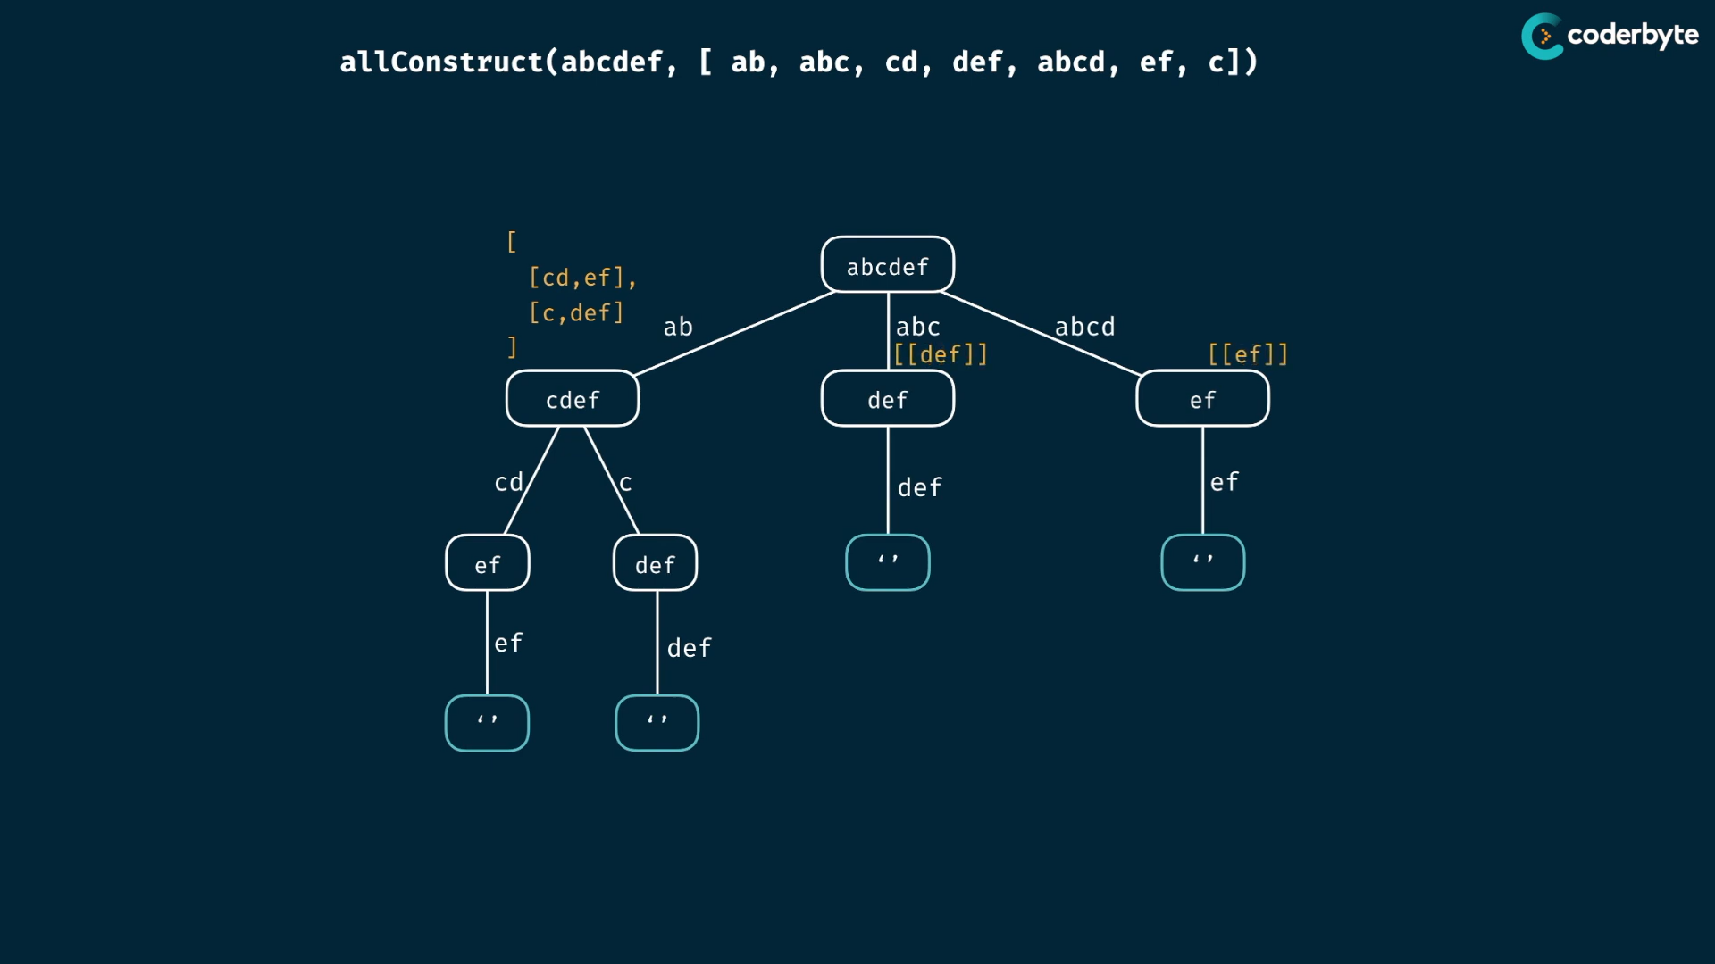

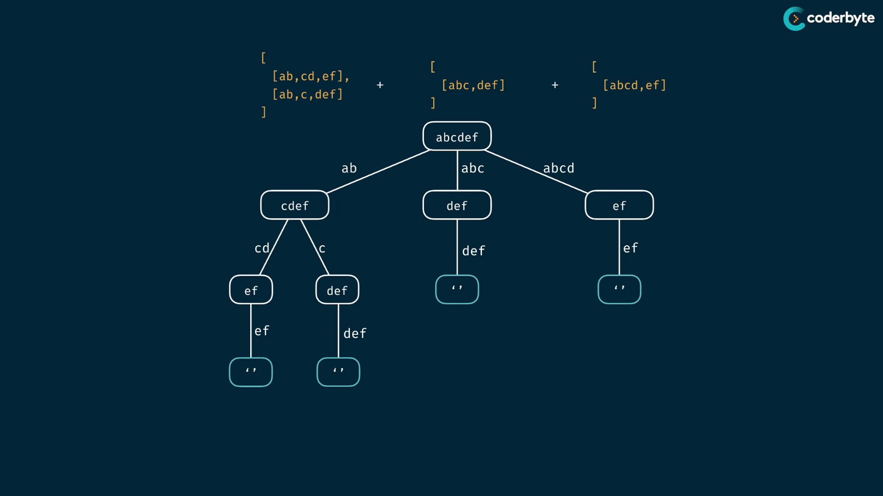

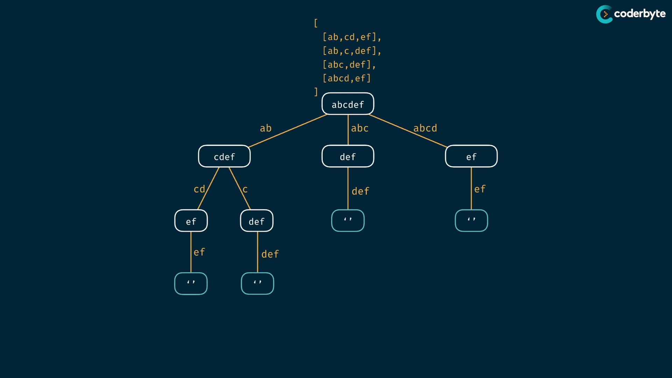

other exp:

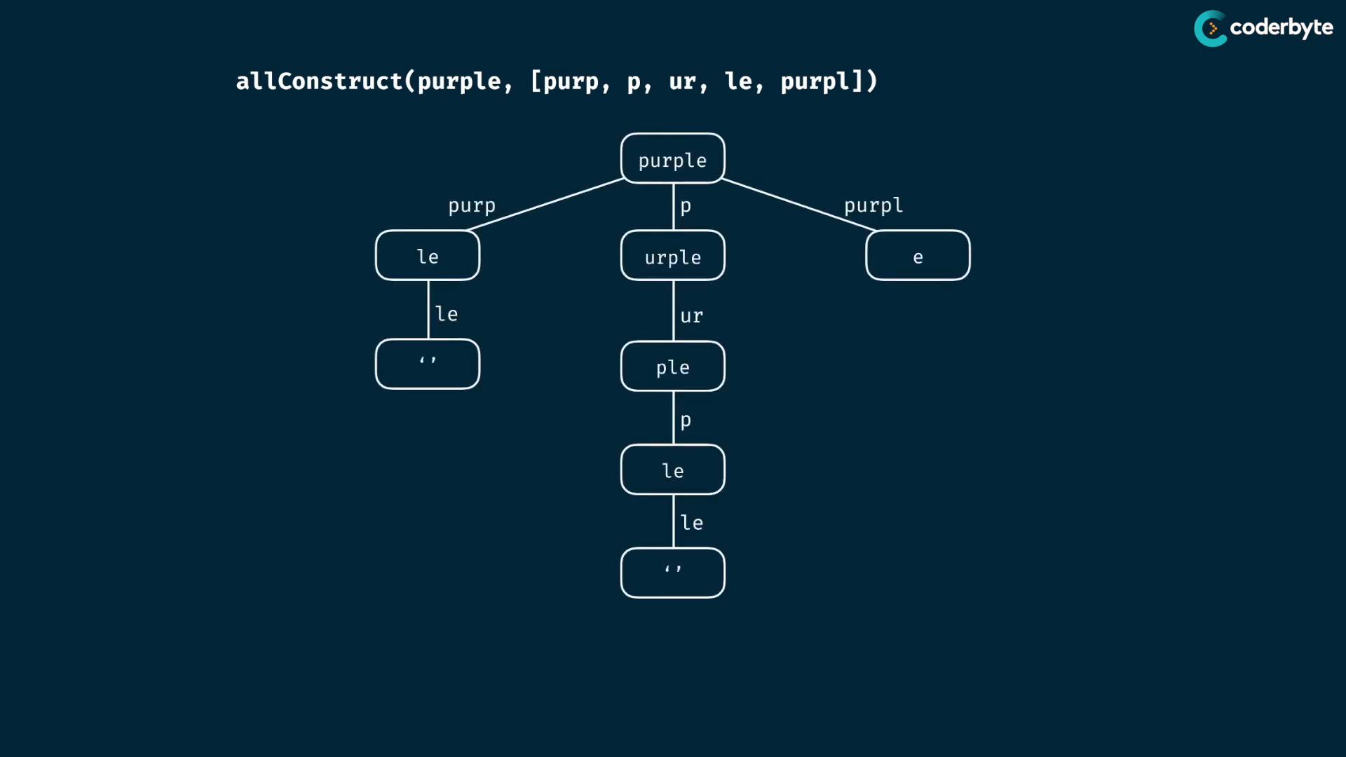

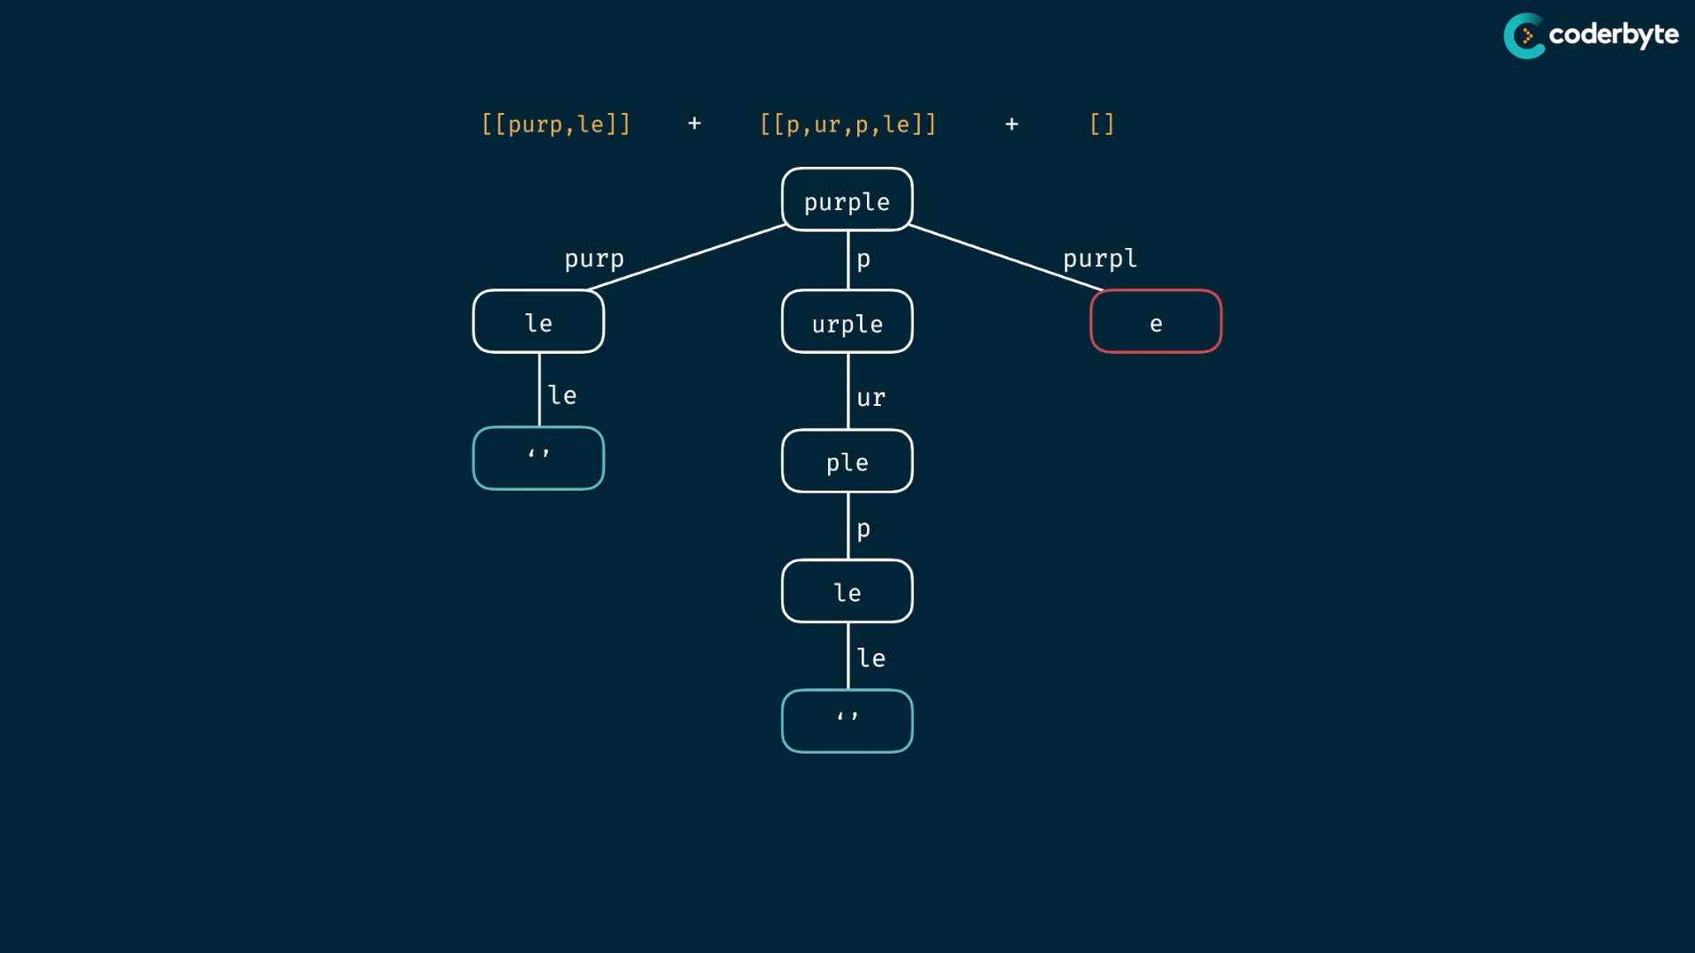

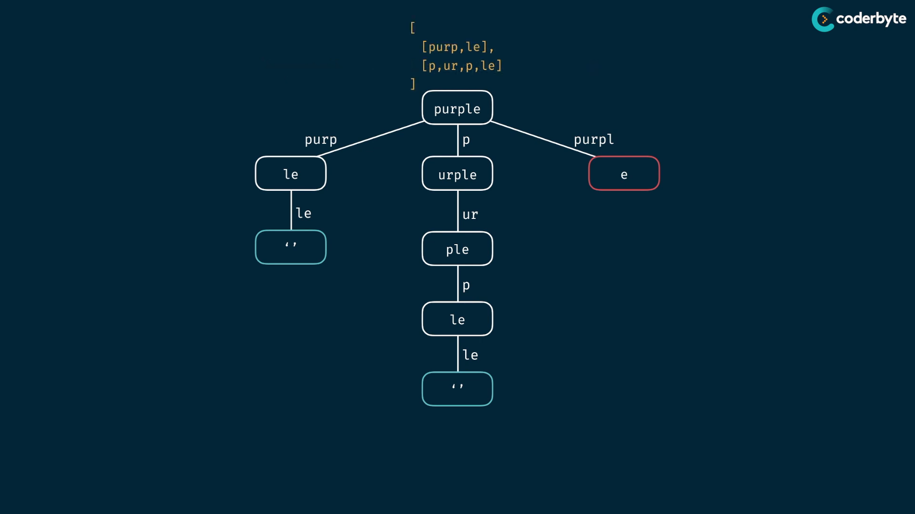

code:

//+ allConstruct (brut)

*const* allConstruct = (*target*,*wordBank*) *=>* {

    if(*target* === '') return [[]];

*const* result = [];

    for(*let* word of *wordBank*){

        if(*target*.indexOf(word) === 0){

*const* suffix = *target*.slice(word.length);

*const* suffixWays = allConstruct(suffix,*wordBank*)

*const* targetWays = suffixWays.map( *way* *=>* [word,...*way*])

            result.push(...targetWays);

        }

    }

    return result;

};

console.log(allConstruct('purple',['purp','p','ur','le','purp']));

/*

[

    [ 'purp', 'le' ],

    [ 'p', 'ur', 'p', 'le' ],

    [ 'purp', 'le' ]

]

*/

console.log(allConstruct('abcdef',['ab','abc','cd','def','abcd','ef','c']));

/*

[

  [ 'ab', 'cd', 'ef' ],

  [ 'ab', 'c', 'def' ],

  [ 'abc', 'def' ],

  [ 'abcd', 'ef' ]

]

*/

console.log(allConstruct('skateboard',['bo','rd','ate','t','ska','sk','boar']));

/*

[]

*/

console.log(allConstruct('aaaaaaaaaaaaaaaa',['a','aa','aaa','aaaa','aaaaa']))

/*

[

  [

    'a', 'a', 'a', 'a',

    'a', 'a', 'a', 'a',

    'a', 'a', 'a', 'a',

    'a', 'a', 'a', 'a'

  ],

  [

    'a', 'a', 'a',  'a',

    'a', 'a', 'a',  'a',

    'a', 'a', 'a',  'a',

    'a', 'a', 'aa'

  ],

  ... 26684 more items

]

*/

console.log(allConstruct('aaaaaaaaaaaaaaaaaaaaaaaaaz',['a','aa','aaa','aaaa','aaaaa']))

/*

[] {take little extra time}

*/

remember :

this is not worst case , since its return []

console.log(allConstruct('aaaaaaaaaaaaaaaaaaaaaaaaaz',['a','aa','aaa','aaaa','aaaaa']))

/*

[]

*/

to make worst case ,remove z.. so that you can get lot of possible ways ..

memoi:

*//+ allConstruct (moi)*

const allConstruct = (target,wordBank,memo={}) => {

*//if(target in memo) return memo[target];*

    if(target === '') return [[]];

    const result = [];

    for(let word of wordBank){

        if(target.indexOf(word) === 0){

            const suffix = target.slice(word.length);

            const suffixWays = allConstruct(suffix,wordBank,memo)

            const targetWays = suffixWays.map( way => [word,...way])

            result.push(...targetWays);

        }

    }

    memo[target] = result;

    return result;

};

console.log(allConstruct('purple',['purp','p','ur','le','purp']));

*/\**

*[*

*[ 'purp', 'le' ],*

*[ 'p', 'ur', 'p', 'le' ],*

*[ 'purp', 'le' ]*

*]*

*\*/*

console.log(allConstruct('abcdef',['ab','abc','cd','def','abcd','ef','c']));

*/\**

*[*

*[ 'ab', 'cd', 'ef' ],*

*[ 'ab', 'c', 'def' ],*

*[ 'abc', 'def' ],*

*[ 'abcd', 'ef' ]*

*]*

*\*/*

console.log(allConstruct('skateboard',['bo','rd','ate','t','ska','sk','boar']));

*/\**

*[]*

*\*/*

console.log(allConstruct('aaaaaaaaaaaaaaaa',['a','aa','aaa','aaaa','aaaaa']))

*/\**

*[*

*[*

*'a', 'a', 'a', 'a',*

*'a', 'a', 'a', 'a',*

*'a', 'a', 'a', 'a',*

*'a', 'a', 'a', 'a'*

*],*

*[*

*'a', 'a', 'a',  'a',*

*'a', 'a', 'a',  'a',*

*'a', 'a', 'a',  'a',*

*'a', 'a', 'aa'*

*],*

*... 26684 more items*

*]*

*\*/*

console.log(allConstruct('aaaaaaaaaaaaaaaaaaaaaaaaaz',['a','aa','aaa','aaaa','aaaaa']))

*/\**

*[]*

*\*/*

cmplx:

like same old sum

each leaf represents one way to create target strings..

height of tree .. is m..

form one level to next , we multiple by n ..

which give O(n^m) combinations,,

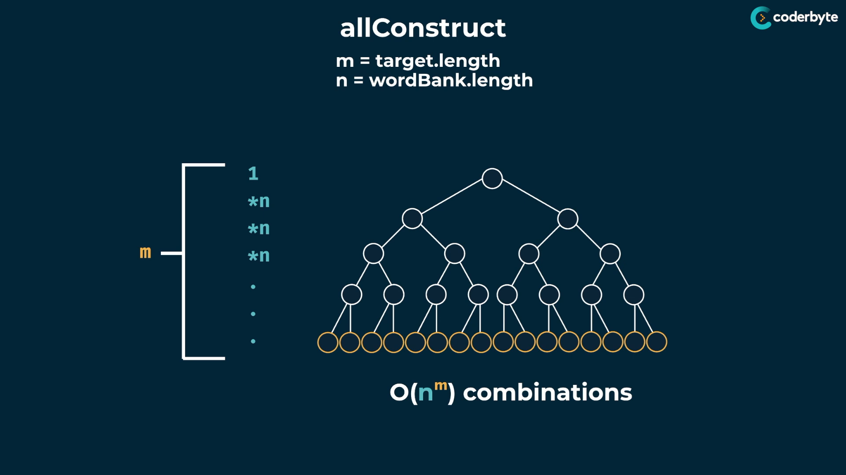

O(n^m) combinations -> each combinations have subarrays ,so O(n^m) subarrays..

no matter how clever we make algo , we result the combinations which is expoinentials in size..

nothing better than exponentials ..

we can add additional cmplx., but they are markless to exponential , so no need to mention..

space complex is just O(m) which is height of the tree. i.e callstacks

the output is subarray , when the output large ,

we usually donot consider the size of result , since its 2D ones.. which is obvious to give exponentials .. since the result itself is exponentials.

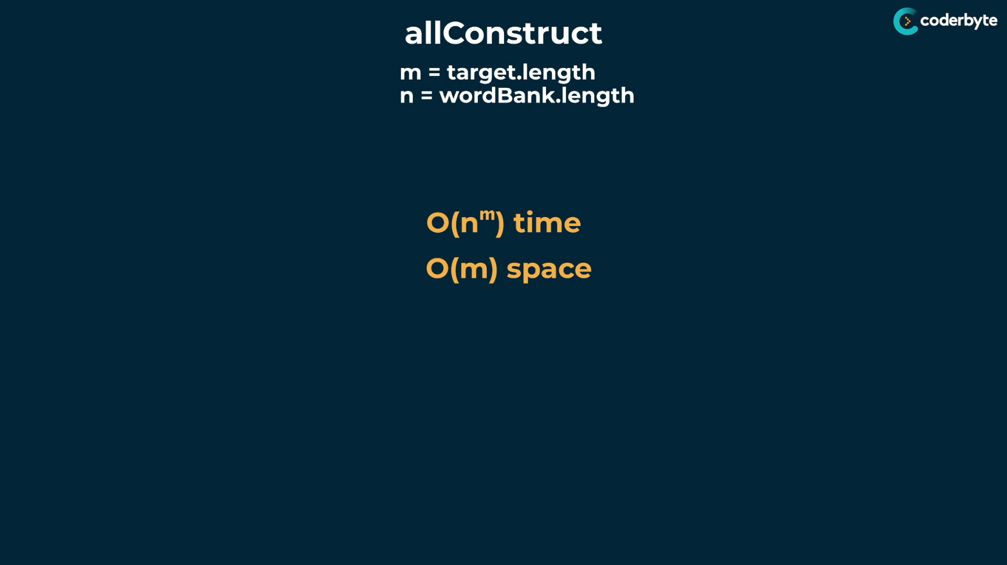

{ time and space cmplx … }